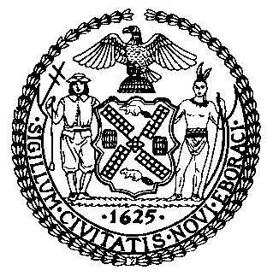 | The Council of the City of New York  Finance Division  Latonia Mckinney, Director  Fiscal Impact Statement  Proposed Intro. No: 2130-A  Committee: Consumer Affairs and Business Licensing
Title: A local law to amend the administrative code of the city of New York, in relation to providing notice regarding student loan forgiveness programs to certain employees and applicants for employment | Sponsor(s): Council Member Rosenthal, Kallos, Adams, Chin, Cornegy, Yeger, Powers and Brooks-Powers
Summary of Legislation: Proposed Int. No. 2130-A would require the Department of Citywide Administrative Services (DCAS), in consultation with the Department of Consumer and Worker Protection (DCWP), to prepare a notice for employees and job applicants regarding the availability of federal and state student loan forgiveness programs. City agencies would provide the notice to agency employees and job applicants, and DCWP would make the notice available to employers in New York City to provide to employees and job applicants.
Effective Date: This bill would take effect 90 days after it becomes law.
Fiscal Year In Which Full Fiscal Impact Anticipated: Fiscal 2023

Fiscal Impact Statement:

 | Effective FY22 | FY Succeeding  Effective FY23 | Full Fiscal  Impact FY23
Revenues | $0 | $0 | $0
Expenditures | $0 | $0 | $0
Net | $0 | $0 | $0

Impact on Revenues: It is anticipated that the enactment of this legislation would not generate any revenue.

Impact on Expenditures: It is estimated that there would be no impact on expenditures resulting from the enactment of this legislation as the agencies responsible for carrying out its requirements would be able to use existing resources.

Source of Funds To Cover Estimated Costs: N/A

Source of Information: New York City Council Finance Division

Estimate Prepared by: Florentine Kabore, Financial Analyst

Estimate Reviewed by: John Russell, Unit Head
Nathan Toth, Deputy Director
Noah Brick, Assistant Counsel

Legislative History: This legislation was introduced by the Council on October 15, 2021 as Int. No. 2130 and was referred to the Committee on Governmental Operations. The legislation was then re-referred to the Committee on Consumer Affairs and Business Licensing (Committee) on July 26, 2021. The Committee heard the legislation on October 22, 2021 and the legislation was laid over. The bill was subsequently amended, and the amended version, Proposed Int. No. 2130-A, will be heard by the Committee on December 8, 2021. Upon successful vote by the Committee, the bill will be submitted to the full Council for a vote on December 9, 2021.

Date Prepared: December 3, 2021

