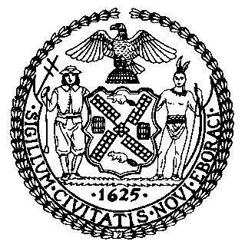 | The Council of the City of New York  Finance Division  Latonia McKinney, Director  Fiscal Impact Statement  Proposed Int. No. 1874-A  Committee: Governmental Operations
Title: A Local Law to amend the administrative code of the city of New York, in relation to permitting interested parties to receive notification of items published in the City Record | Sponsors: Council Members Chin, Kallos and Yeger
Summary of Legislation: Proposed Int. No. 1874-A would permit individuals to sign up to receive email notifications on items in the City Record. The purpose of this legislation is to increase public access to up-to-date information about City political processes.

Effective Date: This local law would take effect 180 days after it becomes law.
Fiscal Year in which Full Fiscal Impact Anticipated: Fiscal 2022
Fiscal Impact Statement:
 | Effective FY21 | FY Succeeding  Effective FY22 | Full Fiscal Impact FY22
Revenues (+) | $0 | $0 | $0
Expenditures (-) | $0 | $0 | $0
Net | $0 | $0 | $0

Impact on Revenues: It is estimated that there would be no impact on revenues resulting from the enactment of this legislation.

Impact on Expenditures: It is estimated that there would be no impact on expenditures resulting from the enactment of this legislation because the relevant agencies would use existing resources to accomplish its requirements.

Source of Funds to Cover Estimated Costs: N/A

Sources of Information: New York City Council Finance Division
Mayor’s Office of Legislative Affairs
Department of Citywide Administrative Services
Office of Management and Budget

Estimate Prepared by: Sebastian Palacio Bacchi, Senior Financial Analyst

Estimate Reviewed by: Nathaniel Toth, Deputy Director
John Russell, Unit Head
Stephanie Ruiz, Assistant Counsel
Legislative History: This legislation was introduced to the Council as Intro. No. 1874 on February 11, 2020 and was referred to the Committee on Governmental Operations (Committee). The Committee heard the legislation on February 12, 2020, and the legislation was laid over. The legislation was subsequently amended, and the amended legislation, Proposed Int. No. 1874-A, will be considered by the Committee on September 16, 2020. Upon a successful vote by the Committee, Proposed Int. No. 1874-A will be submitted to the full Council for a vote on September 16, 2020.
Date Prepared: August 20, 2020

