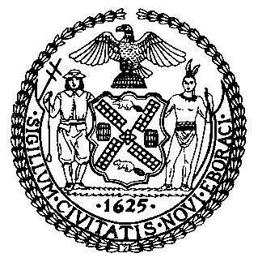 | The Council of the City of New York  Finance Division  Latonia Mckinney, Director  Fiscal Impact Statement  Proposed Int. No: 2096-A  Committee: Consumer Affairs and Business Licensing
Title: A local law to amend the administrative code of the city of New York, in relation to authorizing the department of consumer and worker protection to issue temporary operating licenses to sidewalk café applicants if certain requirements are satisfied | Sponsor(s): Council Member Kallos, Powers, Dromm
Summary of Legislation: Proposed Int. No. 2096-A would allow the Department of Consumer and Worker Protection to issue temporary operating licenses to applicants for a sidewalk café license if the plans for the new sidewalk café are identical to the plans for a previously operating sidewalk café at the same location. This bill would also allow the Department to issue a temporary operating license to new sidewalk cafe applicants whose petitions have been approved but are pending registration by the Comptroller.

Effective Date: This local law would take effect immediately.

Fiscal Year In Which Full Fiscal Impact Anticipated: Fiscal 2023

Fiscal Impact Statement:

 | Effective FY22 | FY Succeeding  Effective FY23 | Full Fiscal  Impact FY23
Revenues | $0 | $0 | $0
Expenditures | $0 | $0 | $0
Net | $0 | $0 | $0

Impact on Revenues: It is anticipated that the enactment of this legislation would not generate any revenue.

Impact on Expenditures: It is estimated that there would be no impact on expenditures resulting from the enactment of this legislation.

Source of Funds To Cover Estimated Costs: N/A

Source of Information: New York City Council Finance Division

Estimate Prepared by: Florentine Kabore, Financial Analyst

Estimate Reviewed by: John Russell, Unit Head
Nathan Toth, Deputy Director
Stephanie Ruiz, Assistant Counsel
Legislative History: This legislation was introduced by the Council on September 23, 2020 as Int. No. 2096 and was referred to the Committee on Consumer Affairs and Business Licensing (Committee). A hearing was held by the Committee, jointly with the Committee on Transportation, on September 30, 2020 and the legislation was laid over. The bill was subsequently amended, and the amended version, Proposed Int. No. 2096-A, will be heard by the Committee on December 14, 2021. Upon successful vote by the Committee, the bill will be submitted to the full Council for a vote on December 15, 2021.

Date Prepared: December 13, 2021

