THE COUNCIL

JOINT REPORT OF THE LAND USE COMMITTEE
AND THE
SUBCOMMITTEE ON ZONING AND FRANCHISES

Preconsidered L.U. Nos. 733 and 734
(Res. Nos. 1614 and 1615)

By Council Members Salamanca and Moya

SUBJECT

BROOKLYN CB-7 - TWO APPLICATIONS RELATED TO 737 FOURTH AVENUE
REZONING

C 200029 ZMK (Pre. L.U. No. 733)

City Planning Commission decision approving an application submitted by 737 Fourth Avenue, LLC, pursuant to Sections 197-c and 201 of the New York City Charter for an amendment of the Zoning Map, Section No. 16d:

- changing from an M1-1D District to an R8A District property bounded by 24th Street, a line 100 feet southeasterly of 4th Avenue, 25th Street, and 4th Avenue;

- establishing within the proposed R8A District a C2-4 District bounded by 24th Street, a line 100 feet southeasterly of 4th Avenue, 25th Street, and 4th Avenue;

- establishing a Special Enhanced Commercial District (EC-1) bounded by 24th Street, a line 100 feet southeasterly of 4th Avenue, 25th Street, and 4th Avenue;

as shown on a diagram (for illustrative purposes only) dated September 14, 2020, and subject to the conditions of CEQR Declaration E-575.

N 200030 ZRK (Pre. L.U. No. 734)

City Planning Commission decision approving an application submitted by 737 Fourth Avenue, LLC, pursuant to Section 201 of the New York City Charter, for an amendment of the Zoning Resolution of the City of New York, extending the boundary of Special Enhanced Commercial District 1 in Article XIII, Chapter 2 (Special Enhanced Commercial District), and modifying APPENDIX F for the purpose of establishing a Mandatory Inclusionary Housing Area, Borough of Brooklyn, Community District 7.

INTENT

To approve an amendment to rezone the Project Area (Block 652, Lots 1 and 7) from M1-1D to R8A/C2-4 and extend the Special Enhanced Commercial District (EC-1) and amend zoning text to establish the Project Area as a Mandatory Inclusionary Housing (“MIH”) area and by including the Project Area within the Special Enhanced Commercial District (EC-1) to facilitate a mixed-use development containing 142 dwelling units, of which approximately 35 would be designated permanently affordable under Option 1 of the Mandatory Inclusionary Housing (MIH) Program, and approximately 8,600 square feet of commercial floor area on the ground floor, at 737 Fourth Avenue in the Sunset Park neighborhood of Community District 7, Brooklyn.

PUBLIC HEARING

DATE: February 23, 2021

Witnesses in Favor: Thirty-four Witnesses Against: Five

SUBCOMMITTEE RECOMMENDATION

DATE: March 16, 2021

The Subcommittee recommends that the Land Use Committee approve the decision of the City Planning Commission on L.U. No. 733 and approve with modifications the decision of the City Planning Commission on L.U. No. 734.

In Favor: Against: Abstain:
Moya None None
Levin
Reynoso
Grodenchik
Ayala
Rivera
Borelli

COMMITTEE ACTION

DATE: March 23, 2021

The Committee recommends that the Council approve the attached resolutions.

In Favor: Against: Abstain:
Salamanca None None
Gibson
Barron
Deutsch
Koo
Levin
Miller
Reynoso
Grodenchik
Adams
Ayala
Diaz Sr.
Moya
Rivera
Riley
Borelli

FILING OF MODIFICATIONS WITH THE CITY PLANNING COMMISSION

The City Planning Commission filed a letter dated April 5, 2021, with the Council on April 8, 2021, indicating that the proposed modifications are not subject to additional environmental review or additional review pursuant to Section 197-c of the City Charter.

THE COUNCIL OF THE CITY OF NEW YORK
RESOLUTION NO. 1614

Resolution approving the decision of the City Planning Commission on ULURP No. C 200029 ZMK, a Zoning Map amendment (Preconsidered L.U. No. 733).

By Council Members Salamanca and Moya

WHEREAS, 737 Fourth Avenue, LLC, filed an application pursuant to Sections 197-c and 201 of the New York City Charter for an amendment of the Zoning Map, Section No. 16d, changing from an M1-1D District to an R8A District, establishing within the proposed R8A District a C2-4 District, and establishing a Special Enhanced Commercial District (EC-1), which in conjunction with the related action would facilitate a mixed-use development containing 142 dwelling units, of which approximately 35 would be designated permanently affordable under Option 1 of the Mandatory Inclusionary Housing (MIH) Program, and approximately 8,600 square feet of commercial floor area on the ground floor, at 737 Fourth Avenue in the Sunset Park neighborhood of Community District 7, Brooklyn (ULURP No. C 200029 ZMK), (the “Application”);

WHEREAS, the City Planning Commission filed with the Council on February 19, 2021, its decision dated February 3, 2021 (the "Decision") on the Application;

WHEREAS, the Application is related to application N 200030 ZRK (Pre. L.U. No. 734), a zoning text amendment to designate an MIH area with Options 1 and 2, and to include the Project Area within the EC-1 District;

WHEREAS, the Decision is subject to review and action by the Council pursuant to Section 197-d of the City Charter;

WHEREAS, upon due notice, the Council held a public hearing on the Decision and Application on February 23, 2021;

WHEREAS, the Council has considered the land use and other policy issues relating to the Decision and Application; and

WHEREAS, the Council has considered the relevant environmental issues, including the negative declaration issued August 17th, 2020 (CEQR No. 19DCP127K), which includes an (E) designation to avoid the potential for significant adverse impacts related to hazardous materials, air quality, and noise (E-575) (the “Negative Declaration”).

RESOLVED:

The Council finds that the action described herein will have no significant impact on the environment as set forth in the (E) Designation (E-575) and Negative Declaration.

Pursuant to Sections 197-d and 200 of the City Charter and on the basis of the Decision and Application, and based on the environmental determination and consideration described in the report, C 200029 ZMK, incorporated by reference herein, and the record before the Council, the Council approves the Decision of the City Planning Commission.

The Zoning Resolution of the City of New York, effective as of December 15, 1961, and as subsequently amended, is further amended by changing the Zoning Map, Section No. 16d:

- changing from an M1-1D District to an R8A District property bounded by 24th Street, a line 100 feet southeasterly of 4th Avenue, 25th Street, and 4th Avenue;

- establishing within the proposed R8A District a C2-4 District bounded by 24th Street, a line 100 feet southeasterly of 4th Avenue, 25th Street, and 4th Avenue;

- establishing a Special Enhanced Commercial District (EC-1) bounded by 24th Street, a line 100 feet southeasterly of 4th Avenue, 25th Street, and 4th Avenue;

as shown on a diagram (for illustrative purposes only) dated September 14, 2020, and subject to the conditions of the CEQR Declaration E-575, Borough of Brooklyn, Community District 7.

Adopted.

Office of the City Clerk,}
The City of New York,} ss.:

I hereby certify that the foregoing is a true copy of a Resolution passed by The Council of The City of New York on April 22, 2021, on file in this office.

.....................................................
City Clerk, Clerk of The Council

THE COUNCIL OF THE CITY OF NEW YORK
RESOLUTION NO. 1615

Resolution approving with modifications the decision of the City Planning Commission on Application No. N 200030 ZRK, for an amendment of the text of the Zoning Resolution (Preconsidered L.U. No. 734).

By Council Members Salamanca and Moya

WHEREAS, 737 Fourth Avenue, LLC, filed an application pursuant to Section 201 of the New York City Charter, for an amendment of the text of the Zoning Resolution of the City of New York, extending the boundary of Special Enhanced Commercial District 1 in Article XIII, Chapter 2 (Special Enhanced Commercial District), and modifying APPENDIX F for the purpose of establishing a Mandatory Inclusionary Housing Area, which in conjunction with the related action would facilitate the construction of a mixed-use building containing a total of approximately 142 residential dwelling units and 8,600 square feet of ground floor commercial space at 737 Fourth Avenue in the Sunset Park neighborhood of Brooklyn, Community District 7, (ULURP No. N 200030 ZRK), (the “Application”);

WHEREAS, the City Planning Commission filed with the Council on February 19, 2021, its decision dated February 3, 2021 (the "Decision") on the Application;

WHEREAS, the Application is related to application C 200029 ZMK (Pre. L.U. No. 733), a zoning map amendment to change an M1-1D zoning district to an R8A/C2-4 zoning district;

WHEREAS, the Decision is subject to review and action by the Council pursuant to Section 197-d of the City Charter;

WHEREAS, upon due notice, the Council held a public hearing on the Decision and Application on February 23, 2021;

WHEREAS, the Council has considered the land use implications and other policy issues relating to the Decision and Application; and

WHEREAS, the Council has considered the relevant environmental issues, including the negative declaration issued August 17th, 2020 (CEQR No. 19DCP127K), which includes an (E) designation to avoid the potential for significant adverse impacts related to hazardous materials, air quality, and noise (E-575) (the “Negative Declaration”).

RESOLVED:

The Council finds that the action described herein will have no significant impact on the environment as set forth in the (E) Designation (E-575) and Negative Declaration.

Pursuant to Sections 197-d and 200 of the City Charter and on the basis of the Decision and Application, and based on the environmental determination and consideration described in the report, N 200030 ZRK, incorporated by reference herein, and the record before the Council, the Council approves the Decision of the City Planning Commission with the following modifications:

Matter underlined is new, to be added;
Matter struck out is to be deleted;
Matter double struck out is old, deleted by the City Council;
Matter double-underlined is new, added by the City Council;
Matter within # # is defined in Section 12-10;
*** indicates where unchanged text appears in the Zoning Resolution.

ARTICLE XIII
Special Purpose Districts

* * *
Chapter 2
Special Enhanced Commercial District

* * *
132-11
Special Enhanced Commercial Districts Specified
The #Special Enhanced Commercial District# is mapped in the following areas:
(a) #Special Enhanced Commercial District# 1
The #Special Enhanced Commercial District# 1 (EC-1) is established on November 29, 2011, on the following #designated commercial streets# as indicated on #zoning maps# 16c and 16d:
(1) Fourth Avenue, in the Borough of Brooklyn, generally between 24th 25th Street and Atlantic Avenue.
* * *
APPENDIX F
Inclusionary Housing Designated Areas and Mandatory Inclusionary Housing Areas

* * *

BROOKLYN

* * *

Brooklyn Community District 7

Map 1 – [date of adoption]

[EXISTING MAP]

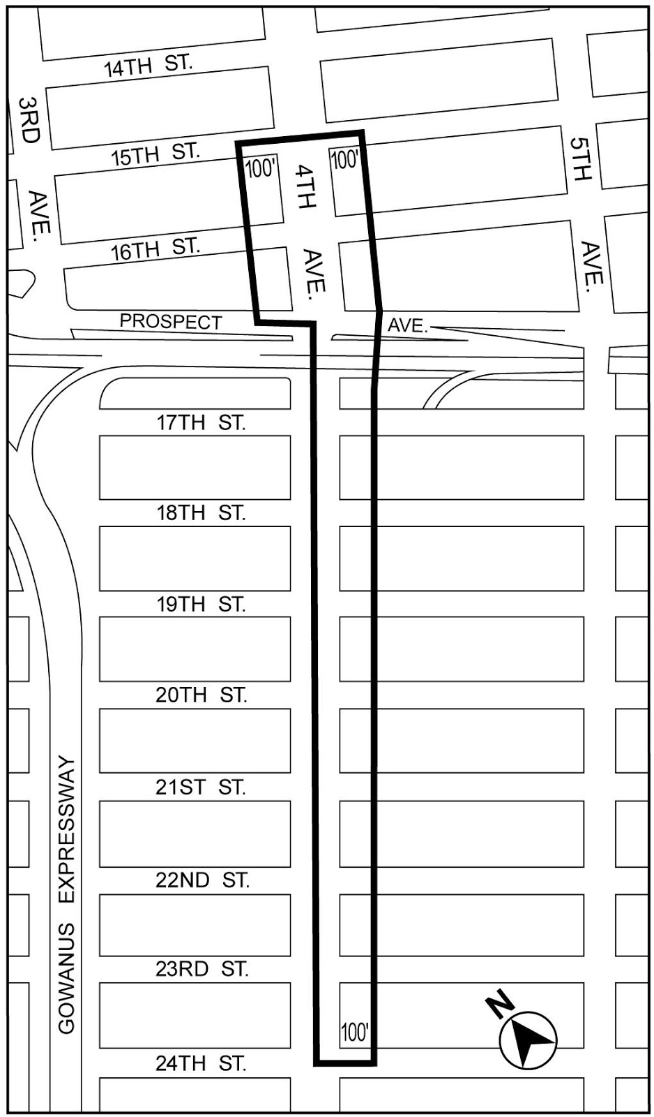

[PROPOSED MAP]
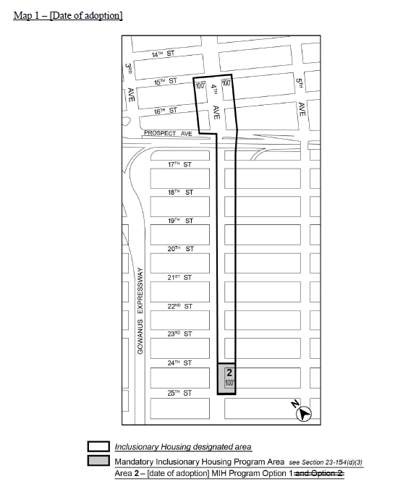

Portion of Community District 7, Brooklyn

* * *

Adopted.

Office of the City Clerk,}
The City of New York,} ss.:

I hereby certify that the foregoing is a true copy of a Resolution passed by The Council of The City of New York on April 22, 2021, on file in this office.

.....................................................
City Clerk, Clerk of The Council

