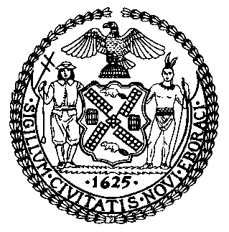 | The Council of the City of New York  Finance Division  Latonia McKinney, Director  Fiscal Impact Statement  Proposed Intro. No: 1729-A  Committee: General Welfare
Title: A Local Law to amend the administrative code of the city of New York, in relation to requiring the administration for children’s services to provide information to parents or caretakers about their right to request a fair hearing to appeal an indicated report | Sponsors: Council Members Levin, Rose, Chin, Ayala, Ampry-Samuel, Lander, Brannan, Reynoso, Adams, D. Diaz, Rosenthal, Koslowitz, Kallos, Louis, and Dinowitz
Summary of Legislation: Proposed Intro. No. 1729-A would require the Administration for Children’s Services (ACS) to provide a parent or caretaker with written information regarding the process to request a fair hearing to challenge an indicated report made against a parent or caretaker during an ACS child protective investigation. This information would be shared in the designated citywide languages.

Effective Date: This local law would take effect 150 days after it becomes law.

Fiscal Year In Which Full Fiscal Impact Anticipated: Fiscal 2023
Fiscal Impact Statement:
 | Effective FY22 | FY Succeeding Effective FY23 | Full Fiscal Impact FY23
Revenues | $0 | $0 | $0
Expenditures | $0 | $0 | $0
Net | $0 | $0 | $0
Impact on Revenues: It is estimated that there would be no impact on revenues resulting from the enactment of this legislation.

Impact on Expenditures: It is estimated that there would be no impact on expenditures because ACS could use existing resources to comply with the provisions of the local law and any hiring that the agency believes would be necessary to fulfill the requirements of the legislation could be done within existing vacancies that are already accounted for in the budget.
Source of Funds to Cover Estimated Costs: N/A
Source of Information: New York City Council Finance Division
Mayor’s Office of Legislative Affairs
Administration for Children’s Services
Estimate Prepared by: Daniel Kroop, Senior Financial Analyst
Estimate Reviewed by: Dohini Sompura, Unit Head
Stephanie Ruiz, Assistant Counsel
Legislative History: This legislation was first introduced to the Council as Intro. No. 1729 on September 25, 2019 and referred to the Committee on General Welfare (the Committee). A hearing was held by the Committee on October 31, 2019, and the bill was laid over. The legislation was subsequently amended and the amended version, Proposed Intro. No. 1729-A, will be considered by the Committee on October 21, 2021. Upon successful vote by the Committee, Proposed Intro. No. 1729-A will be submitted to the full Council for a vote on October 21, 2021.
Date Prepared: October 14, 2021

