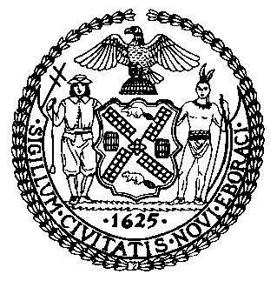 | The Council of the City of New York  Finance Division  Latonia Mckinney, Director  Fiscal Impact Statement  Proposed Intro. No: 480-A  Committee: Youth Services
Title: A Local Law to amend the administrative code of the city of New York, in relation to requiring the department of youth and community development to create a runaway and homeless youth immigration information plan | Sponsors: Council Members Dromm, Ayala, Rose, Kallos and Gibson
Summary of Legislation: Proposed Intro. 480-A would require the Department of Youth and Community Development (DYCD) to establish a plan to provide information about resources and services relating to immigration relief and benefits for runaway and homeless youth (RHY) in programs operated by DYCD. These resources and services would include information that would potentially allow RHY immigrants to obtain permanency status in the United States. The plan would be due by June 1, 2019 and would require annual reporting thereafter on plan implementation and goals.

Effective Date: This local law would take effect 90 days after enactment.

Fiscal Year in Which Full Fiscal Impact Anticipated: Fiscal 2020
Fiscal Impact Statement:
 | Effective FY19 | FY Succeeding Effective FY20 | Full Fiscal Impact FY20
Revenues | $0 | $0 | $0
Expenditures | $0 | $0 | $0
Net | $0 | $0 | $0

Impact on Revenues: It is anticipated that there would be no impact on revenues as a result of this legislation.

Impact on Expenditures: It is anticipated that there would be no impact on expenditures as a result of this legislation because existing resources would be used to implement the legislation.

Source of Funds To Cover Estimated Costs: N/A

Source of Information: Department of Youth and Community Development, Mayor’s Office of Immigrant Affairs, and New York City Council Finance Division

Estimate Prepared by: Michele Peregrin, Financial Analyst
Estimate Reviewed by: Regina Poreda Ryan, Deputy Director
Eisha Wright, Unit Head
Rebecca Chasan, Senior Counsel
Legislative History: This legislation was introduced to the Council on February 14, 2018 as Intro. No. 480 and referred to the Committee on Youth Services. A hearing was held jointly by the Committee on Youth Services and the Committee on Immigration on September 17, 2018 and the bill was laid over. The legislation was subsequently amended, and the amended version Proposed Intro. No. 480-A, will be voted on by the Committee on Youth Services at a hearing on November 27, 2018. Upon successful vote by the Committee, Proposed Intro. No. 480-A will be submitted to the full Council for a vote on November 28, 2018.
Date Prepared: November 26, 2018

