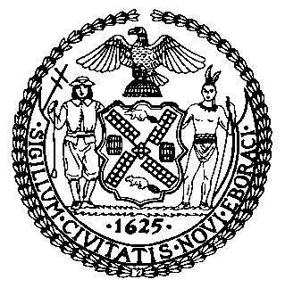 | The Council of the City of New York  Finance Division  Tanisha S. Edwards, Esq., Chief Financial Officer, and Deputy Chief of Staff to the Speaker  Fiscal Impact Statement  Proposed Intro. No: 460-A  Committee: Sanitation and Solid Waste Management
Title: A Local Law to amend the administrative code of the city of New York, in relation to receptacles in a building or dwelling that has a high concentration of rodent infestation. | Sponsor(S): By Council Members Abreu, Nurse, Bottcher, Louis, Hudson, Hanif, Brewer, Joseph, Gutiérrez, Avilés, Restler, Schulman, Marte, Ossé, Velázquez, Williams, Won, Krishnan, Richardson Jordan, Riley, Ayala, Cabán, Menin, Powers, Gennaro, Narcisse, De La Rosa, Holden, Sanchez, Farías, Hanks, and Dinowitz (in conjunction with the Brooklyn Borough President)
Summary of Legislation: This bill would require buildings that receive two or more notices of violation for either 27-2017.4 of the housing maintenance code or 151.02 of the health code, to place their refuse in rodent-proof containers for at least two years. The bill would provide that the Department of Sanitation (DSNY) may waive this container requirement where it would cause an undue hardship or public safety hazard.

Effective Date: This local law would take effect on April 1, 2023.

Fiscal Year In Which Full Fiscal Impact Anticipated: Fiscal Year 2024

Fiscal Impact Statement:

 | Effective FY23 | FY Succeeding Effective FY24 | Full Fiscal Impact FY24
Revenues | $0 | $0 | $0
Expenditures | $0 | $0 | $0
Net | $0 | $0 | $0

Impact on Revenues: It is estimated that there would be no impact on revenues resulting from the enactment of this legislation.

Impact on Expenditures: It is estimated that there would be no fiscal impact on expenditures resulting from the enactment of this legislation as DSNY would use existing resources to fulfill its requirements.

Source of Funds To Cover Estimated Costs: Not Applicable
Source of Information: New York City Department of Sanitation
Estimate Prepared By: Andrew Lane-Lawless, Financial Analyst, NYC Council Finance Division

Estimate Reviewed By: Masis Sarkissian, Unit Head, NYC Council Finance Division
Crilhien Francisco, Assistant Director, NYC Council Finance Division
Jonathan Rosenberg, Managing Deputy Director, NYC Council Finance Division
Legislative History: The legislation was introduced to the full Council on June 2, 2022, as Intro. 460 and referred to the Committee on Sanitation and Solid Waste Management. The legislation was considered by the Committee on Sanitation and Solid Waste Management and the Committee on Public Housing at a hearing held on June 21, 2022, and was subsequently amended, and the amended version of Proposed Into. No. 460-A will be considered by the Committee on Sanitation and Solid Waste Management on October 26, 2022. Upon Successful vote by the Committee on Sanitation and Solid Waste Management, Proposed Intro. No. 460-A will be submitted to the full Council for a vote on October 27, 2022.
Date Prepared: 10/20/2022

