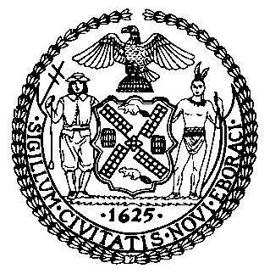 | The Council of the City of New York  Finance Division  Latonia McKinney, Director  Fiscal Impact Statement  Proposed Intro. No: 348-A  Committee: Housing and Buildings
Title: A Local Law to amend the administrative code of the city of New York, in relation to inspection fees for certain recurring violations of the housing maintenance code. | Sponsor(S): Council Members Torres, Reynoso, Chin, Johnson, Levin, Levine, Mendez, Rosenthal, Garodnick, Constantinides, Palma, Kallos, Rodriguez, Dromm, Richards, Cornegy, Gentile, Miller, Lander and Cohen
Summary of Legislation: This legislation would allow the Department of Housing Preservation and Development (HPD) to impose an inspection fee of $200 for the third, and for each subsequent, complaint-based inspection that it performs in a dwelling unit within a 12-month period provided that the prior 2 inspections resulted in the issuance of a hazardous or immediately hazardous violation that have not all been certified as corrected. The legislation would grant HPD the authority, by rule, to increase this fee for inspections performed between October 1st and May 31st.

The fee would not be imposed on certain buildings, including a multiple dwelling that is active in HPD’s alternative enforcement program or Article 7-A program, or if the inspection results exclusively in hazardous or immediately hazardous violations for inoperable smoke detectors, carbon monoxide detectors, double cylinder locks on entry doors of dwelling units, illegal window gates, or absence of window guards.

All fees that remain unpaid shall constitute a debt recoverable from the owner and a lien can be placed upon the property.

Effective Date: This local law would take effect 180 days after its enactment, except that the Commissioner of HPD may take measures to implement the legislation, including the promulgation of rules, prior to the effective date.
Fiscal Year In Which Full Fiscal Impact Anticipated: Fiscal 2015
Fiscal Impact Statement:

 | Effective FY15 | FY Succeeding  Effective FY16 | Full Fiscal  Impact FY15
Revenues | $0 | $0 | $0
Expenditures | $0 | $0 | $0
Net | $0 | $0 | $0

Impact on Revenues: It is estimated that there would be minimal to no impact on revenues as a result of this legislation because full compliance with the legislation is anticipated.

Impact on Expenditures: It is estimated that there will be no impact on expenditures as a result of this legislation.

Source of Funds To Cover Estimated Costs: New York City Department of Housing Preservation and Development

Source of Information: New York City Council, Finance Division

Estimate Prepared by: Sarah Gastelum, Legislative Financial Analyst

Estimate Reviewed by: Rebecca Chasan, Assistant Finance Counsel
Nathan Toth, Deputy Director, New York City Council, Finance Division

Legislative History: This legislation was introduced to the full council on May 14, 2014 as Intro. No. 348 and was referred to the Committee on Housing and Buildings. On October 1, 2014, the Committee on Housing and Buildings held a hearing to consider the legislation. The legislation was subsequently amended, and the amended version, Proposed Intro. No. 348-A will be considered by the Committee on Housing and Buildings on November 13, 2014. Following a successful vote by the Committee, Proposed Intro. No. 348-A will be submitted to the full Council for a vote on November 13, 2014.

Date Prepared: November 12, 2014

