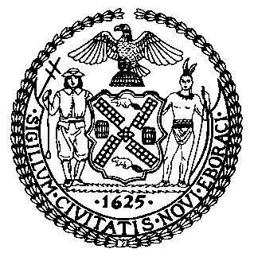 | The Council of the City of New York  Finance Division  Latonia Mckinney, Director  Fiscal Impact Statement  Proposed Intro. No: 1368-A  Committee: Sanitation and Solid Waste Management
Title: A Local Law to amend the administrative code of the city of New York, in relation to providing information to private sanitation employees | Sponsor: By Council Members Moya and Rosenthal
Summary of Legislation: Proposed Int. No. 1368-A would mandate that the Business Integrity Commission (BIC) post information about workers’ rights on their website and that private carters disseminate this information directly to their employees. The information to be provided would include the following: the maximum number of hours an employee can work in a 24 hour period; minimum wage; any required worker safety trainings; safety equipment that must be provided by employers; description on how to contact BIC to log a complaint; and a list of additional government agencies that accept complaints about workers’ rights violations.
Effective Date: This local law would take effect 270 days after it becomes law.
Fiscal Year in Which Full Fiscal Impact Anticipated: Fiscal 2021
Fiscal Impact Statement:
 | Effective FY20 | FY Succeeding Effective FY21 | Full Fiscal Impact FY21
Revenues | $0 | $0 | $0
Expenditures | $0 | $0 | $0
Net | $0 | $0 | $0
Impact on Revenues: It is anticipated that there would be no impact on revenues resulting from the enactment of this legislation.
Impact on Expenditures: It is anticipated that there would be no impact on expenses resulting from the enactment of this legislation because BIC would use existing resources to implement the requirements of this legislation.
Source of Funds to Cover Estimated Costs: N/A
Source of Information: New York City Council Finance Division
Mayor’s Office of Legislative Affairs
Estimate Prepared by: Jonathan Seltzer, Senior Financial Analyst, Finance Division
Estimate Reviewed by: Crilhien Francisco, Unit Head, Finance Division
Nathan Toth, Deputy Director, Finance Division
Stephanie Ruiz, Assistant Counsel, Finance Division
Legislative History: This legislation was introduced by the City Council as Intro.1368 on January 24, 2019 and was referred to the Committee on Sanitation and Solid Waste Management (Committee). A hearing was held by the Committee on January 29, 2019, and the bill was laid over. The legislation was subsequently amended and the amended version, Proposed Intro. 1368-A, will be voted on by the Committee at a hearing on February 27, 2019. Upon successful vote by the Committee, Proposed Intro. 1369-A will be submitted to the Council for a vote on February 28, 2019.
Date Prepared: February 26, 2019

