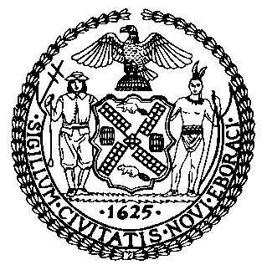 | The Council of the City of New York  Finance Division  Latonia Mckinney, Director  Fiscal Impact Statement  Proposed Intro. No: 376-B  Committee: Youth Services
Title: A Local Law to amend the New York City Charter, in relation to educational outreach and materials on bullying prevention, awareness and resources | Sponsors: Council Members Torres, Salamanca, Brannan, Cabrera, Kallos, Rosenthal, Lander, Constantinides and Rose
Summary of Legislation: Proposed Intro. 376-B would require the Department of Youth and Community Development (DYCD) to conduct outreach to youth about the availability of bullying awareness and prevention resources, including counseling, mental health care, and Department of Education (DOE) resources. Outreach would include disseminating resource materials through existing DYCD programs and posting information on DYCD’s website and on any other agency websites as determined by the mayor. The proposed bill also would require the DOE to distribute to students information regarding any existing online portal operated by DOE through which students or their parents may report bullying, harassment, intimidation or discrimination. DYCD would also provide information regarding DOE’s portal to youth participating in its programs.

Effective Date: This local law would take effect 180 days after enactment

Fiscal Year in Which Full Fiscal Impact Anticipated: Fiscal 2020
Fiscal Impact Statement:
 | Effective FY19 | FY Succeeding Effective FY20 | Full Fiscal Impact FY20
Revenues | $0 | $0 | $0
Expenditures | $0 | $0 | $0
Net | $0 | $0 | $0

Impact on Revenues: It is anticipated that there would be no impact on revenues as a result of this legislation.

Impact on Expenditures: It is anticipated that there would be no impact on expenditures as a result of this legislation because existing resources would be used to implement the legislation.

Source of Funds To Cover Estimated Costs: N/A

Source of Information: Department of Youth and Community Development and the Department of Education

Estimate Prepared by: Michele Peregrin, Financial Analyst
Estimate Reviewed by: Regina Poreda Ryan, Deputy Director
Eisha Wright, Unit Head
Rebecca Chasan, Senior Counsel
Legislative History: This legislation was introduced to the Council on January 31, 2018 as Intro. No. 376 and referred to the Committee on Youth Services. The legislation was subsequently amended and a hearing was held by the Committee on Youth Services on the amended legislation, Proposed Intro. 376-A, on April 26, 2018 and the bill was laid over. The legislation was subsequently amended a second time and the most recently amended version, Proposed Intro. No.376-B, will be voted on by the Committee on Youth Services at a hearing on November 13, 2018. Upon successful vote by the Committee, Proposed Intro. No. 376-B will be submitted to the full Council for a vote on November 14, 2018.
Date Prepared: November 9, 2018

