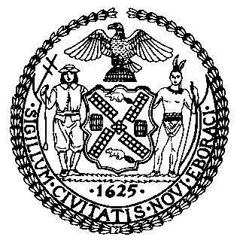 | The Council of the City of New York  Finance Division  Latonia Mckinney, Director  Fiscal Impact Statement  Proposed Intro. No: 411-A  Committee: Aging
Title: A Local Law to amend the administrative code of the city of New York, in relation to inspections for social adult day cares and senior centers | Sponsors: Council Members Chin, Levine, Rosenthal, Adams, Vallone, Rose, and Rivera
Summary of Legislation: Proposed Intro. No. 411-A would require the Department of Health and Mental Hygiene (DOHMH) to ensure that all senior centers and social adult day cares (SADCs) that are food service establishments under Article 81 of the New York City Health Code are inspected on an annual basis. The bill would further require DOHMH to submit an annual report to the Mayor and the Speaker regarding the Department’s activities with respect to these inspections, including a list of all senior centers and SADCs inspected (disaggregated by Council district), as well as additional information. The bill would also require the Department for the Aging to provide DOHMH with a list of all senior centers and SADCs in the city on an annual basis and update DOHMH monthly with any changes to that list.

Effective Date: This local law would take effect 180 days after becoming law.
Fiscal Year In Which Full Fiscal Impact Anticipated: Fiscal 2020
Fiscal Impact Statement:
 | Effective FY19 | FY Succeeding Effective FY20 | Full Fiscal Impact FY20
Revenues | $0 | $0 | $0
Expenditures | $0 | $0 | $0
Net | $0 | $0 | $0

Impact on Revenues: There would be no impact on revenues resulting from this legislation.

Impact on Expenditures: It is anticipated that there would be no impact on expenditures resulting from the enactment of this legislation because the Department of Health and Mental Hygiene could use existing staff and resources to conduct the inspections and complete the annual reporting. Furthermore, the Department for the Aging could use existing staff to share information with DOHMH.
Source of Funds To Cover Estimated Costs: Not applicable.
Source of Information: New York City Council Finance Division
Department for the Aging
Department of Health and Mental Hygiene

Estimate Prepared by: Daniel Kroop, Financial Analyst

Estimate Reviewed by: Regina Poreda Ryan, Deputy Director
Dohini Sompura, Unit Head
Rebecca Chasan, Counsel

Legislative History: This legislation was introduced to the full Council on February 14, 2018 as Intro. No. 411 and was referred to the Committee on Aging (Committee). A hearing was held by the Committee on April 23, 2018, and the bill was laid over. The legislation was subsequently amended and the amended version, Proposed Intro. No. 411-A, will be considered by the Committee on July 17, 2018. Following a successful Committee vote, the bill will be submitted to the full Council for a vote on July 18, 2018.
Date Prepared: July 13, 2018

