THE COUNCIL OF THE CITY OF NEW YORK
RESOLUTION NO. 1888

Resolution approving with modifications the decision of the City Planning Commission on Application No. N 210463 (A) ZRK, for an amendment of the text of the Zoning Resolution (Preconsidered L.U. No. 915).

By Council Members Salamanca and Moya

WHEREAS, Building 77 QALICB, Inc. and NYC Small Business Services, filed an application pursuant to Section 201 of the New York City Charter, for an amendment of the Zoning Resolution of the City of New York, establishing the Special Brooklyn Navy Yard District (Article XIV, Chapter 4) and modifying related sections in the Borough of Brooklyn, Community District 2, which in conjunction with the related action would facilitate the expansion of the Brooklyn Navy Yard through the construction of an additional 4.6 million square feet for a total of 11 million square feet of industrial, commercial, and community facility uses along the waterfront in Brooklyn, Community District 2 (Application No. N 210463 (A) ZRK) (the “Application”);

WHEREAS, the City Planning Commission filed with the Council on October 22, 2021, its decision dated October 20, 2021 (the “Decision”), on the Application;

WHEREAS, the Application is related to application C 210462 ZMK (Pre. L.U. No. 914), a zoning map amendment to change an R6B, M1-2, and M3-1 district to an M2-1 district and to establish the Special Brooklyn Navy Yard District (BNY);

WHEREAS, the Decision is subject to review and action by the Council pursuant to Section 197-d of the City Charter;

WHEREAS, upon due notice, the Council held a public hearing on the Decision and Application on October 25, 2021;

WHEREAS, the Council has considered the land use implications and other policy issues relating to the Decision and Application; and

WHEREAS, the Council has considered the relevant environmental issues, including the Revised Negative Declaration issued August 18, 2021, which supersedes the Negative Declaration issued June 7, 2021, and Revised Environmental Assessment Statement issued August 18, 2021 (CEQR No. 19DME011K);

RESOLVED:

The Council finds that the action described herein will have no significant impact on the environment as set forth in the Revised Environmental Assessment Statement and Revised Negative Declaration.

Pursuant to Sections 197-d and 200 of the City Charter and on the basis of the Decision and Application, and based on the environmental determination and consideration described in the report, N 210463 (A) ZRK, incorporated by reference herein, and the record before the Council, the Council approves the Decision of the City Planning Commission with the following modifications:

Matter underlined is new, to be added;
Matter struck out is to be deleted;
Matter within # # is defined in Section 12-10;
* * * indicates where unchanged text appears in the Zoning Resolution
Matter double struck out is old, deleted by the City Council;
Matter double-underlined is new, added by the City Council

* * *

ARTICLE I
GENERAL PROVISIONS

Chapter 1
Title, Establishment of Controls and Interpretation of Regulations

* * *

11-12
Establishment of Districts

* * *

11-122
Districts established

In order to carry out the purposes and provisions of this Resolution, the following districts are hereby established:

* * *

Special Purpose Districts

* * *

Establishment of the Special Bay Street Corridor District

In order to carry out the special purposes of this Resolution as set forth in Article XIII, Chapter 5, the #Special Bay Street Corridor District# is hereby established.

Establishment of the Special Brooklyn Navy Yard District

In order to carry out the special purposes of this Resolution as set forth in Article XIV, Chapter 4, the #Special Brooklyn Navy Yard District# is hereby established.

Establishment of the Special City Island District

In order to carry out the special purposes of this Resolution as set forth in Article XI, Chapter 2, the #Special City Island District# is hereby established.

* * *
Chapter 2
Construction of Language and Definitions

* * *

12-10
Definitions

* * *

Special Bay Street Corridor District (6/26/19)

The “Special Bay Street Corridor District” is a Special Purpose District designated by the letters “BSC” in which special regulations set forth in Article XIII, Chapter 5, apply.

Special Brooklyn Navy Yard District ([date of adoption])

The “Special Brooklyn Navy Yard District” is a Special Purpose District designated by the letters “BNY” in which special regulations set forth in Article XIV, Chapter 4, apply.

Special City Island District (2/2/11)

The “Special City Island District” is a Special Purpose District designated by the letters “CD” in which special regulations set forth in Article XI, Chapter 2, apply.

* * *

Chapter 4
Sidewalk Café Regulations

* * *

14-44
Special Zoning Districts Where Certain Sidewalk Cafes Are Permitted

#Enclosed# or #unenclosed sidewalk cafes# shall be permitted, as indicated, in the following special zoning districts, where allowed by the underlying zoning. #Small sidewalk cafes#, however, may be located on #streets# or portions of #streets# within special zoning districts pursuant to the provisions of Section 14-43 (Locations Where Only Small Sidewalk Cafes Are Permitted).

* * *

Brooklyn | #Enclosed Sidewalk Café# | #Unenclosed Sidewalk Café#
* * * | * * * | * * *
#Bay Ridge District# | Yes | Yes
#Brooklyn Navy Yard District# | Yes | Yes
#Coney Island District# | Yes | No
* * * | * * * | * * *

ARTICLE VI
SPECIAL REGULATIONS APPLICABLE TO CERTAIN AREAS

Chapter 2
Special Regulations Applying in the Waterfront Area

* * *
62-13
Applicability of District Regulations

* * *

The provisions of this Chapter shall not apply to the following Special Purpose Districts unless expressly stated otherwise in the special district provisions:

#Special Battery Park City District#

#Special Brooklyn Navy Yard District#

#Special Governors Island District#

* * *

ARTICLE XIV
SPECIAL PURPOSE DISTRICTS

* * *

Chapter 4
Special Brooklyn Navy Yard District (BNY)

144-00
GENERAL PURPOSES

The “Special Brooklyn Navy Yard District” established in this Resolution is designed to promote and protect public health, safety and general welfare. These goals include, among others, the following specific purposes:

(a) to encourage investment in the Brooklyn Navy Yard and facilitate the expansion of the Brooklyn Navy Yard as a modern manufacturing complex;

(b) to promote job growth;

(c) to allow for a mix of office, community facility, retail, and other commercial uses to complement the industrial and manufacturing facilities at the Brooklyn Navy Yard;

(d) to use traffic management planning to meet loading and parking needs including through alternate means of travel

(e) to better integrate the Brooklyn Navy Yard with the urban fabric of surrounding residential and mixed-use communities and to introduce publicly accessible open space areas within the perimeter of the Yard; and

(f) to promote the most desirable use of land in accordance with a well-considered plan and thus conserve the value of land and buildings, and thereby protect the City’s tax revenues.

144-01
Definitions

Definitions specifically applicable to this Chapter are set forth in this Section and may modify definitions set forth in Section 12-10 (DEFINITIONS). Where a term in italics is defined in both Section 12-10 and in this Chapter, the definitions in this Chapter shall govern. The terms #pier#, #platform#, and #floating structure# shall have the meaning set forth in Section 62-11 (Definitions).

Barge Basin

#Barge Basin# shall mean that inlet from the East River identified on Map 2 in the Appendix to this Chapter as the Barge Basin.

Shoreline

The definition of #shoreline# set forth in Section 12-10 is modified for the purposes of this Chapter to mean the shoreline on a survey available on the Department of City Planning website.

144-02
General Provisions

The provisions of this Chapter shall apply within the #Special Brooklyn Navy Yard District#. The regulations of all other Chapters of this Resolution are applicable, except as superseded, supplemented, or modified by the provisions of this Chapter. In the event of a conflict between the provisions of this Chapter and other regulations of this Resolution, the provisions of this Chapter shall control. However, in #flood zones#, in the event of a conflict between the provisions of this Chapter and the provisions of Article VI, Chapter 4 (Special Regulations Applying in Flood Zones), the provisions of Article VI, Chapter 4 shall control.

144-03
District Plan and Maps

The regulations of this Chapter are designed to implement the #Special Brooklyn Navy Yard District# Plan. The district plan includes the following maps in the Appendix to this Chapter:

Map 1 Special Brooklyn Navy Yard District and Subdistricts

Map 2 Barge Basin Subareas

Map 3 Navy Street Central Subarea

Map 4 Flushing Avenue Subareas and View Corridors

Map 5 Street Line Locations in the Barge Basin Subdistrict

Map 6 Primary Street Frontages

The maps are hereby incorporated and made part of this Resolution for the purpose of specifying locations where the special regulations and requirements set forth in the text of this Chapter apply.

144-04
Subdistricts and Subareas

In order to carry out the purposes and provisions of this Chapter, four subdistricts are established within the #Special Brooklyn Navy Yard District# comprised of three perimeter subdistricts and one core subdistrict for the remainder of the Yard. In addition, one subarea is established in the Navy Street Subdistrict, two subareas are established within the Flushing Subdistrict and two subareas are established within the Barge Basin Subdistrict.

Perimeter Subdistricts

Navy Street Subdistrict
Navy Street Central Subarea

Flushing Subdistrict

Flushing West Subarea

Flushing East Subarea

Barge Basin Subdistrict

Barge Basin East Subarea

Barge Basin West Subarea

Core Subdistrict

The boundaries of the Subdistricts are shown in Map 1 and the boundaries of the Subareas are shown on Maps 2 through 4 in the Appendix to this Chapter.

144-05
Applicability of Special Regulations Applying in the Waterfront Area

The provisions of Article VI, Chapter 2 (Special Regulations Applying in the Waterfront Area) shall not apply in the #Special Brooklyn Navy Yard District# except as expressly provided in this Chapter.

144-06
Single Zoning Lot

For all purposes of this Chapter, the #Special Brooklyn Navy Yard District# shall be deemed to be a single #zoning lot# except where expressly provided otherwise in this Chapter. #Floor area# attributable to the #zoning lot# may be located anywhere on the #zoning lot# without regard to Subdistrict boundary lines, and all #floor area# located within a Subdistrict shall be subject to the #use# and #bulk# requirements of such Subdistrict.

144-10
SPECIAL USE REGULATIONS

Within the #Special Brooklyn Navy Yard District, the #use# provisions of Article IV, Chapter 2 are modified by the provisions of this Section, inclusive.

144-11
Additional Uses Permitted in All Districts

In all districts, the underlying #use# regulations are modified as follows:

(a) Alcoholic beverages and breweries

The manufacture of alcoholic beverages and breweries, as specified in Section 42-15 (Use Group 18), shall be permitted, subject to the applicable performance standards, except that the provisions of Section 42-27 (Performance Standards Regulating Fire and Explosive Hazards) shall not apply.

(b) Water-dependent #uses#

The provisions of Section 62-21 (Classification of Uses in the Waterfront Area), Section 62-22 (Commercial Docking Facilities), Section 62-24 (Uses on Piers and Platforms), and Section 62-25 (Uses on Floating Structures) shall apply, provided that all #uses# existing on #piers# and #platforms# as of [date of adoption] shall be deemed conforming #uses#.

[Removing provisions relating to physical culture establishments because they have been superseded by the CPC-approved Health and Fitness Citywide Text Amendment (N 210382 ZRY).]

144-12
Additional Uses Permitted in M2-1 Districts

The provisions of Section 42-10 (USES PERMITTED AS-OF-RIGHT) shall be modified to permit the following uses in M2-1 Districts, subject to the requirements of Section 144-212 (Floor area limitations on additional uses):

(a) all Use Group 3A #uses#, as set forth in Section 22-13, not otherwise permitted by the underlying regulations other than #uses# containing sleeping accommodations; and

(b) all Use Groups 6C, 9A, 10A and 12B #uses#, as set forth in Sections 32-15, 32-18, 32-19 and 32-21, respectively, not otherwise permitted by the underlying regulations.

144-13
Additional Uses in M3-1 Districts

Within M3-1 Districts, the City Planning Commission may allow, by authorization, #schools#, colleges or universities, without sleeping accommodations, as listed in Use Group 3A, provided that the Commission finds that:

(a) such #school#, college or university has an academic program compatible with a tenant or industrial operation in the #Brooklyn Navy Yard Special District#; and

(b) the location of the #school#, college or university will not interfere with any #manufacturing use# or alter the essential industrial character of the #Special Brooklyn Navy Yard District#.

The Commission may impose appropriate conditions and safeguards to minimize adverse impacts effects on the character of the surrounding area.

144-14
Special Sign Regulations

In the #Special Brooklyn Navy Yard District#, the underlying #sign# regulations of Section 42-50 (SIGN REGULATIONS) shall apply, except as modified by the provisions of Section 144-141 (Illuminated non-flashing signage) through Section 144-143 (Special provisions near certain parks).

144-141
Illuminated non-flashing signage

The provisions of Section 42-533 (Illuminated or flashing signs) shall be modified to allow one #accessory# non-#flashing illuminated sign# to have a #surface area# of 750 square feet in each of the following Subareas: the Navy Street Central Subarea, the Flushing East Subarea, between Clinton Avenue and Washington Avenue, the Barge Basin East Subarea, and the Barge Basin West Subarea. All other #illuminated signs# shall comply with the requirements of Section 42-533 (Illuminated or flashing signs).

144-142
Special provisions along district boundaries

The provisions of Section 42-56 (Special Provisions Applying Along District Boundaries) shall be modified as follows:

(a) within the Flushing East Subarea, the provisions of Section 42-561 (Restrictions along the district boundary located in a street) shall not apply to any #sign# provided in accordance with Section 144-141 (Illuminated non-flashing signage); and

(b) within the Navy Street Central Subarea, the Flushing East Subarea, and the Barge Basin Subdistrict, the orientation provisions of Section 42-562 (Restriction on angle and height above curb level) shall not apply to #signs# provided in accordance with Section 144-141 (Illuminated non-flashing signage).

144-143
Special provisions near certain parks

The provisions of Section 42-55 (Additional Regulations for Signs Near Certain Parks and Designated Arterial Highways) shall not apply to any #signs# provided in accordance with Section 144-141 (Illuminated non-flashing signage) within the Barge Basin East Subarea.

144-20
SPECIAL BULK REGULATIONS

Within the #Special Brooklyn Navy Yard District, the #bulk# provisions of Article IV, Chapter 3 are modified by the provisions of this Section, inclusive.

144-21
Floor Area Regulations

The underlying #floor area# regulations of Section 43-10 (FLOOR AREA REGULATIONS), inclusive, are modified by the provisions of Sections 144-211 (Floor area ratio) through 144-213 (Floor area limitations on additional uses).

144-211
Floor area ratio
In all districts, the maximum #floor area ratio# for all #uses# shall be 2.0.

144-212
Floor area ratio calculations

For the purposes of calculating #floor area# on #waterfront zoning lots#, the provisions of Section 62-31 (Bulk Computations on Waterfront Zoning Lots) shall apply.

144-213
Floor area limitations on additional uses

The additional #uses# allowed pursuant to Section 144-11 (Additional Uses Allowed in M2 Districts) shall be limited to 300,000 square feet of #floor area# within each Subdistrict where such additional #uses# are allowed, and the total #floor area# allocated to such additional #commercial uses# shall not exceed 100,000 square feet in each Subdistrict where the additional #uses# are allowed.

144-22
Yards and Shoreline Setback

The underlying #yards# regulations of Section 43-20 (Yard Regulations), inclusive, and Section 43-31 (Other Special Provisions for Rear Yards) shall not apply. In lieu thereof, the provisions of this Section shall apply.

In all districts, no #building# shall be located closer to the #shoreline# than 30 feet, except for #buildings# used for water dependent #uses#, as set forth in 62-21 (Classification of Uses in the Waterfront Area), or #buildings# containing not more than 5,000 square feet of #floor area#.

The #shoreline# setback requirement shall be reduced in dimension, or eliminated, where the Chair of the City Planning Commission certifies to the Commissioner of the Department of Buildings or the Commissioner of the Department of Small Business Services, as applicable, that either:

(a) a #building# proposed to be located within such 30-foot setback area incorporates flood protection measures for the immediate area of the #building# that protect the #building# to a level that is fifty-eight inches above the mean high water line existing on [date of adoption]; or

(b) a district-wide resiliency plan for the #Special Brooklyn Navy Yard# has been adopted and the measures to be incorporated in connection with the #development# or already in place are in furtherance of the district-wide plan.

Measures shall be deemed protective if they alone or together with other measures in place at the time of construction protect the #building# from flooding to the elevation set forth in paragraph (a) of this Section or if they would support protection of the entire #Special Brooklyn Navy Yard District# to such elevation without further improvement of the portion of area directly seaward of the proposed #building#.

The Chairperson shall certify the application within 45 days of receipt of a complete application. Failure to certify within the 45-day period will release the Department of Buildings or the Department of Small Business Services from any obligation to withhold the excavation or building permit and authorize such agency to determine compliance with the provisions of this Section.

144-23
Height and Setback Regulations

The underlying height and setback regulations of Section 43-40 (Height and Setback Regulations) are modified by the provisions of this Section, inclusive.

144-231
Flushing East Subarea

In the Flushing East Subarea, the following height and setback modifications shall apply.

(a) Wide street designation

For purposes of applying the height and setback controls, Flushing Avenue shall be deemed a #wide street#.

(b) Street wall location

The #street wall# of any #development# or horizontal #enlargement# within the Flushing East Subarea shall be located at least 50 feet from the Flushing Avenue #street line#. The area between such #development# or horizontal #enlargement# and the adjoining #street# shall be improved as publicly accessible space in accordance with Section 144-30 (Special Public Access Area Regulations).

(c) View corridors

View corridors with a minimum width of 50 feet shall be provided:
(1) within the Vanderbilt Avenue view corridor; and

(2) within one of the Clinton Avenue or Waverly Avenue view corridors.

The locations of such required view corridors are designated on Map 4 in the Appendix to this Chapter.

No #development# or #enlargement# may be located in the required view corridors, provided that gates and fencing, entry signage, sentry booths, and other entry and security measures may be located within such areas. Any gates or fencing shall be designed to allow for views into the #Special Brooklyn Navy Yard District#.

144-232
Barge Basin Subdistrict

In the Barge Basin Subdistrict, as shown on Map 5 in the Appendix to this Chapter, the height and setback regulations set forth in Section 43-40 (HEIGHT AND SETBACK REGULATIONS), inclusive, shall apply, as modified by the provisions of this Section.

For purposes of applying the height and setback provisions of this Section, the #street walls# of #abutting# #building# shall be considered a single #building# #street wall#.

- Sidewalk widening

A sidewalk widening shall be provided along Kent Avenue to the extent necessary so that a minimum width of 15 feet is achieved, including portions within and beyond the #zoning lot#. Such sidewalk widening shall be:

(i) improved as a sidewalk to Department of Transportation standards;

(ii) at the same level as the adjoining public sidewalk; and

(iii) accessible to the public at all times.

The interior boundary of the sidewalk widening shall be considered the #street line# for the purposes of this Section.

- Establishing #street lines# along #Barge Basin#

For the purposes of applying the height and setback regulations of this Section to portions of #buildings# fronting #Barge Basin# and prolongations thereof, the following shall be considered #street lines# along a #wide street#.

- Along the long dimension of the #Barge Basin#

Along the long dimension of the #Barge Basin# a line offset 40 feet northeast from the northeastern boundary of the #Barge Basin# in the Barge Basin East Subarea, and a line offset 50 feet southwest from the southwestern boundary of the #Barge Basin# in the Barge Basin West Subarea, shall be considered #street lines#.

The area between the #Barge Basin# and such #street lines# shall be improved as publicly accessible areas in accordance with the applicable provisions of Section 144-30 (SPECIAL PUBLIC ACCESS AREA REGULATIONS), inclusive.

- Along the short dimension of the #Barge Basin#

Along the short dimension of the #Barge Basin#, the southeasterly boundaries of the Barge Basin Subdistrict, including the boundary extending from the centerline prolongation of Taylor Street, and the boundary constructed from an offset of the southeastern terminus of the #Barge Basin#, shall be considered #street lines#.

Within the area between the #Barge Basin# and such #street lines# shall be an area adjacent to the short dimension of the #Barge Basin# that connects the Barge Basin east pedestrian esplanade and the Barge Basin west pedestrian esplanade that shall be:

(i) improved as a sidewalk to Department of Transportation standards;

(ii) shall be at the same level as the adjoining public sidewalk; and

(iii) shall be accessible to the public at all times the public access areas are required to be open to the public, pursuant to Section 144-33 (Hours of Operation).

The locations of these #street lines#, are shown on Map 5 in the Appendix to this Chapter.

- #Street wall# location, and articulation

At least 70 percent of the #aggregate width of street walls# facing #Barge Basin# shall be located within eight feet of the #street line# and shall extend to at least a minimum base height of 30 feet, or two #stories#, whichever is lower. The remaining #aggregate width of street walls# may be recessed beyond eight feet of the #street line#, provided that any recesses deeper than 10 feet are located within an #outer court#.

Any open area between a #street wall# and the #street lines# along #Barge Basin# that is within eight feet of such #street line# shall be improved as publicly accessible areas in accordance with the applicable provisions of Section 144-30, inclusive. Open areas between the #street line# and #street walls# that are beyond eight feet of such #street line# may be publicly accessibly areas, as needed, to achieve the minimum percentage of public access area required by each Subarea pursuant to Section 144-31 (Required Public Access Area).

For those portions of #buildings# facing #Barge Basin# with a #street wall# width exceeding 200 feet, a minimum of 20 percent of the surface area of such #street wall# up to the height of the second #story#, or 30 feet, whichever is lower, and a maximum of 50 percent of such surface area, shall either recess or project from the remaining surface area of the #street wall# by a minimum of three feet. #Building# projections shall be a permitted obstruction within any open area between the #street wall# and #street line#, including publicly accessible areas, provided that the minimum percentage of public access area required by each Subarea pursuant to Section 144-31 remains open to the sky. Additional permitted obstructions are allowed in accordance with paragraph (a) of Section 144-32 (Design Requirements).

- Base heights, required setbacks, and dormers

The front setback provisions applicable to an M1-5 District set forth in Section 43-43 (Maximum Height of Front Wall and Required Front Setbacks) shall apply, except as modified by the provisions of this Section. The alternate front setback regulations of Section 43-44 (Alternate Front Setbacks) shall not apply.

- Initial setback distances

The #initial setback distance# regulations shall be modified as follows:

- along the #Barge Basin#, such #initial setback distance# shall have a depth of at least 30 feet from the #street line#;

- along all other #wide streets#, such #initial setback distance# shall have a depth of at least 15 feet from the #street line#; and

- such #initial setback distance# shall be provided at a height not lower than the minimum base height, where applicable, nor higher than a maximum base height of 85 feet, or six #stories#, whichever is lower.

- Dormers

Along the #Barge Basin# frontages, dormers shall be a permitted obstruction within an #initial setback distance#, provided that:

- the depth of such dormers does not exceed 10 feet for #buildings# fronting along the northeastern boundary of the #Barge Basin# or 20 feet for #buildings# fronting along the southwestern boundary;

- the #street wall# width of such dormer does not exceed 30 percent of the #street wall# width of the #building# above the maximum base height; and

- the #street wall# width of such dormer along a single tower does not exceed 100 feet.

(e) Towers

The allowances for towers to penetrate a #sky exposure plane# applicable to an M1-5 District, as set forth in Section 43-45 (Tower Regulations), shall apply, except as modified by the provisions of this Section.

The tower allowances shall be modified as follows:

- for the purposes of determining the #lot area# a tower may occupy, the Barge Basin East Subarea and the Barge Basin West Subarea shall each be considered an individual #zoning lot#;

- the underlying setback provisions, including the aggregate area permitted within 40 feet of a #wide street#, shall not apply. In lieu thereof, the setbacks and dormer allowances set forth in paragraph (d) of this Section shall apply; and

- the #street wall# width of a tower fronting #Barge Basin# shall not exceed 200 feet within 200 feet of the #street line# fronting #Barge Basin#.

144-24
Special Permit for Modification of Bulk Regulations

Within the #Special Brooklyn Navy Yard District# the City Planning Commission may, by special permit, allow modifications to the #bulk# regulations of this Chapter and the underlying #bulk# regulations, except #floor area# regulations, provided the Commission finds that:

(a) such modifications further the needs and objectives of the #Special Brooklyn Navy Yard District#;
(b) such #bulk# modifications will result in a better site plan and will benefit the occupants and users of the #Special Brooklyn Navy Yard District# and the residents of the surrounding neighborhood;
(c) such #bulk# modifications will permit adequate access of light and air to surrounding public access areas, #streets# and properties; and
(d) such distribution of #bulk# will not unduly increase the #bulk# of #buildings# in the #Special Brooklyn Navy Yard District# to the detriment of the occupants or users of #buildings# in the #Special Brooklyn Navy Yard District# or on nearby #blocks#.
The Commission may impose appropriate conditions and safeguards to assure that such modifications will not adversely affect the surrounding area.

144-30
SPECIAL PUBLIC ACCESS AREA REGULATIONS

Within the #Special Brooklyn Navy Yard District#, public access areas shall be provided in connection with #developments# or #enlargements# located within the Subareas identified in this Section, inclusive, as applicable. For purposes of determining the amount of public access area required in the Navy Street Central Subarea, the Barge Basin East Subarea, and the Barge Basin West Subarea, each such Subarea shall be deemed a single #zoning lot#.

144-31
Required Public Access Areas

Mandatory public access areas in connection with any #development# or #enlargement# shall be provided in accordance with the provisions of paragraphs (a) through (c) of this Section. The phasing of public access areas shall be permitted in accordance with paragraph (d). #Developments# or #enlargements# that are exempt from public access area requirements are set forth in paragraph (e).

(a) Navy Street Central Subarea

A public access area in an amount equal to at least 15 percent of the #lot area# of the Navy Street Central Subarea shall be provided within the boundaries of such Subarea. The required public access area shall have a minimum dimension, in all directions, of 50 feet for at least 80 percent of the public access area and shall have no dimension of less than 30 feet for the remainder of the required public access area.

(b) Flushing East Subarea

A public access area with a minimum depth of 50 feet, as measured perpendicular to the #street line# of Flushing Avenue, shall be provided within the boundaries of such Subarea along the entire length of the #street wall line# adjacent to the #development# or #enlargement#, and shall extend to the nearest view corridors depicted on Map 4 (Flushing Avenue Subareas and View Corridors) of this Chapter, and for #developments# or #enlargements# located east of the Waverly Avenue view corridor, to the boundary of the prolongation of Washington Avenue.

(c) Barge Basin East and West Subareas

A public access area in an amount of at least 30 percent of the #lot area# of Barge Basin East Subarea, and a public access area in an amount of at least 20 percent of the #lot area# of Barge Basin West Subarea shall be provided within such respective Subareas.

Such public access areas shall consist of:

(1) in the Barge Basin East Subarea, a pedestrian esplanade with a seaward edge contiguous with the eastern edge of the #Barge Basin# and a minimum width of 40 feet, as measured perpendicular to such edge, and in the Barge Basin West Subarea, a pedestrian esplanade with a seaward edge contiguous with the western edge of the #Barge Basin# and a minimum width of 50 feet, as measured perpendicular to such edge;

(2) in the Barge Basin East Subarea, a pedestrian connection with a minimum width of 30 feet located along the shared boundary between the Barge Basin East Subarea and the contiguous property to the northeast connecting the Kent Avenue and eastern portion of the pedestrian esplanade required by this Section;

(3) in the Barge Basin East Subarea, a pedestrian connection with a minimum width of 60 feet, located within 150 feet of the southern boundary of the Barge Basin East Subarea and connecting Kent Avenue and the pedestrian esplanade required by this Section;

(4) in the Barge Basin West Subarea, an esplanade entry area at the southern end of the Barge Basin West Subarea having a minimum width of 60 feet and a minimum length of 30 feet measured parallel to western edge of the #Barge Basin#; and

(5) any supplemental publicly accessible space contiguous to one or more of the elements set forth above as may be required to achieve the required percentage of publicly accessible area.

(d) Public Access Area Phasing

Where the Navy Street, Barge Basin East and Barge Basin West Subareas are #developed# with more than one #building# or #enlarged# in phases, or there is an increase in #building# #lot coverage#, the mandatory public access area may be constructed in phases, provided that, at the completion of each phase by certification of the Chairperson of City Planning, the following criteria are met:

(1) The square footage of public access area being provided in any phase shall be in proportion to the total public access requirement based on the area of the Subarea being #developed# or #enlarged# as compared to the #lot coverage# of the Subarea. Any public access area provided in an earlier phase in excess of the amount required for such phase may be applied to a later phase;

(2) The public access area being proposed in any phase shall not prevent the total amount of public access area required for a Subarea from being achieved;

(3) Any phased portion of the required public access area shall comply with the minimum widths and other dimensions required for the public access areas;

(4) Any phased portion of the required public access area shall connect directly to either a #street# or an improved public access area;

(5) In the Barge Basin West Subarea:

(i) public access to be provided shall include the portion of the required public access area located between the #development# or #enlargement# and the #Barge Basin#; and

(ii) where any #development# or #enlargement# included in a phase is located within 100 feet the southern boundary of the Subarea, the public access area shall also include the required public access area between the southern boundary and the #development# or #enlargement#; and

(6) A proportionate amount of planting shall be included within each phase.

(e) Exceptions to Public Access Area Requirements for Minor Developments

The public access area requirements of paragraphs (a) through (d) of this Section shall not apply to any #development# or #enlargement# where:

(1) the additional #floor area# created through such #development# or #enlargement# in the respective Subarea, as compared to the #floor area# existing on [date of enactment], does not exceed: 10,000 square feet in either the Barge Basin East or the Navy Street Central Subareas; or 20,000 square feet in either the Barge Basin West or Flushing East Subareas;

(2) such #floor area# is allocated exclusively to #uses# in Use Group 11, 16, 17, or 18; and

(3) such #floor area# is not located within the boundaries of designated public access areas required pursuant to this Section, or if located in the Navy Street Central Subarea, is not within 50 feet of a #street#.

144-32
Design Requirements

The required public access areas in each Subarea shall comply with the following provisions:

(a) The required public access area shall be open to the sky, provided that #building# awnings, entrance canopies, solar shading devices, and similar structures attached to an adjoining #building# and extending over the public access area shall be permitted;

(b) The required public access area shall include planted areas in an amount not less than 20% of the area of the required open space;

(c) At least one linear foot of seating shall be provided for each 200 square feet of required public access areas, except that for the pedestrian connection required pursuant to paragraph (c)(2) of Section 144-31, at least 12 linear feet of seating for every 100 feet of pedestrian connection shall be provided.

(d) Public access area signage complying with the requirements of Section 37-751 (Public space signage systems) shall be located at all entry points to the public access areas.

(e) In the Barge Basin Subdistrict:

(1) The pedestrian esplanade around the #Barge Basin# and the pedestrian connections from Kent Avenue to the eastern pedestrian esplanade shall include a primary circulation path along the length of such elements with a minimum clear width of 10 feet; and

(2) At least three different types of seating shall be provided, which may include moveable seating, fixed individual seats, fixed benches with and without backs, and design-feature seating such as seat walls, planter ledges, or seating steps.

Additional amenities including pathways, seating steps, entrances to adjoining #buildings#, artwork, maritime or industrial elements, tables, seating above the required minimum, lighting fixtures, litter receptacles, kiosks, children play areas, railings, drinking fountains, water features, planting and trees may be included in the public access areas and shall be permitted obstructions.

144-33
Hours of Operation

All public access areas shall be open to the public from 6:00 a.m. to 10:00 p.m. from April 15th to October 31st and from 7:00 a.m. to 8:00 p.m. from November 1st to April 14th, except when required to be closed for repairs.

144-34
Maintenance

The owner of each applicable portion of a Subarea, or a ground tenant if the applicable portion is subject to a ground lease, shall be responsible for the maintenance and operation of the required public access area. Maintenance shall include, but not be limited to, necessary repairs, litter control and the care and replacement of vegetation. The owner or ground tenant of a public access area may temporarily close the smallest portion reasonably necessary for the shortest period of time reasonably necessary to make repairs or to mitigate hazardous or emergency conditions, or in connection with construction on adjacent areas.

144-35
Chairperson Certification of Waterfront Compliance and Phasing

No excavation or building permit shall be issued for any #development# or #enlargement# requiring the provision of public access area in the Navy Street Central Subarea, the Barge Basin East Subarea, or the Barge Basin West Subarea until the Chairperson of the City Planning Commission certifies to the Department of Buildings or Department of Small Business Services, as applicable, that a complete application has been submitted showing compliance with the applicable provisions of Section 144-30, inclusive. Within 45 days of submission of such complete application, the Chairperson shall either certify that the proposed public access area complies with the requirements of this Section or disapprove such complete application in writing, citing the nature of any failure to comply. Failure to certify or disapprove such complete application within the 45-day period will release the Department of Buildings or the Department of Small Business Services from any obligation to withhold the excavation or building permit and authorize such agency to determine compliance with the provisions of this Section.

144-36
Certificates of Occupancy for Developments or Enlargements in Public Access Areas

No temporary certificate of occupancy shall be issued by the Department of Buildings or Department of Small Business Services for #floor area# in a #development# or #enlargement# resulting in a public access area requirement under Section 144-31 (Required Public Access Areas) without the substantial completion of the public access area required for such #development# or #enlargement#, and no final certificate of occupancy shall be issued prior to the final completion of the required public access area.

Notwithstanding the provisions above, the Department of Buildings or the Department of Small Business Services, as applicable, may issue a temporary certificate of occupancy allowing for #floor area# allocated to #uses# in Use Groups 11, 16, 17, or 18 without the substantial completion of the required public access area, in which case the public access area shall be completed within one year of the issuance of the first such certificate of occupancy. Following such one-year period, no additional #floor area# within the #development# or #enlargement# shall receive a certificate of occupancy until the substantial completion of the required public access area.

144-40
MANDATORY DISTRICT PLAN ELEMENTS

Within the #Special Brooklyn Navy Yard District#, mandatory district plan elements shall be provided in connection with #developments# or #enlargements# in the Navy Street Central Subarea, the Flushing East Subarea, and the Barge Basin Subdistrict.

144-41
Ground Floor Level Streetscape Provisions

The provisions of this Section shall apply to #developments# and #ground floor level# # enlargements#.

For the purposes of applying to this Chapter the special #ground floor level# streetscape provisions set forth in Section 37-30 (SPECIAL GROUND FLOOR LEVEL STREETSCAPE PROVISIONS FOR CERTAIN AREAS), inclusive, a #ground floor level# #street# frontage designated on Map 6 in the Appendix to this Chapter shall be considered a #primary street frontage#, and any #ground floor level# frontage within 50 feet of a #primary street frontage# shall be considered a #secondary street frontage#. #Primary street frontages# shall also include Priority Zones, which are also designated on Map 6.

Any #primary# or #secondary street frontages# shall be considered #streets# for the purposes of applying the provisions of this Section. For the purposes of this Section, defined terms shall include those in Sections 12-10 and 37-311.

(a) Along #primary street frontages#

- Minimum frontage width

For portions of #buildings# fronting a #primary street frontage#, at least 50 percent of the #street wall# width of the #ground floor level# of such #primary street frontage# shall be occupied by #floor area.

In addition, for portions of #buildings# fronting a Priority Zone of a #primary street frontage#, at least 50 percent of the #street wall# width of the #ground floor level# of such Priority Zone shall be occupied by #floor area#. #Floor area# provided within a Priority Zone may be counted towards the #floor area# requirement along the #primary street frontage#.

- Minimum depth

The #floor area# provided to meet the requirements of paragraph (a)(1) of this Section shall extend to the minimum depth set forth in Section 37-32 (Ground Floor Depth Requirements for Certain Uses) within the Priority Zone, and outside of a Priority Zone, shall extend to a minimum depth of 15 feet.

- Transparency requirement

The portion of the #ground floor level street wall# along a #primary street frontage# allocated to such minimum #floor area# requirements of paragraph (a)(1) of this Section shall be glazed in accordance with the provisions set forth in Section 37-34 (Minimum Transparency Requirements). However, where such minimum #floor area# is attributed to #uses# in Use Groups 11, 16, 17 or 18, the minimum percentage to fulfill the minimum transparency requirement shall be reduced to 25 percent and the maximum width of a portion of the ground floor level street wall without transparency may exceed 10 feet provided that any portion of the ground floor level street wall without transparency shall be the subject to the provisions for Type 1 blank walls.

(b) Blank wall provisions along #primary# and #secondary street frontages#

Along both #primary# and #secondary street frontages#, any #street wall# width of 50 feet or more with no transparent elements on the #ground floor level# shall provide visual mitigation elements in accordance with the provisions for Type 1 blank walls set forth in Section 37-361 (Blank wall thresholds).

144-50
SPECIAL PARKING AND LOADING REGULATIONS

Within the #Special Brooklyn Navy Yard District, the #accessory# off-street parking and loading regulations of Article IV, Chapter 4 shall not apply, except as specifically set for the in this Section.

144-51
Permitted Accessory Parking

In all districts, #accessory# off-street parking spaces shall be permitted in #group parking facilities# without a limitation in the overall number of spaces.

144-52
Required Accessory Off-street Parking

In all districts, the requirements of Section 44-21 (General Provisions) shall apply, except that, in the event that a Transportation Management Plan has been prepared in accordance with Section 144-56 (Transportation Management Planning), no parking shall be required.

144-53
Loading Berths

In all districts, loading berths are not required, but are permitted. Any loading berths provided shall be deemed required loading berths for purposes of determining the amount of #floor area# in any #building#.

144-54
Curb Cuts

Access to any #accessory# off-street loading berth and off-street parking areas for a #development# or #enlargement within the Navy Street Central Subarea, the Flushing East Subarea, and the Barge Basin East Subarea shall be limited to one curb cut from the adjoining #street#.

An additional curb cut may be added in the Barge Basin East Subarea upon certification by the Chairperson of the City Planning Commission to the Commissioner of Buildings or the Department of Small Business Services, as applicable, that an additional curb cut has been
approved by the Commissioner of the Department of Transportation.

In addition, where the Chairperson of the City Planning Commission certifies such an additional curb cut, the Chairperson may certify a reduction in the ground floor level streetscape provisions of paragraph (a) of Section 144-41, to the minimum extent necessary, where the applicant demonstrates that the reduction is necessary to accommodate the proposed loading configuration on the ground floor. For such portions of the #ground floor level#, the provisions of paragraph (b) of Section 144-41 shall continue to apply.

The Chairperson shall issue the certification within 45 days of receipt of a communication from the Department of Transportation approving an additional curb cut or receipt of application materials demonstrating the proposed loading configuration, as applicable. Failure to certify within the 45-day period will release the Department of Buildings or the Department of Small Business Services from any obligation to withhold the excavation or building permit and authorize such agency to determine compliance with the provisions of this Section.

144-55
Bicycle Parking

The requirements of Section 44-60 (Bicycle Parking) shall apply, provided that up to half of the required spaces may be provided as unenclosed bicycle parking spaces, and may be located anywhere on the #zoning lot#.

144-56
Transportation Management Planning

In lieu of the requirements of Section 44-21 (General Provisions), a Transportation Management Plan may be prepared for the #Special Brooklyn Navy Yard District# that documents: (i) existing parking within the Special District; (ii) parking and bicycle parking utilization rates; (iii) transportation mode choice; (iv) plans, if any, for additional parking within the Special District; (v) public transportation options in and around the Special District; (vi) indoor and outdoor bicycle parking facilities, including any covered outdoor bicycle spaces, and (vii) measures being employed and planned to incentivize alternate means of transportation. Any Transportation Management Plan shall be filed with the Department of City Planning and made available to the public via a website. The Transportation Management Plan shall be updated not less than every three years with surveys or other data collection undertaken not less than annually to document changes in parking facilities and utilization; the average number of employees and visitors arriving at the #Special Brooklyn Navy Yard District# and their modes of arrival; bike parking availability and utilization of both open and enclosed facilities; transit options, and new technologies and strategies for managing the number of private vehicles accessing the #Special Brooklyn Navy Yard District#. Such updates shall be submitted to the Department of City Planning and made available to the public via a website and the submission to the Department of City Planning shall be accompanied by an affidavit from the owner or ground tenant stating that the Transportation Management Plan remains in effect, or if it is no longer in effect the date that the Transportation Management Plan terminated.

Any #development# or #enlargement# occurring after the date a Transportation Management Plan has terminated will be subject to the requirements of Section 44-21 (General Provisions).

144-57
Reporting Requirements

No later than April 1 of every other calendar year, beginning April 1, 2023, the Brooklyn Navy Yard Development Corporation shall submit to the Chairperson of the City Planning Commission and to the Speaker of the City Council a report on the #development# and #enlargement# of #buildings#, and the types of #uses# contained within the #Special Brooklyn Navy Yard District#. Such report shall include, but shall not be limited to:

(a) the name of each business establishment existing in the #Special Brooklyn Navy Yard District#. For each business establishment, the address or building number and floor, type of business, size, and lease duration;

(b) new leases executed during the reporting period, categorized by tenant name, type of business, size, and lease duration;

(c) the amount of #floor area# in #developments# and #enlargements# created after [date of adoption] in each of the following Use Groups, subgroups and specific #use# as listed in this Resolution:

- #community facility uses# in Use Groups 3 and 4;

- retail #uses# in Use Groups 6A, 6C, 9A, 10A and 12B;

- office #uses# in Use Group 6B;

(4) art, music, dancing or theatrical studios in Use Group 9;

(5) photographic or motion picture production studios, or radio or television studios in Use Group 10;

(6) #manufacturing uses# in Use Groups 11, 16A, 16D, 17, and 18; and

(7) any other #uses#; and

(d) the number of #buildings developed# or enlarged# during the reporting period and the
amount of #floor area# and #uses# contained within such #development# or #enlargement#.

APPENDIX A
Special Brooklyn Navy Yard District Plan

Map 1 - Special Brooklyn Navy Yard District and Subdistricts

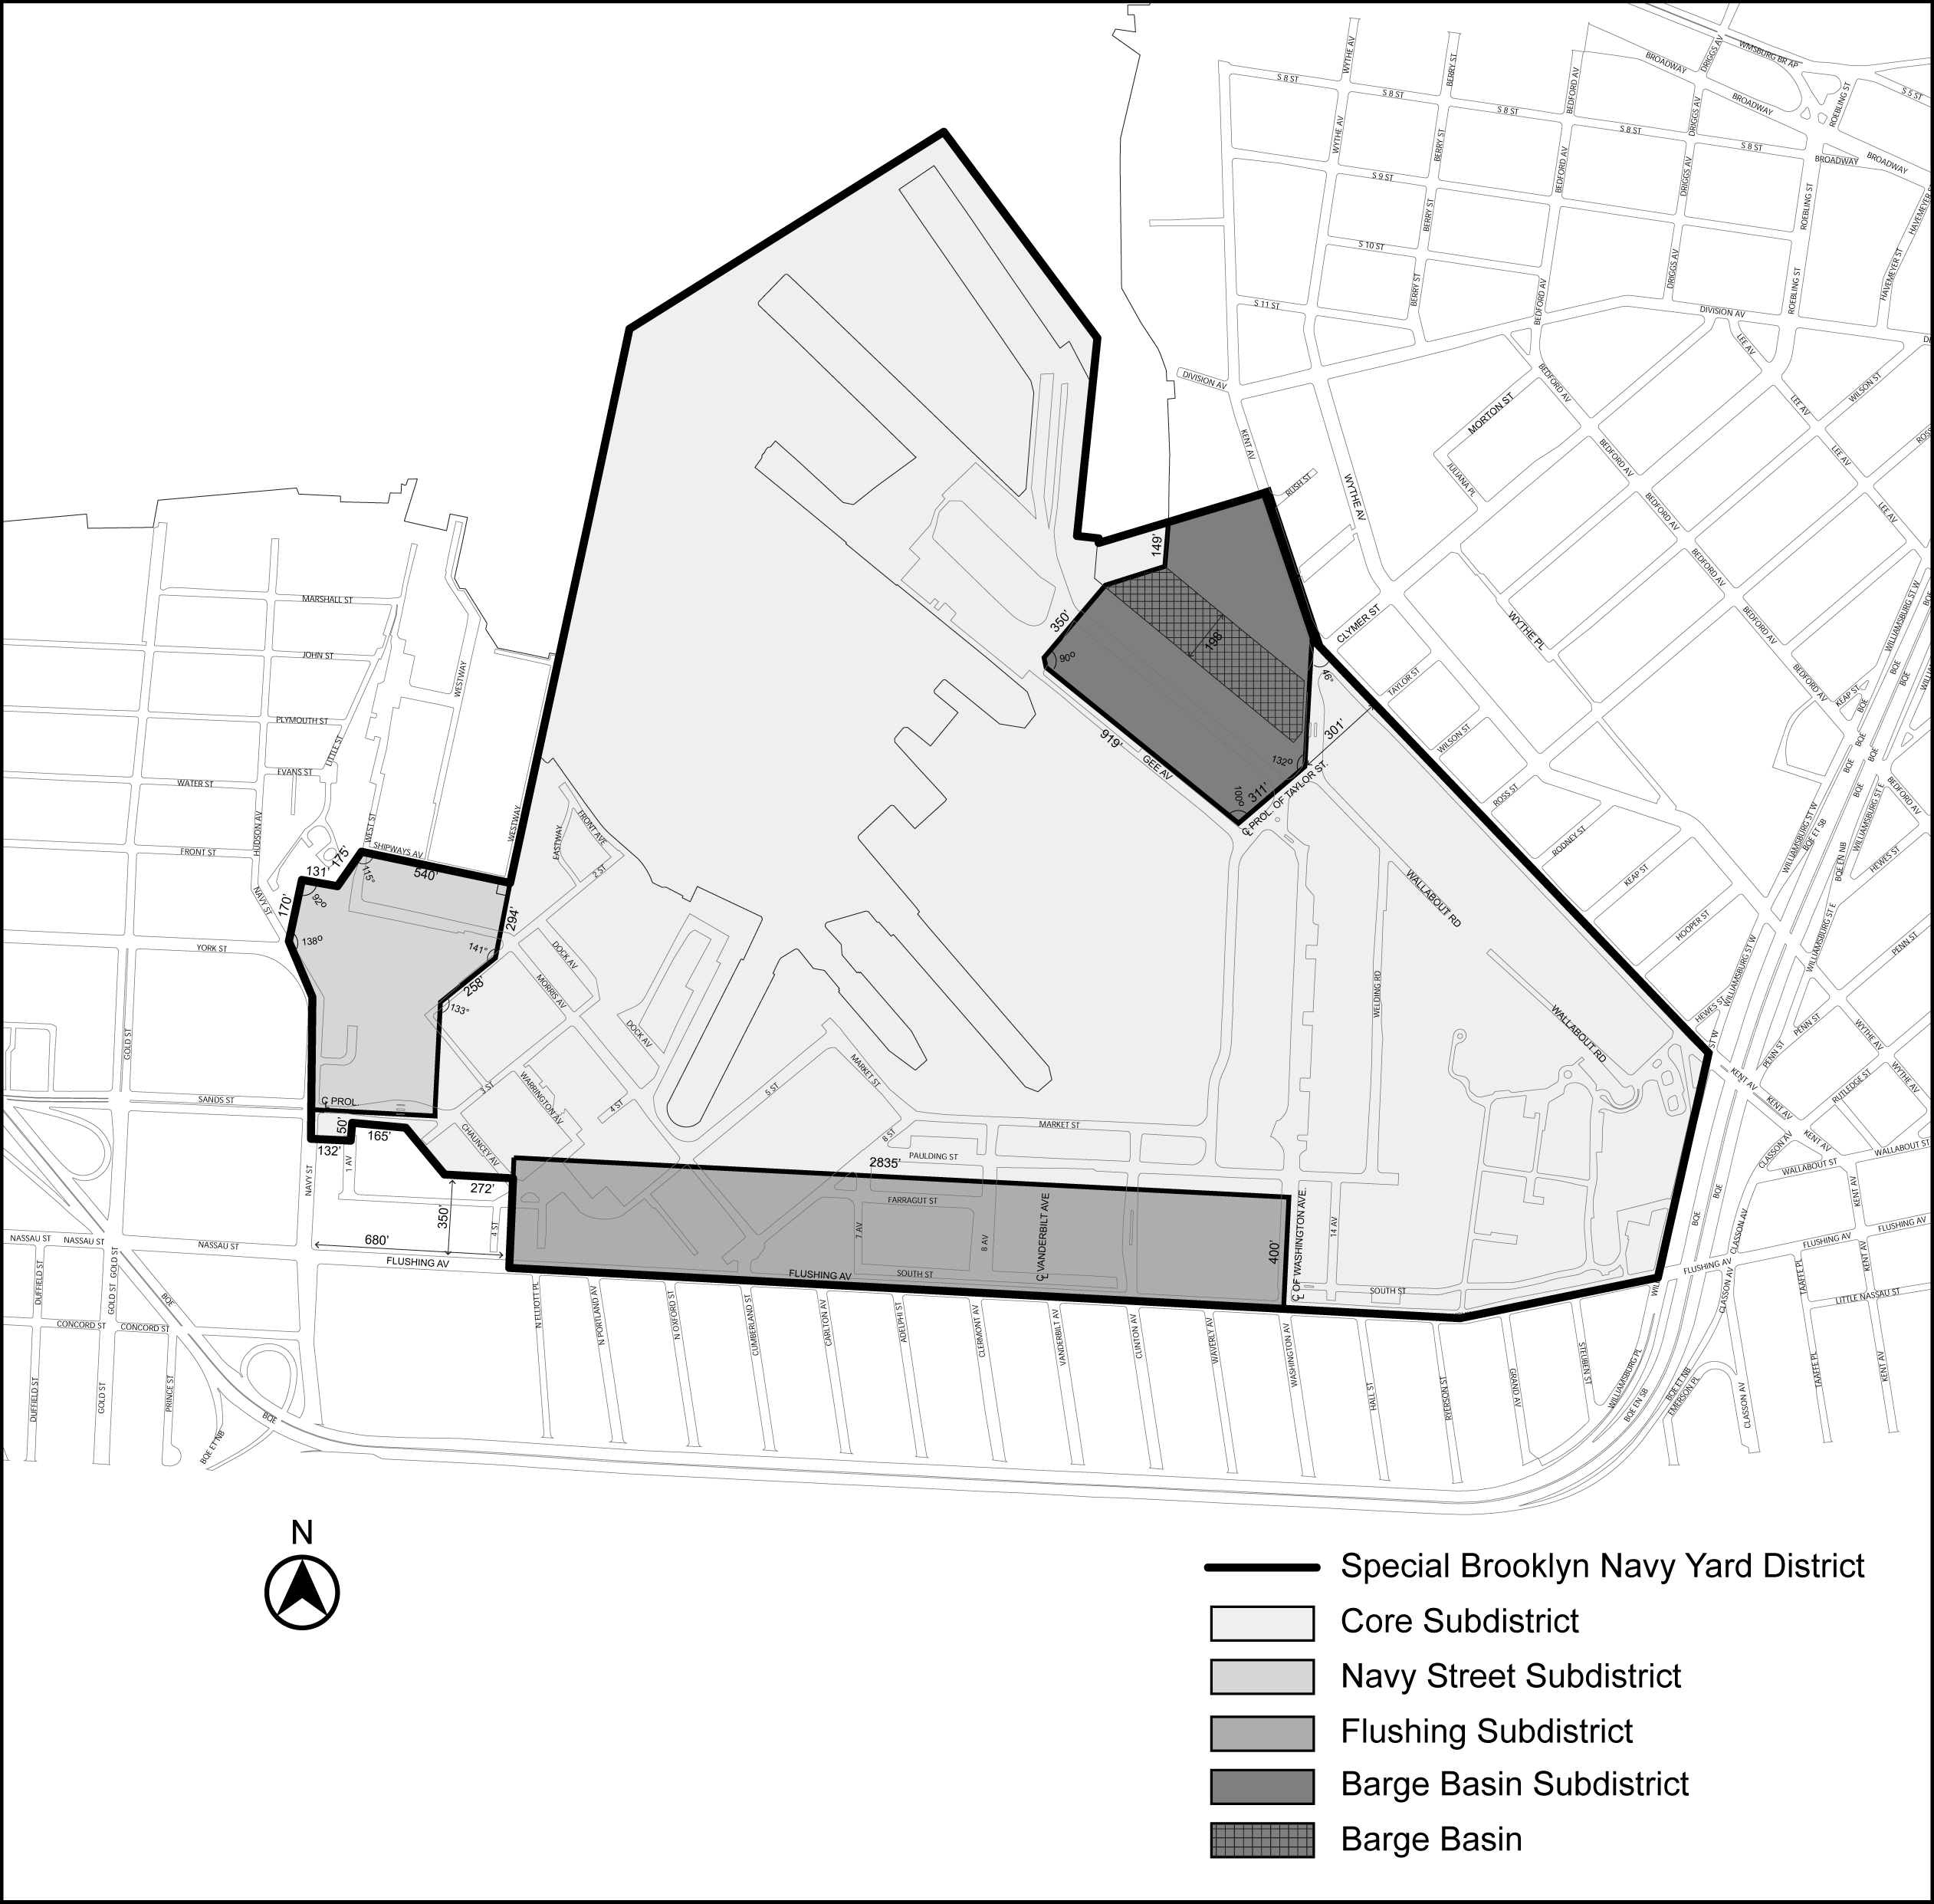
Map 2 - Barge Basin Subareas

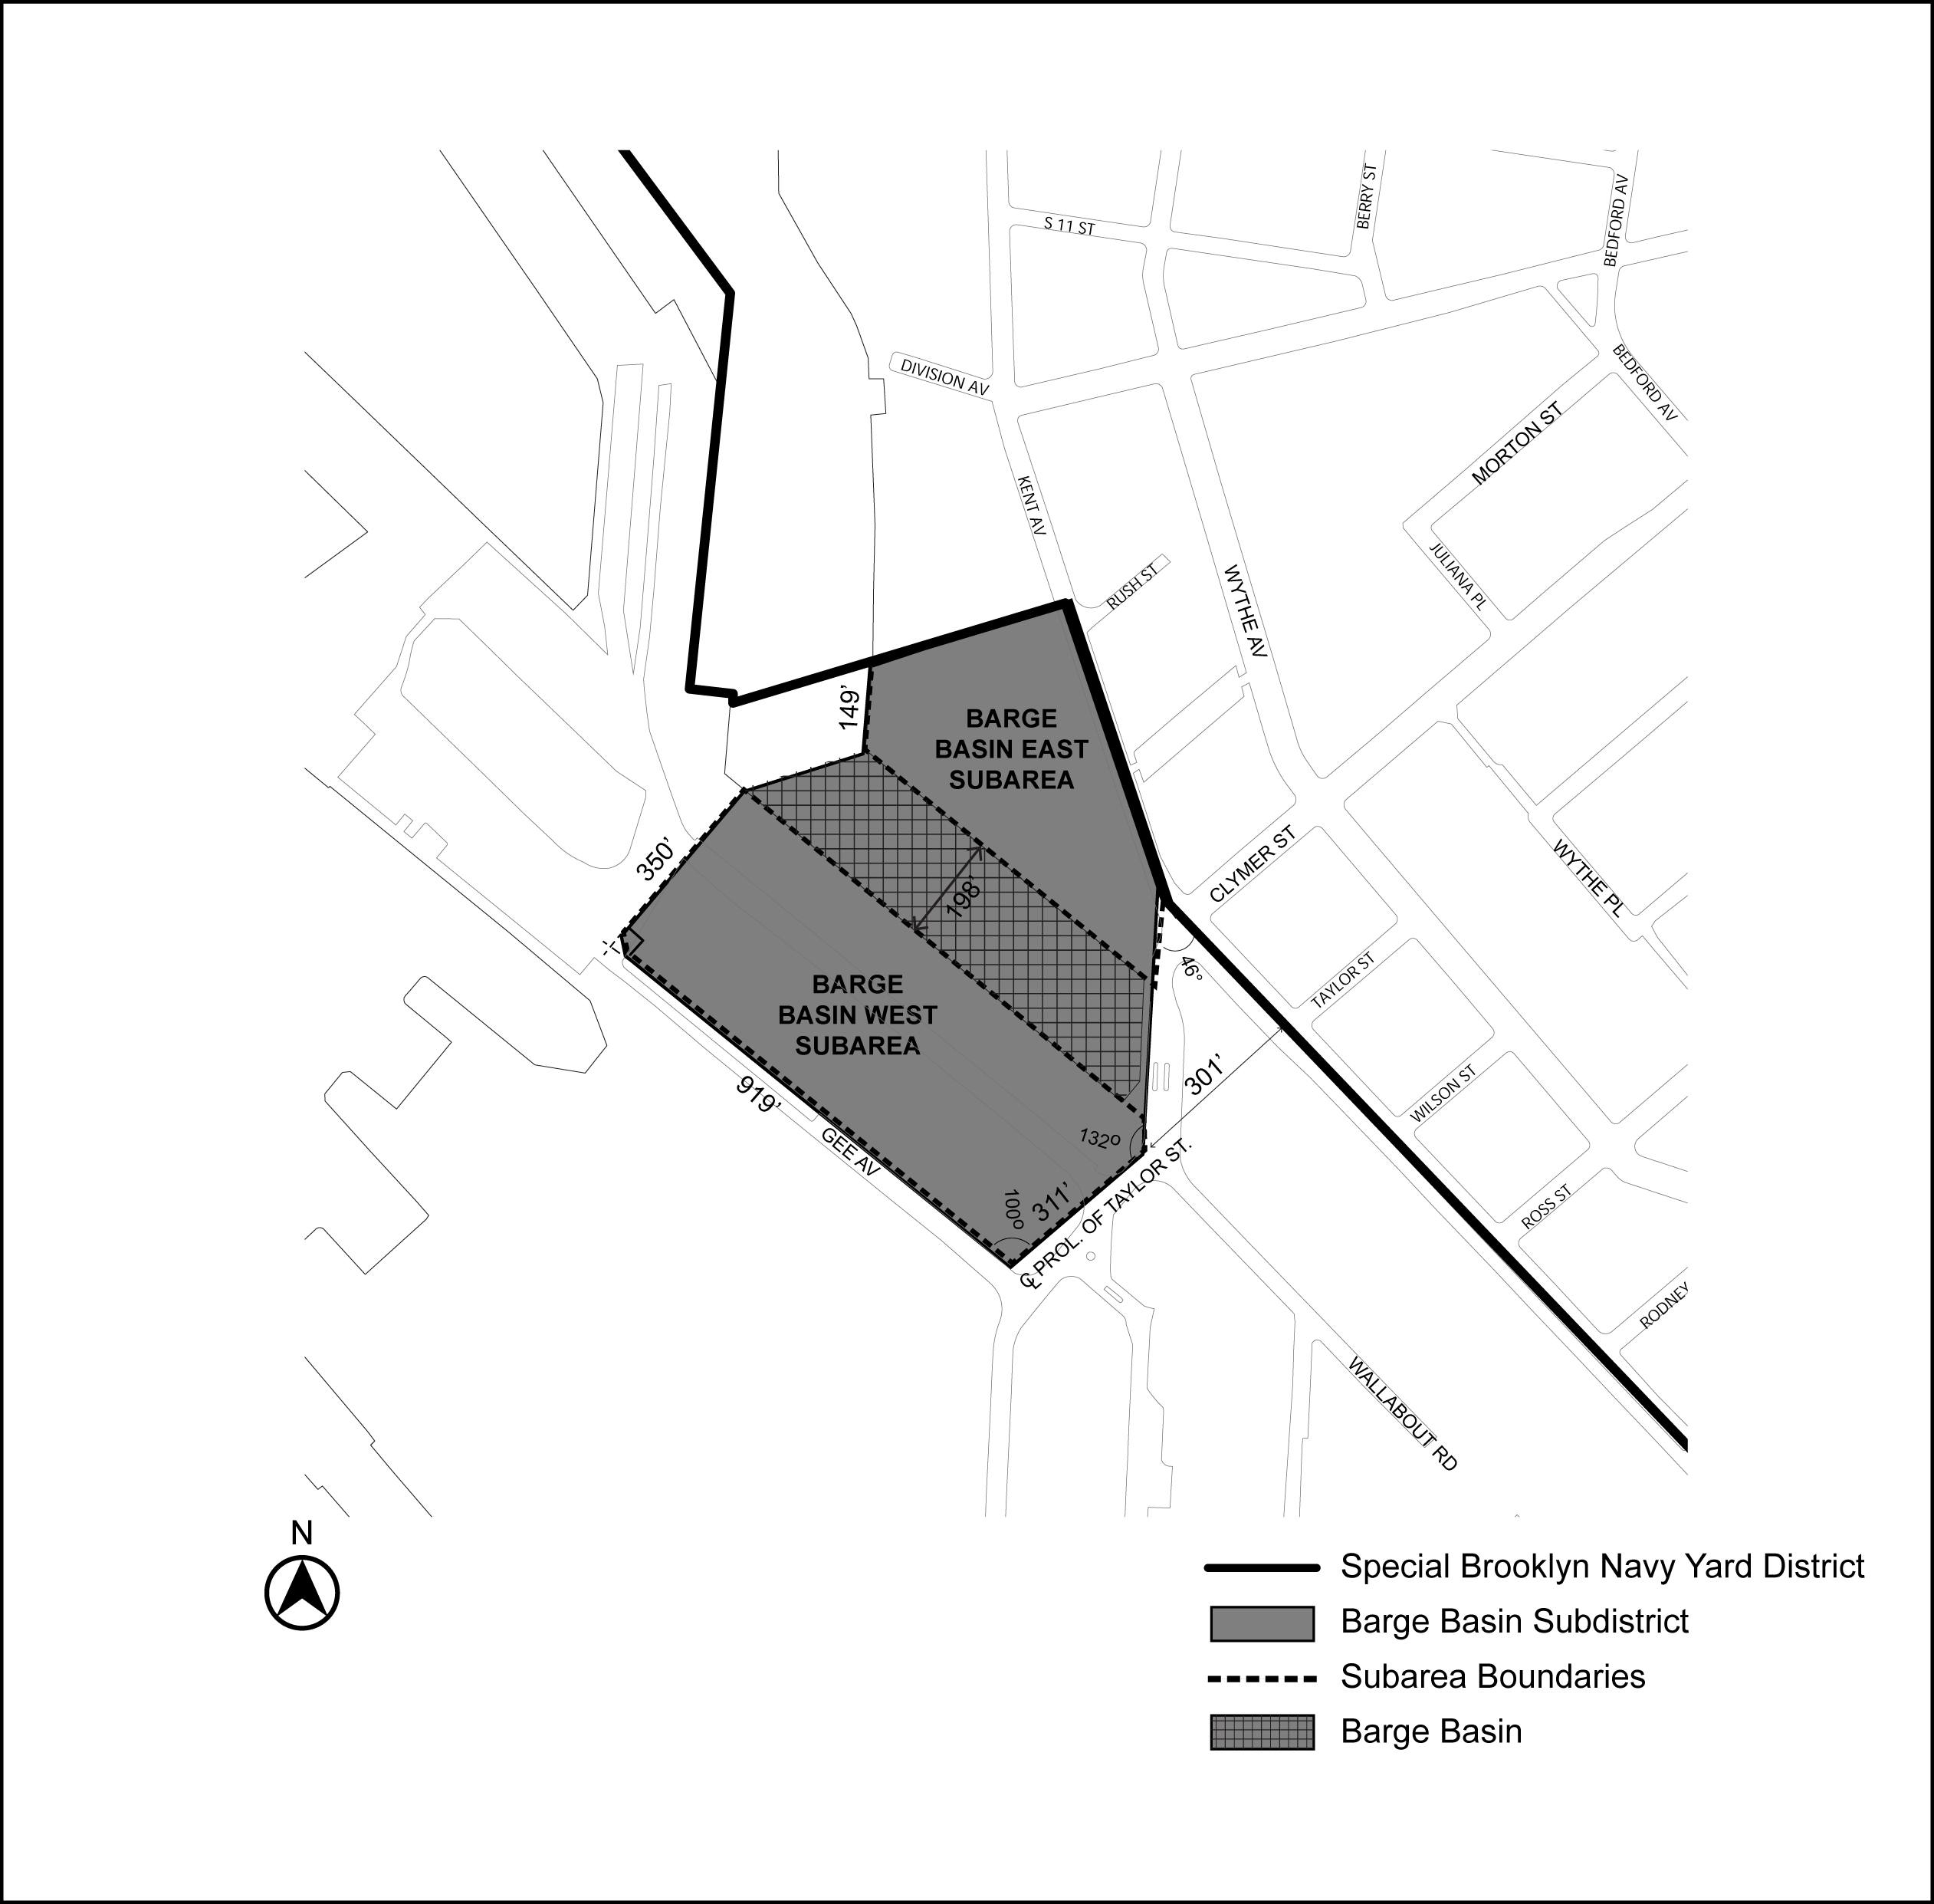
Map 3 - Navy Street Central Subarea

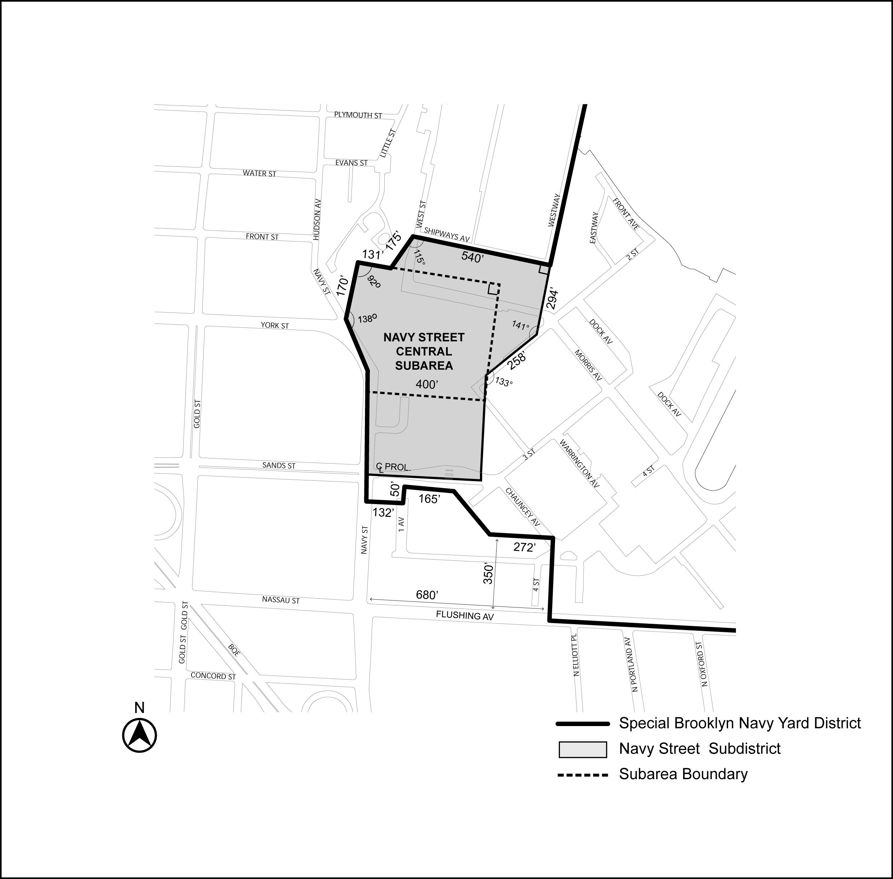
Map 4 - Flushing Avenue Subareas and View Corridors

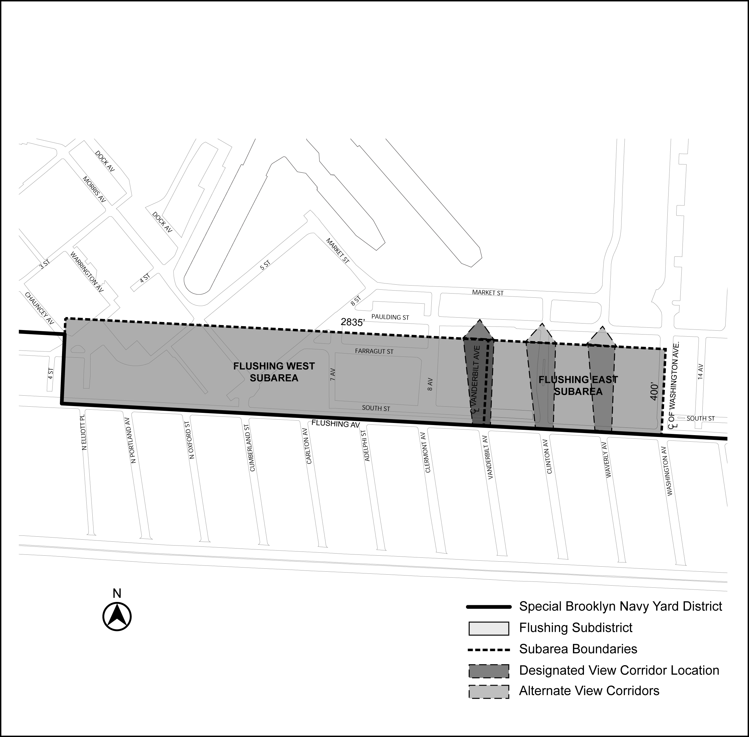

Map 5 Street Line Locations in the Barge Basin Subdistrict

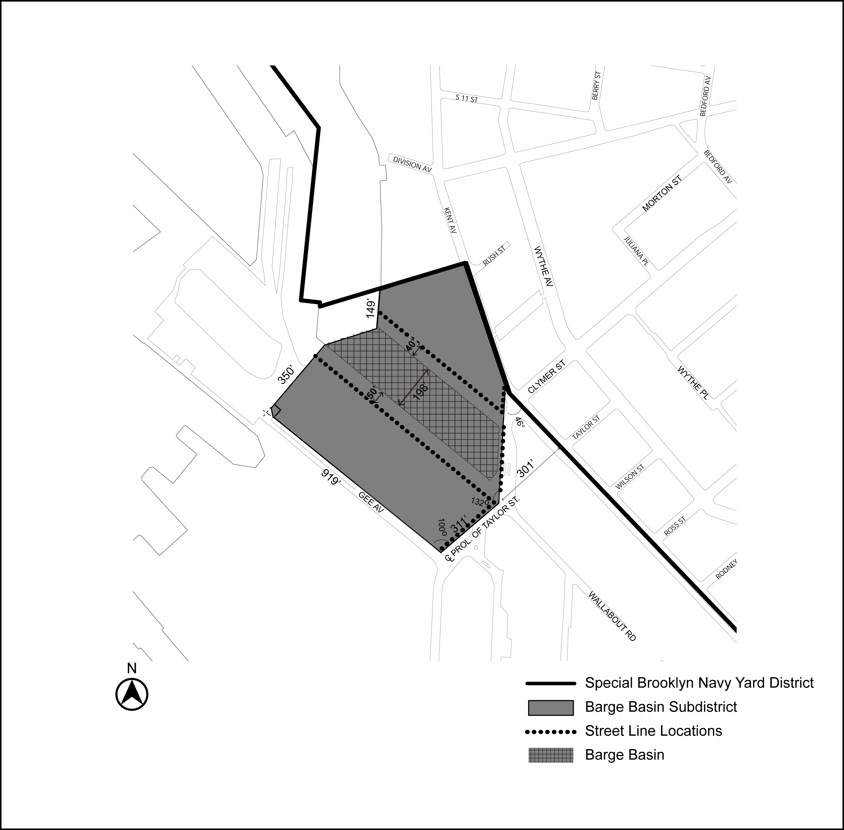

Map 6 Primary Street Frontages

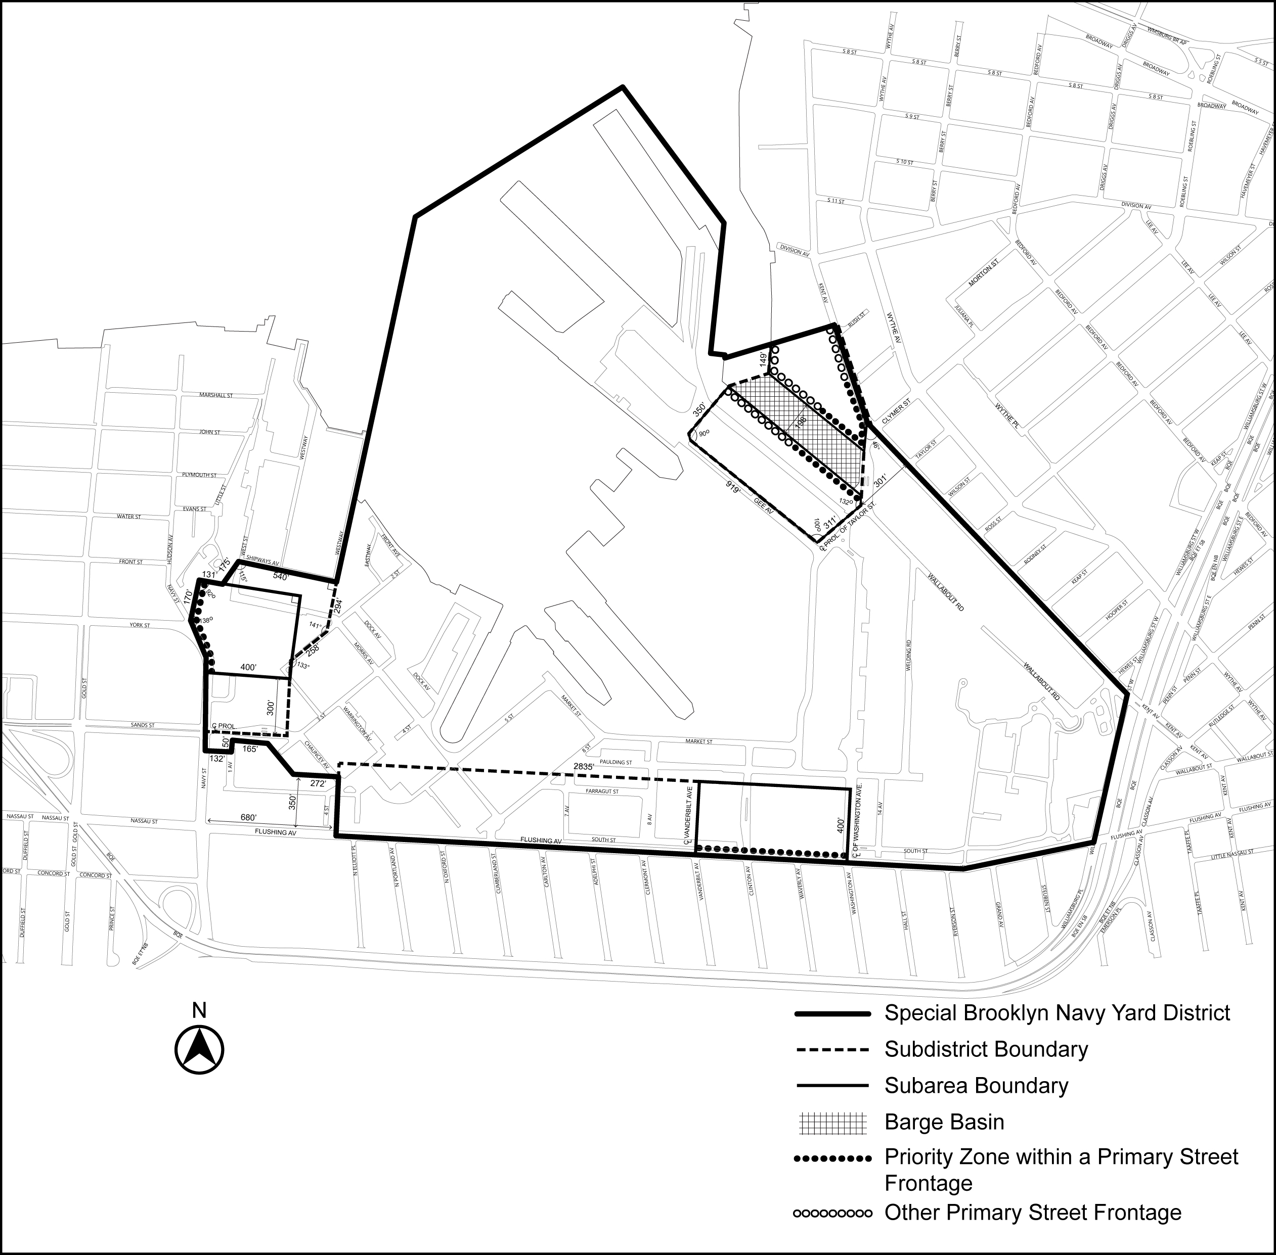

* * *

Adopted.

Office of the City Clerk, }
The City of New York, } ss.:

I hereby certify that the foregoing is a true copy of a Resolution passed by The Council of The City of New York on ________, 2021, on file in this office.

.....................................................
City Clerk, Clerk of The Council

