THE COUNCIL OF THE CITY OF NEW YORK
RESOLUTION NO. 1615

Resolution approving with modifications the decision of the City Planning Commission on Application No. N 200030 ZRK, for an amendment of the text of the Zoning Resolution (Preconsidered L.U. No. 734).

By Council Members Salamanca and Moya

WHEREAS, 737 Fourth Avenue, LLC, filed an application pursuant to Section 201 of the New York City Charter, for an amendment of the text of the Zoning Resolution of the City of New York, extending the boundary of Special Enhanced Commercial District 1 in Article XIII, Chapter 2 (Special Enhanced Commercial District), and modifying APPENDIX F for the purpose of establishing a Mandatory Inclusionary Housing Area, which in conjunction with the related action would facilitate the construction of a mixed-use building containing a total of approximately 142 residential dwelling units and 8,600 square feet of ground floor commercial space at 737 Fourth Avenue in the Sunset Park neighborhood of Brooklyn, Community District 7, (ULURP No. N 200030 ZRK), (the “Application”);

WHEREAS, the City Planning Commission filed with the Council on February 19, 2021, its decision dated February 3, 2021 (the "Decision") on the Application;

WHEREAS, the Application is related to application C 200029 ZMK (Pre. L.U. No. 733), a zoning map amendment to change an M1-1D zoning district to an R8A/C2-4 zoning district;

WHEREAS, the Decision is subject to review and action by the Council pursuant to Section 197-d of the City Charter;

WHEREAS, upon due notice, the Council held a public hearing on the Decision and Application on February 23, 2021;

WHEREAS, the Council has considered the land use implications and other policy issues relating to the Decision and Application; and

WHEREAS, the Council has considered the relevant environmental issues, including the negative declaration issued August 17th, 2020 (CEQR No. 19DCP127K), which includes an (E) designation to avoid the potential for significant adverse impacts related to hazardous materials, air quality, and noise (E-575) (the “Negative Declaration”).

RESOLVED:

The Council finds that the action described herein will have no significant impact on the environment as set forth in the (E) Designation (E-575) and Negative Declaration.

Pursuant to Sections 197-d and 200 of the City Charter and on the basis of the Decision and Application, and based on the environmental determination and consideration described in the report, N 200030 ZRK, incorporated by reference herein, and the record before the Council, the Council approves the Decision of the City Planning Commission with the following modifications:

Matter underlined is new, to be added;
Matter struck out is to be deleted;
Matter double struck out is old, deleted by the City Council;
Matter double-underlined is new, added by the City Council;
Matter within # # is defined in Section 12-10;
*** indicates where unchanged text appears in the Zoning Resolution.

ARTICLE XIII
Special Purpose Districts

* * *
Chapter 2
Special Enhanced Commercial District

* * *
132-11
Special Enhanced Commercial Districts Specified
The #Special Enhanced Commercial District# is mapped in the following areas:
(a) #Special Enhanced Commercial District# 1
The #Special Enhanced Commercial District# 1 (EC-1) is established on November 29, 2011, on the following #designated commercial streets# as indicated on #zoning maps# 16c and 16d:
(1) Fourth Avenue, in the Borough of Brooklyn, generally between 24th 25th Street and Atlantic Avenue.
* * *
APPENDIX F
Inclusionary Housing Designated Areas and Mandatory Inclusionary Housing Areas

* * *

BROOKLYN

* * *

Brooklyn Community District 7

Map 1 – [date of adoption]

[EXISTING MAP]

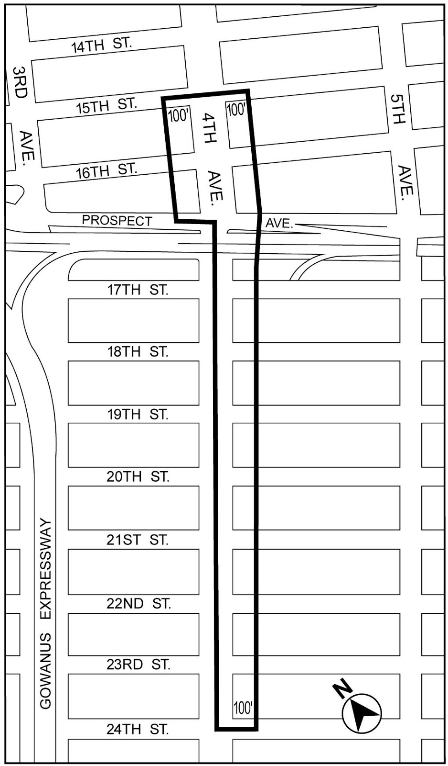

[PROPOSED MAP]
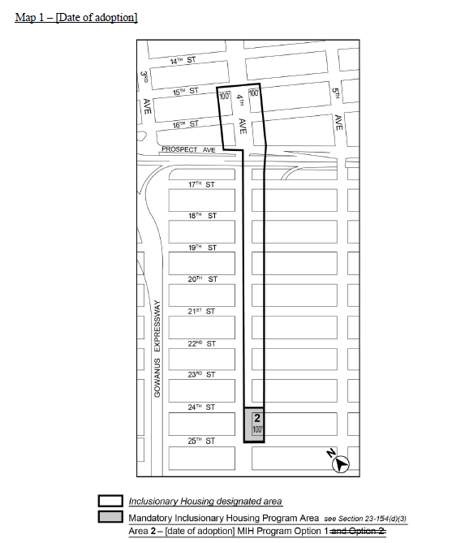

Portion of Community District 7, Brooklyn

* * *

Adopted.

Office of the City Clerk,}
The City of New York,} ss.:

I hereby certify that the foregoing is a true copy of a Resolution passed by The Council of The City of New York on April 22, 2021, on file in this office.

.....................................................
City Clerk, Clerk of The Council

