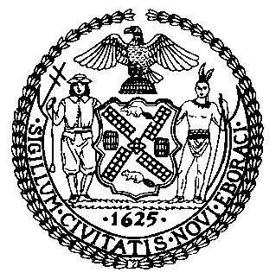 | The Council of the City of New York  Finance Division  Latonia McKinney, Director  Fiscal Impact Statement  Proposed Intro. No: 1607-A  Committee: General Welfare
Title: A Local Law to amend the administrative code of the city of New York, in relation to requiring the administration for children's services to report more information regarding the caseloads of its front-line workers and child safety conferences | Sponsor(S): By Council Members Rose, Rosenthal, Levin, Johnson, and Gentile

Summary of Legislation: Proposed Intro. 1607-A would require ACS to complete a study on child protective caseloads and workloads. The study would include an examination of key milestones and tasks required in a child protective investigation, an analysis of how certain factors impact the complexity of a case, an examination of the relationship between the aforementioned data, an assessment of best practices in caseload and workload standards, and recommendations for how ACS will implement best practices. The study would be required to be completed by March 31, 2019 and would be due to the Speaker of the Council by September 30, 2019. After the submission of the required report, the law would be deemed repealed.

Effective Date: Immediately

Fiscal Year in which Full Fiscal Impact Anticipated: Fiscal 2019
Fiscal Impact Statement:

 | Effective FY18 | FY Succeeding Effective FY19 | Full Fiscal Impact FY19
Revenues | $0 | $0 | $0
Expenditures | $0 | $0 | $0
Net | $0 | $0 | $0

Impact on Revenues: There would be no impact on revenues resulting from this legislation.

Impact on Expenditures: It is anticipated that there would be no impact on expenditures resulting from the enactment of this legislation because existing resources within ACS can be used to conduct the study and complete the recommendations.
Source of Funds To Cover Estimated Costs: Not applicable.
Source of Information: New York City Council Finance Division
Estimate Prepared By: Daniel Kroop, Legislative Financial Analyst

Estimate Reviewed By: Eric Bernstein, Counsel
Dohini Sompura, Unit Head
Legislative History: This legislation was introduced to the Council on May 10, 2017 as Intro. No. 1607 and was referred to the Committee on General Welfare (Committee). The Committee considered the legislation at a hearing on June 14, 2017 and the legislation was laid over. The legislation was subsequently amended and the amended version, Proposed Intro. No. 1607-A, will be voted on by the Committee at a hearing on November 29, 2017. Upon successful vote by the Committee, Proposed Intro. No. 1607-A will be submitted to the full Council for a vote on November 30, 2017.
Date Prepared: November 27, 2017

