Committee Counsel:
Lance Polivy

THE COUNCIL OF THE CITY OF NEW YORK

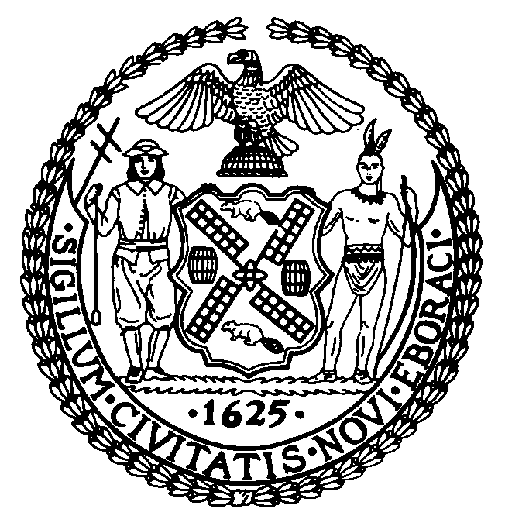

OFFICE OF THE GENERAL COUNSEL
Jason Otaño, General Counsel

COMMITTEE REPORT OF THE
COMMITTEE ON RULES, PRIVILEGES AND ELECTIONS

Hon. Keith Powers, Chair

February 24, 2022

PRECONSIDERED RES. NO. []: By Council Member Keith Powers

SUBJECT: Resolution amending Rule 7.00 of the Rules of the Council in relation to changes in membership of the standing committees and subcommittees of the Council.

ANALYSIS: Before the Committee, for its consideration, are proposed changes to the membership of certain standing committees and subcommittees, through changes to the Rules of the Council. Pursuant to Chapter 2 § 46 of the New York City Charter, the Council sets the rules of its proceedings at the first Stated meeting of each calendar year. These rules may be amended by a resolution introduced and passed by the Council’s Committee on Rules, Privileges and Elections (“Rules Committee”) pursuant to Rules 7.00(a) and 7.70(a), followed by a majority vote of all Council Members pursuant to Rules 7.00(a) and 10.20.

See attached for the changes to membership.

