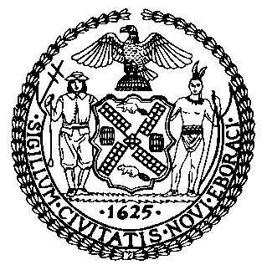 | The Council of the City of New York  Finance Division  Latonia Mckinney, Director  Fiscal Impact Statement  Proposed Intro. No: 932-A  Committee: Transportation
Title: A local law in relation to the misuse of City-issued parking permits | Sponsors: Council Members Chin, Lander, Powers, Rose, Rivera, Ampry-Samuel, Kallos, Cohen, Constantinides, Holden and Ayala
Summary of Legislation: Proposed Intro. No. 932-A would require parking permits issued by the Police Department to be revoked in accordance with the disciplinary rules of that department, and would require all other City-issued parking permits to be revoked from individuals who receive three or more violations of a rule or law related to the misuse of the parking permit, receive any violation of section 19-166 of the Administrative Code, which relates to unauthorized or fraudulent use of a parking permit, or have unpaid parking or traffic violations in excess of $350.

Effective Date: This local law would take effect 90 days after it becomes law, except that the Commissioner of Transportation, in consultation with the Police Commissioner as needed, shall take any necessary actions to implement this law, including the promulgation of rules, prior to the effective date.

Fiscal Year In Which Full Fiscal Impact Anticipated: Fiscal 2021
Fiscal Impact Statement:
 | Effective FY20 | FY Succeeding Effective FY21 | Full Fiscal Impact FY21
Revenues | $0 | $0 | $0
Expenditures | $0 | $0 | $0
Net | $0 | $0 | $0
Impact on Revenues: It is estimated that this legislation would have no impact on revenues.

Impact on Expenditures: It is estimated that this legislation would have no impact on expenditures because the relevant City agencies would utilize existing resources to fulfill its requirements.
Source of Funds to Cover Estimated Costs: N/A
Source of Information: New York City Council Finance Division
Mayor’s Office of Legislative Affairs
Estimate Prepared by: John Basile, Financial Analyst

Estimate Reviewed by: Nathan Toth, Deputy Director
Chima Obichere, Unit Head
Noah Brick, Assistant Counsel
Legislative History: This legislation was introduced to the full Council as Intro. No. 932 on May 23, 2018 and was referred to the Committee on Transportation (Committee). The Committee heard the legislation on June 12, 2019 and the legislation was laid over. The legislation was subsequently amended and the amended version, Proposed Intro. No. 932-A, will be considered by the Committee on November 26, 2019. Upon a successful vote by the Committee, Proposed Intro. No. 927-A will be submitted to the full Council for a vote on November 26, 2019
Date Prepared: November 21, 2019

