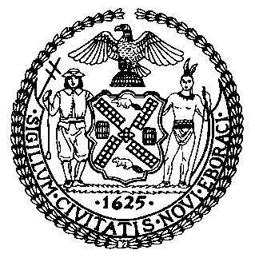 | The Council of the City of New York  Finance Division  Latonia Mckinney, Director  Fiscal Impact Statement  Proposed Intro. No: 716-A  Committee: Housing and Buildings
Title: A Local Law to amend the administrative code of the city of New York, in relation to a report on the waiting lists of Mitchell-Lama housing developments | Sponsors: The Public Advocate (Mr. Williams) and Council Members Reynoso, Perkins, Chin, Kallos, Lander, Louis, Barron and Ayala
Summary of Legislation: Proposed Intro. No. 716-A would require the Department of Housing Preservation and Development (“HPD” or “Department”)) to report annually on certain information regarding the waiting lists of Mitchell-Lama housing developments that have been digitized and are incorporated into the housing portal. The report would be submitted to the Mayor, the Speaker of the Council, and the Public Advocate, and be posted on the Department’s website by September 1, 2021, and by September 1 of each year thereafter.
Effective Date: This local law would take effect immediately.

Fiscal Year In Which Full Fiscal Impact Anticipated: Fiscal 2021
Fiscal Impact Statement:

 | Effective FY20 | FY Succeeding Effective FY21 | Full Fiscal Impact FY21
Revenues | $0 | $0 | $0
Expenditures | $0 | $0 | $0
Net | $0 | $0 | $0

Impact on Revenues: It is estimated that there would be no impact on revenues resulting from the enactment of this legislation.
Impact on Expenditures: It is estimated that there would be no impact on expenditures resulting from the enactment of this legislation because existing resources would be used by HPD to implement the provisions of this local law.
Source of Funds To Cover Estimated Costs: N/A.
Source of Information: New York City Council Finance Division
Estimate Prepared by: Luke Zangerle, Financial Analyst

Estimate Reviewed by: Nathan Toth, Deputy Director
Chima Obichere, Unit Head
Stephanie Ruiz, Assistant Counsel
Legislative History: This legislation was introduced to the full Council on March 7, 2018 as Intro. No. 716 and was referred to the Committee on Housing and Buildings (“Committee”). The Committee heard the legislation on January 14, 2019, and the legislation was laid over. The legislation was subsequently amended and the amended version, Proposed Intro. No. 716-A, will be considered by the Committee on November 14, 2019. Following a successful Committee vote, the bill will be submitted to the full Council for a vote on November 14, 2019.

Date Prepared: November 13, 2019

