Committee on Small Business
Kristoffer Sartori, Senior Legislative Counsel
Noah Meixler, Legislative Policy Analyst
Aliya Ali, Principal Fiscal Policy Analyst

THE COUNCIL OF THE CITY OF NEW YORK

Committee Report of the Governmental Affairs Division
Jeffrey Baker, Legislative Director
Rachel Cordero, Deputy Director, Governmental Affairs Division

COMMITTEE ON SMALL BUSINESS
Hon. Mark Gjonaj, Chair

The Mayor’s Recovery Agenda

January 22, 2020

- Introduction

On January 22, 2020, the Committee on Small Business, chaired by Council Member Mark Gjonaj, will hold a remote hearing on “The Mayor’s Recovery Agenda.” Those invited to testify include the Department of Small Business Services (SBS), small business advocates, chambers of commerce, Business Improvement Districts and other members of the public.
- Background
In late December 2019, a new virus, SARS-CoV-2, was detected in Wuhan, China and by January 30, 2020, the World Health Organization (WHO) declared that COVID-19, the disease caused by the SARS-CoV-2 virus, was now a Public Health Emergency of International Concern (PHEIC). As of January 19, 2021, COVID-19 has infected over 96 million people across 219 countries and territories, and has killed over two million people. In the United States alone, there have been over 24 million infections and over 400,000 deaths. To date, New York has had over 1,200,000 infections and over 41,000 deaths, many of which took place in New York City.
While COVID cases remained consistently low throughout the summer of 2020 and the City began to reopen, COVID cases in New York began to steadily increase by October of last year. Over the past week, there have been an average of over 15,170 cases per day in New York State – an increase of ten percent from the average two weeks earlier.
The progressive nature by which the virus spreads has caused governments across the globe to shutdown businesses, schools, religious and cultural institutions, and mandate various levels of social isolation. While these measures have helped to limit the spread of the virus, stay-at-home orders have had a catastrophic impact on economic markets, particularly small businesses that thrive from regular contact with their community and neighbors.
A survey of approximately 600 small businesses conducted in September 2020 by Comcast Business found that 86 percent of respondents experienced a decline in business revenue in 2020, with 70 percent projecting that they could lose up to half their annual revenue in 2020. Further, since the pandemic began, only 21 percent of businesses surveyed report having resumed normal operations, and 53 percent predict that it will take about six months to a year to return to what was previously considered “normal.”
Limitations on City Businesses in Response to COVID-19
As businesses were subject to operational restrictions and New Yorkers stayed home to stop the spread of the virus, consumer spending declined in the City. In late March 2020, consumer spending dropped 44 percent year-over-year, according to Mastercard. The Manhattan Chamber of Commerce reported that foot traffic in Manhattan at the end of August was down nearly 40 percent compared to pre-COVID times. According to the research firm Opportunity Insights, small business revenues dropped over 70 percent in NYC in early April in comparison to January 2020. As of December 30, 2020, small business revenues were still down over 53 percent in comparison to January 2020.
The drastic drop in consumer spending in the City and resulting loss in revenue for businesses has made it difficult for business owners to continue paying rent. The Hospitality Alliance surveyed over 400 restaurants, bars, nightclubs and event venues in NYC about their rent obligations in October. The resulting report found that approximately 88 percent of respondents could not pay their full rent in October, while around 59 percent of landlords did not waive rent payments for restaurants, bars and night clubs. The current outlook for many small businesses is dire as they experience massive revenue declines but must continue paying the same fixed costs, such as rent, as pre-COVID times.
Thousands of small businesses have closed in New York due to their inability to continue paying their fixed costs. According to a report by City Comptroller, Scott Stringer, at least 2,800 small businesses closed permanently between March 1st and July 10th. The Partnership for New York City predicts that as many as a third of the 230,000 small businesses in NYC may never reopen.
As small businesses have shut their doors, the livelihoods they generate for both employees and business owners have disappeared. The unemployment rate in the City, at 11.4 percent as of December 2020, was 7.8 percentage points higher than the previous December, and may continue to be high even after the pandemic subsides as thousands of small businesses might permanently close. Labor statistics from the New York State Department of Labor indicate that employment in the “Food Services and Drinking Places” industries are down 43.4 percent in December 2020 as compared to December 2019, and employment in “Full Service Restaurants” is down 55.3 percent. Many “Retail Trade” businesses are also down. For example, employment in “Clothing and Clothing Accessories Stores” is down 36.9 percent, with “Clothing Stores” specifically down 49.9 percent. Employment in “Furniture and Home Furnishings Stores” is down 27.3 percent, and in “Sport, Goods, Hobby, Book, and Music Stores,” it is down 17.6 percent. Employment in the “Personal and Laundry Services” sector, which includes barbershops, hair salons and the other personal care businesses, is down 30.7 percent in December 2020 as compared to December 2019.
A Partnership for New York City report from July 2020 classifies an estimated 679,000 accommodation and food service jobs as vulnerable to loss – the most of any sector in the city – 58 percent coming from small businesses that employ fewer than 100 people. The survival of the small business economy is essential to ensure the City can have a strong, equitable economic recovery from the financial collapse caused by the pandemic.
- SBS Financial Relief Programs
Small Business Continuity Loan Fund and Employee Retention Grant Program
In response to the economic devastation caused by the pandemic, City, State, and Federal financial relief programs were developed to distribute money to small business owners in need. Prior to the announcement of the Small Business Administration’s Paycheck Protection Program (PPP), SBS announced the Employee Retention Grant Program and Small Business Continuity Loan Fund to provide immediate financial relief to small businesses during the COVID-19 crisis. To qualify for either program, businesses were required to provide documentation proving that over a two-month period in 2020 their revenues decreased by 25 percent due to COVID-19. Businesses with fewer than five employees were eligible for the Employee Retention Grant Program, which provided a grant covering up to 40 percent of a business's payroll for two months, with a maximum amount of $27,000. On April 3, 2020, SBS stopped accepting applications to the grant program. The Small Business Continuity Loan Fund provided a zero-interest loan to businesses with fewer than 100 employees for up to $75,000. On April 8, 2020, SBS paused application intake for the loan fund due to an overwhelming number of applications. While the programs were successful in providing money to business owners in need quickly, the disbursement of City funds did not equitably provide relief to businesses across the five boroughs, with Manhattan businesses receiving the majority of funds. On November 27, 2020, SBS submitted a breakdown of the loans and grants issued by Council District (CD), zip code, and industry type to the City Council pursuant to Local Law 94 of 2020.
The results of the report reflect how certain neighborhoods in the City benefitted more from available resources than others. The three CDs that received the most money from the Employee Retention Grant Program are all in Manhattan, while the three CDs that received the least amount of grant money were in the Bronx (See Appendix A). Businesses in Council District 11 qualified for more total grant money than businesses in any other Bronx Council District, but CD11 still received the 37th lowest amount of grant money. In addition to being geographically inequitable, SBS’s disbursement of grant money predominantly benefitted more professional and technical small businesses. During his press conference on March 8, 2020, Mayor de Blasio described the purpose of the Employee Retention Grant Program of providing money to “our smallest small businesses [with] under five employees, a lot of mom and pop stores, neighborhood-based stores.” However, attorney’s offices, physicians and dentists were the three professional groups that received the most amount of money through the program (See Appendix B).
The Small Business Continuity Loan Fund similarly failed to disburse loans equitably across the five boroughs. Seven Council Districts, five of which are from the Bronx, received zero money through the program. The top three Council Districts that received the most money from the Loan program were the same Districts that received the most money from the grant program as well (See Appendix C). It is important to note that certain Council Districts in the City, such as CD 1, were perhaps able to qualify for a high number of grants and loans because they have a greater concentration of businesses than do other neighborhoods in the City. Overall, however, the outer boroughs qualified for less City-funded aid through these programs than did businesses in Manhattan. Small business owners who were not conversant in English may have had difficulty understanding the terms and conditions and how to apply to the programs, without materials available in other languages. SBS took weeks to translate application materials on their website, and even then only translated certain materials, with text on the website translated by browser tools.
Unlike SBS’s grant program, the Small Business Continuity Loan Fund did not primarily benefit more professional and technical businesses. Restaurants, bars and nightclubs, and nail salons were among the business sectors that qualified for the most loans from the program (See Appendix D).
Support for Hard-Hit Low and Moderate Income (LMI) Communities
On November 25, 2020, Mayor de Blasio announced three financial relief programs to benefit small businesses in low-to-moderate (LMI) income neighborhoods. The NYC LMI Storefront Loan, Interest Rate Reduction Grant, and Strategic Impact COVID-19 Commercial District Support Grant will disburse $37 million exclusively to small businesses located in LMI neighborhoods. According to SBS Commissioner Jonnel Doris, “The launch of these programs is a targeted approach to provide relief efforts in communities that need it most.”
SBS partnered with the New York City Economic Development Corporation (NYCEDC) and Pursuit BDC to develop the NYC LMI Storefront Loan, a $35 million loan program. Businesses with at least two and under 100 employees located in LMI neighborhoods are eligible under the program for a zero-interest loan for up to $100,000. To determine which businesses could qualify for the program, SBS used the Department of Housing and Urban Development’s 2020 area median income for the NYC region to determine low-to-moderate income zip codes. On November 30, 2020, applications for the loan program opened exclusively for small businesses located in the lowest income zip codes. The program then expanded to accepting applications from moderate-income neighborhoods on December 15, 2020.
SBS’s Interest Rate Reduction Grant Program was created to help business owners reduce the interest they owe on existing loans from certain Community Development Financial Institutions (CDFI). SBS partnered with 11 CDFI’s to provide the grant, which will enable business owners to increase their cash flow by helping them pay off these existing financial obligations.
SBS’s Strategic Impact COVID-19 Commercial District Support Grant is providing grants to community-based development organizations (CBDOs) to run local COVID-19 recovery support programs for small businesses. CBDOs must use the grants from SBS to fund outreach efforts, provide technical support, and increase awareness of new City and State rules for local small businesses. A total of $700,000 is available in the program, and eligible CBDOs must serve at least one of the following 39 LMI neighborhoods and communities of color:
“Bronx: Crotona, East Tremont, Highbridge, Hunts Point, Jerome Park, Longwood, Melrose, Morris Heights, Morrisania, Mott Haven, Soundview, Soundview Bruckner, Van Cortlandt Park
Brooklyn: Bedford-Stuyvesant, Brighton Beach, Brownsville, Bushwick, Canarsie, East Flatbush, East New York, Starrett City, Sunset Park, and Coney Island
Manhattan: Central Harlem, Chinatown, East Harlem, Hamilton Heights, Inwood, Lower East Side, Morningside Heights, Washington Heights
Queens: Briarwood, Corona, Jamaica, Queensbridge, Rockaways
Staten Island: St. George, Stapleton”
Advocate Concerns with SBS’s LMI Programs
As previously mentioned, to determine which neighborhoods qualify as LMI, SBS used the Department of Housing and Urban Development’s 2020 area median income for the NYC region. This dataset overlooked certain lower-income neighborhoods in the City, however, that are part of the same zip codes as neighborhoods with more affluent residents. The zip code 10013, which includes parts of Chinatown including Mott Street, Pell Street, and Doyers Street, was excluded from the LMI Storefront Loan program, as it includes parts of SoHo and Tribeca, which have higher median incomes. One census tract within zip code 10013-census tract 29-has a median household income of around $27,000, and over 40 percent of families rely on social security. SBS’s use of area median incomes to determine which zip codes qualify as LMI has therefore overlooked income diversity that can exist within a certain zip code.
The failure of the LMI Storefront Loan program to include certain areas of Chinatown angered Chinatown advocates. According to Yin Kong, director of Think! Chinatown, "My first initial reaction was that I'm sure this is some sort of administrative oversight. They didn't realize that 10013 is also a part of Chinatown." Jan Lee, a member of the Chinatown Core Block Association, commented, “The loan is designed for minority communities and minority businesses. I don't understand how [SBS] can leave out Chinatown because you're using us in your publicity for your office.” Manhattan Borough President Brewer called on SBS to explain why they choose to use zip codes to determine which areas qualify as LMI, and for the agency to include zip code 10013 in the LMI Storefront Loan.
To qualify for the LMI Storefront Loan, businesses are also required to provide a personal guarantee on the loan. Personal guarantees reduce the lender’s risk in issuing the loan because it provides the lender the right to pursue the business owner’s personal assets if the business fails to repay the debt owed. As small businesses in the City are experiencing drastically decreased revenues without a clear idea of when the City will resume its normal economic activity, requiring all applicants to agree to a personal guarantee on the LMI Storefront Loan may depress applications to the program. As the purpose of the loan program is to benefit businesses in low-income neighborhoods, the possibility of low-income business owners losing their personal assets may cause further harm in certain communities in the future.
- Conclusion
The COVID-19 pandemic and the regulations implemented to limit the virus’ spread continue to have harmful effects on the ability of small businesses of all types to operate and generate sustainable revenue. While the City’s past and current financial relief programs have been successful in disbursing necessary relief to small business owners, SBS’s programs have encountered numerous equity-based problems. This hearing will provide an opportunity for SBS to update the Committee on the current state of their recent financial relief programs, and for advocates to describe the experiences of small business owners applying and qualifying for relief through SBS’s programs.

Appendix A

Council District | Grant Amount
4 | $5,432,819.81
3 | $3,950,686.04
1 | $3,197,655.96
14 | $28,328.93
12 | $27,103.58
16 | $11,833.39

Appendix B

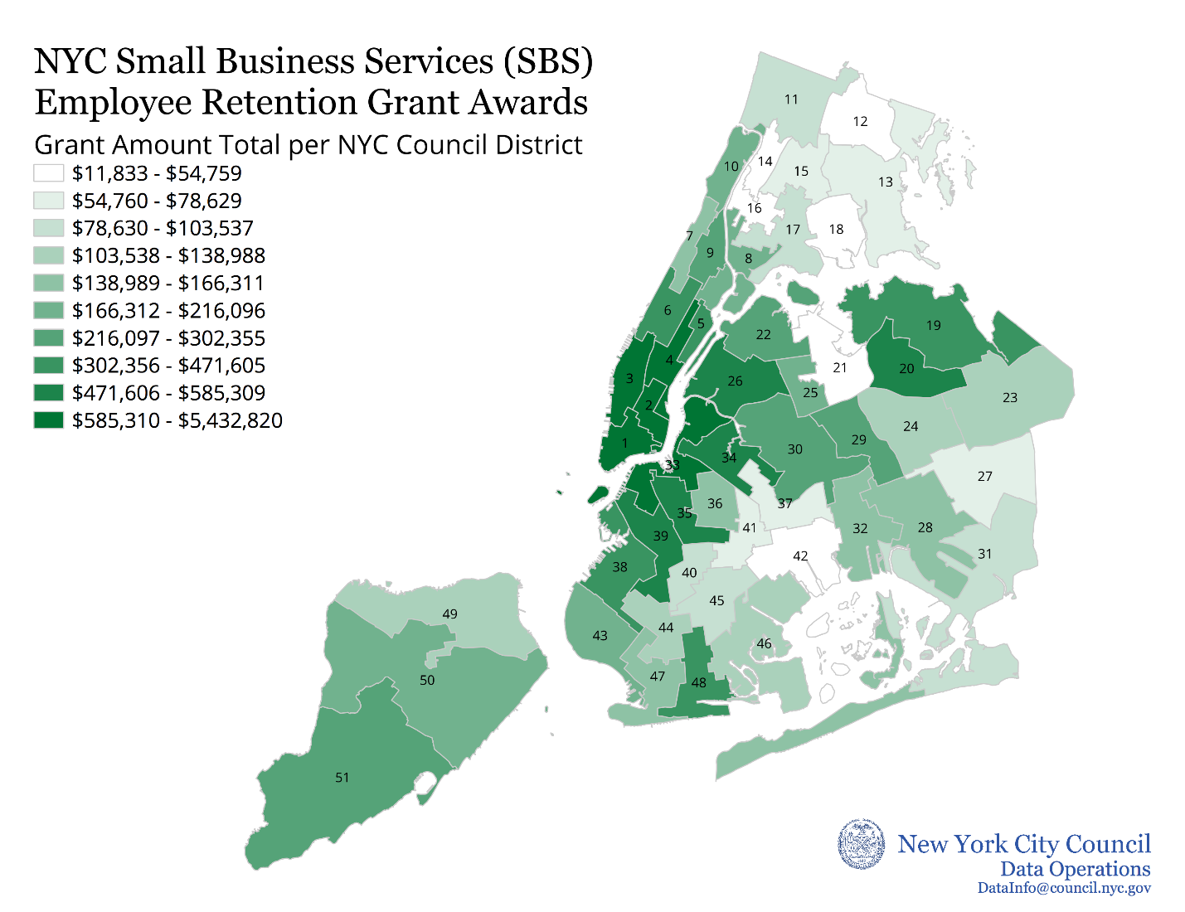

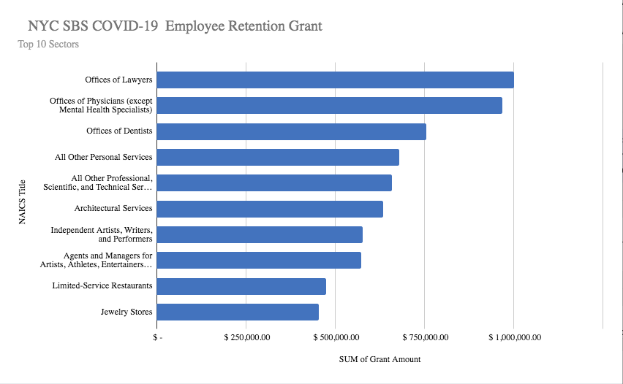
Appendix C

Appendix D

Council District | Loan Amount
4 | $4,274,250
3 | $3,588,083.34
1 | $3,079,466
12 | $53,000
21 | $38,000
16 | $3,000

Appendix E

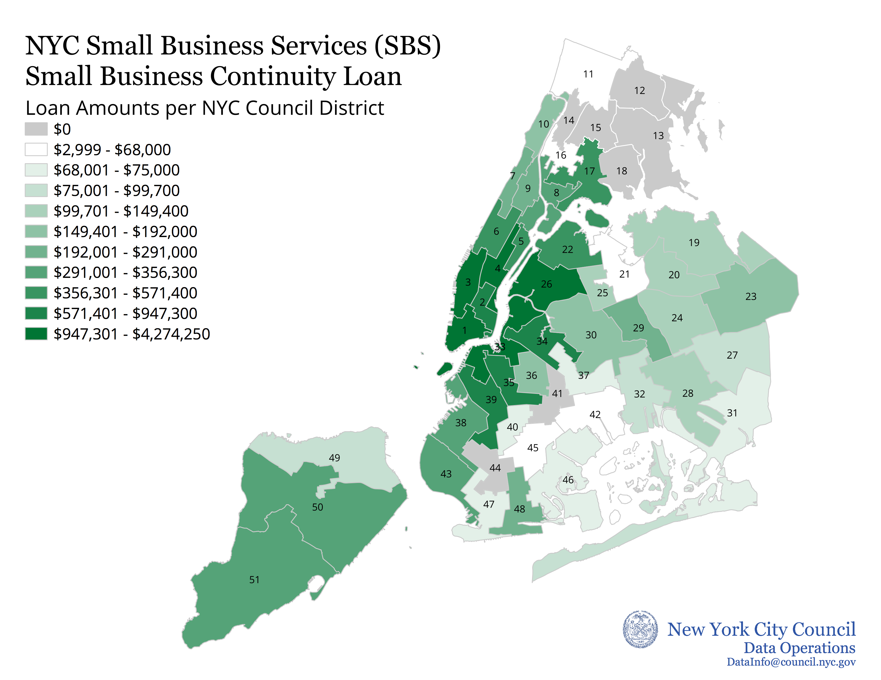

Appendix F

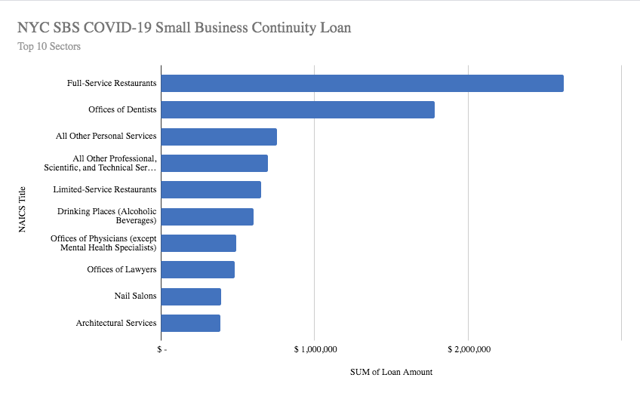

World Health Organization “Rolling updates on coronavirus disease (COVID-19)”, Updated April 18, 2020, available at: https://www.who.int/emergencies/diseases/novel-coronavirus-2019/events-as-they-happen
Worldometer “Countries where COVID-19 has spread”, Updated January 19, 2020 at 19:53 GMT, available at: https://www.worldometers.info/coronavirus/countries-where-coronavirus-has-spread/.
Johns Hopkins University of Medicine, Coronavirus Resource Center, Updated September 8, 2020, available at: https://coronavirus.jhu.edu/.
Id.
Joseph Goldstein and Liam Stack, “N.Y.C. Reports Large Uptick in Virus Cases” The New York Times, Updated October 16, 2020, https://www.nytimes.com/2020/09/29/nyregion/nyc-coronavirus-uptick.html
“New York Covid Map and Case Count”, The New York Times, Updated November 17, 2020, https://www.nytimes.com/interactive/2020/us/new-york-coronavirus-cases.html (last accessed on January 11, 2021)
“Most Business Owners Feel Prepared for Second COVID-19 Wave,” Comcast Business, September 29, 2020, https://corporate.comcast.com/press/releases/small-business-owners-prepared-second-wave-covid-19-comcast-business.
Id.
“A Call for Action and Collaboration”, Partnership for New York City, July 2020, pg. 14 https://pfnyc.org/research/a-call-for-action-and-collaboration/.
“Indicators of Progress,” Manhattan Chamber of Commerce, https://www.nycindicators.com/.
“Percent Change in Small Business Revenue” available at: https://tracktherecovery.org/
Id.
“October 2020 Rent Survey”, NYC Hospitality Alliance, available at: https://thenycalliance.org/assets/documents/informationitems/22Rtf.pdf
“Save Main Street: A Crash Program to Help Save NYC Small Businesses”, New York City Comptroller Scott M. Stringer, August 5, 2020, available at: https://comptroller.nyc.gov/wp-content/uploads/documents/Save_Main_Street_8_5_20.pdf.
“A Call for Action and Collaboration”, Partnership for New York City, July 2020, pg. 4, https://pfnyc.org/research/a-call-for-action-and-collaboration/.
New York State Department of Labor, “Labor Statistics for the New York City Region”, available at: https://www.labor.ny.gov/stats/nyc/
Id.
See New York State Department of Labor, Labor Statistics for the New York City Region: NYC Current Employment Statistics (CES) Latest Month, available at: https://www.labor.ny.gov/stats/nyc/ (last accessed on January 21, 2020).
Id.
Id.
Id.
Id.
Id.
Id.
“A Call for Action and Collaboration”, Partnership for New York City, July 2020, pg. 34, https://pfnyc.org/wp-content/uploads/2020/07/actionandcollaboration.pdf. See also McKinsey & Company, “Lives and livelihoods: Assessing the near-term impact of COVID-19 on US workers,” April 2, 2020, https://www.mckinsey.com/industries/public-and-social-sector/our-insights/lives-and-livelihoods-assessing-the-near-term-impact-of-covid-19-on-us-workers (projecting that the food services industry has the highest number of vulnerable jobs nationwide – Exhibit 3).
Office of the Mayor, Mayor de Blasio Provides Updates on New York City's COVID-19 Response, March 8, 2020, available at: https://www1.nyc.gov/office-of-the-mayor/news/124-20/mayor-de-blasio-provides-on-new-yorkcity-scovid-19-response.
Id.
NYC Department of Small Business Services “NYC Employee Retention Grant Program”, (as of April 2, 2020), available at: https://www1.nyc.gov/nycbusiness/article/nyc-employee-retention-grant-program. Program information is still available at: https://www.paulweiss.com/media/3979874/nyc2-employee-retention-grant-program-summary_4-6.pdf.
Id.
NYC Department of Small Business Services “NYC Small Business Continuity Loan Program”, (as of April 7, 2020) available at: https://www1.nyc.gov/nycbusiness/article/nyc-small-business-continuity-loan-program. Program Information still available at: https://www.natlawreview.com/article/nyc-financial-assistance-businesses-impacted-covid-19
Angelica Acevedo, “New Small Business Services Commissioner Says Equitable Distribution of Resources is Main Priority”, amNY, May 19, 2020, https://www.amny.com/business/new-small-business-services-commissionersays-equitable-distribution-of-resources-is-main-priority/.
The City Council’s data operations unit produced a map of total grants issued by Council District (Appendix B)
“Transcript: Mayor de Blasio Holds Media Availability on COVID-19” The City of New York, https://www1.nyc.gov/office-of-the-mayor/news/125-20/transcript-mayor-de-blasio-holds-media-availability-covid-19
Businesses from Council Districts 12, 13, 14, 15, 18, 41 and 44 all received no money from the program.
The City Council’s data operations unit produced a map of total loans issued by Council District (Appendix E)
See NYC Department of Small Business Services “Assistance & Guidance for Businesses Impacted Due to Novel Coronavirus”, available at: https://www1.nyc.gov/site/sbs/businesses/covid19-business-financial-assistance.page (last viewed on April 24, 2020). Page has since been updated to reflect the fact that the programs are no longer being offered, but materials had not been translated as of March 20, 2020. See also a tweet publicizing an SBS guide in languages other than English from NYC Mayor’s Office of Immigrant Affairs, March 24, 2020, available at: https://twitter.com/NYCImmigrants/status/1242484476057354240 . Re-tweeted by NYC Department of Small Business Services on March 24, 2020, available at: https://twitter.com/nyc_sbs.
“Recovery Agenda: City Launches Small Business Supports for Hard-Hit Low and Moderate Income (LMI) Communities”, City of New York, November 25, 2020, https://www1.nyc.gov/office-of-the-mayor/news/812-20/recovery-agenda-city-launches-small-business-supports-hard-hit-low-moderate-income-lmi-
Id.
Id.
“NYC LMI Storefront Loan Eligible Zip Codes”, City of New York, https://www1.nyc.gov/assets/sbs/downloads/pdf/businesses/COVID19_LMI_Storefront_Loan_eligible_zipcodes.pdf
Id.
Id.
“Recovery Agenda: City Launches Small Business Supports for Hard-Hit Low and Moderate Income (LMI) Communities”, City of New York, November 25, 2020, https://www1.nyc.gov/office-of-the-mayor/news/812-20/recovery-agenda-city-launches-small-business-supports-hard-hit-low-moderate-income-lmi-
Id.
“Recovery Agenda: City Launches Small Business Supports for Hard-Hit Low and Moderate Income (LMI) Communities”, City of New York, November 25, 2020, https://www1.nyc.gov/office-of-the-mayor/news/812-20/recovery-agenda-city-launches-small-business-supports-hard-hit-low-moderate-income-lmi-
“Recovery Agenda: City Launches Small Business Supports for Hard-Hit Low and Moderate Income (LMI) Communities”, City of New York, November 25, 2020, https://www1.nyc.gov/office-of-the-mayor/news/812-20/recovery-agenda-city-launches-small-business-supports-hard-hit-low-moderate-income-lmi-
“NYC LMI Storefront Loan Eligible Zip Codes”, City of New York, https://www1.nyc.gov/assets/sbs/downloads/pdf/businesses/COVID19_LMI_Storefront_Loan_eligible_zipcodes.pdf
Sydney Pereira, “City Excludes Parts Of Chinatown From Small Business Pandemic Loans Intended For Lower Income Neighborhoods”, Gothamist, January 3, 2021, https://gothamist.com/news/city-excludes-parts-chinatown-small-business-pandemic-loans-intended-lower-income-neighborhoods
Tanay Warerkar, “Chinatown Businesses Frustrated Over Exclusion from NYC COVID-19 Loan Program”, Eater NY, January 5, 2021, https://ny.eater.com/2021/1/5/22213569/chinatown-loan-small-business-covid-19-relief
Sydney Pereira, “City Excludes Parts Of Chinatown From Small Business Pandemic Loans Intended For Lower Income Neighborhoods”, Gothamist, January 3, 2021, https://gothamist.com/news/city-excludes-parts-chinatown-small-business-pandemic-loans-intended-lower-income-neighborhoods; and “Economic Profile: Census Tract Manhattan: 29”, NYC Planning, https://popfactfinder.planning.nyc.gov/profile/1492/economic
Sydney Pereira, “City Excludes Parts Of Chinatown From Small Business Pandemic Loans Intended For Lower Income Neighborhoods”, Gothamist, January 3, 2021, https://gothamist.com/news/city-excludes-parts-chinatown-small-business-pandemic-loans-intended-lower-income-neighborhoods
Id.
Id.
“NYC LMI Storefront Loan” Evergreen, December 1, 2020, https://evergreenexchange.org/news/nyc-lmi-storefront-loan
Data is based on SBS’s report detailing which businesses received a grant or loan from the New York City Employee Retention Program and New York City Small Business Continuity Loan Fund pursuant to Local Law 94 of 2020.
Data is based on SBS’s report detailing which businesses received a grant or loan from the New York City Employee Retention Program and New York City Small Business Continuity Loan Fund pursuant to Local Law 94 of 2020.
Data is based on SBS’s report detailing which businesses received a grant or loan from the New York City Employee Retention Program and New York City Small Business Continuity Loan Fund pursuant to Local Law 94 of 2020.
Data is based on SBS’s report detailing which businesses received a grant or loan from the New York City Employee Retention Program and New York City Small Business Continuity Loan Fund pursuant to Local Law 94 of 2020.
Data is based on SBS’s report detailing which businesses received a grant or loan from the New York City Employee Retention Program and New York City Small Business Continuity Loan Fund pursuant to Local Law 94 of 2020.
Data is based on SBS’s report detailing which businesses received a grant or loan from the New York City Employee Retention Program and New York City Small Business Continuity Loan Fund pursuant to Local Law 94 of 2020.

