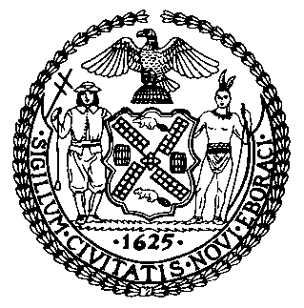 | The Council of the City of New York  Finance Division  Latonia McKinney, Director  Fiscal Impact Statement  Proposed Intro. No: 1520-A  Committee: Finance
Title: A Local Law to amend the administrative code of the city of New York, in relation to requiring the department of finance to report on the parking violations bureau | Sponsor: Council Member Dromm
Summary of Legislation: Proposed Intro. No. 1520-A would require the Department of Finance (Department) to report on the operations of the Parking Violations Bureau, including specific information about the number and types of parking violations and camera violations issued, the Bureau’s efficiency of collection of penalties, the adjudication efficiency and outcomes, and separate information about violations subject to any program of the department that allows for the payment of a reduced fine by waiving a right to a hearing. Such report would be submitted to the Mayor, the Speaker of the Council, and posted on the department’s website on or before September 30 of each year.

Effective Date: This local law would take effect immediately.

Fiscal Year In Which Full Fiscal Impact Anticipated: Fiscal 2023
Fiscal Impact Statement:
 | Effective FY22 | FY Succeeding Effective FY23 | Full Fiscal Impact FY23
Revenues | $0 | $0 | $0
Expenditures | $0 | $0 | $0
Net | $0 | $0 | $0
Impact on Revenues: It is estimated that there would be no impact on revenues resulting from the enactment of this legislation.

Impact on Expenditures: It is estimated that there would be no impact on expenditures resulting from the enactment of this legislation because the department would utilize existing resources to implement the requirements of this legislation.
Source of Funds to Cover Estimated Costs: N/A
Source of Information: New York City Council Finance Division
New York City Department of Finance
Estimate Prepared by: John Basile, Senior Financial Analyst

Estimate Reviewed by: Chima Obichere, Unit Head
Noah Brick, Assistant Counsel
Legislative History: This legislation was first introduced to the Council as Intro. No. 1520 on April 18, 2019 and referred to the Committee on Finance (Committee). A joint hearing was held by the Committee, the Committee on Transportation, and the Committee on Government Operations on April 29, 2019 and the bill was laid over. The legislation was subsequently amended and the amended version, Proposed Intro. No. 1520-A, will be considered by the Committee on December 9, 2021. Upon a successful vote by the Committee, Proposed Intro. No. 1520-A will be submitted to the full Council for a vote on December 9, 2021.
Date Prepared: December 4, 2021

