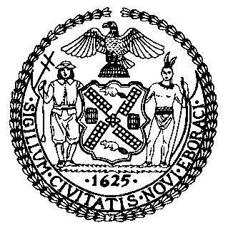 | The Council of the City of New York  Finance Division  Latonia Mckinney, Director  Fiscal Impact Statement  Proposed Intro. No: 936-A  Committee: Consumer Affairs and Business Licensing
Title: A Local Law to amend the administrative code of the city of New York, in relation to restricting single-use plastic beverage straws, beverage stirrers and beverage splash sticks, and to repeal chapter 4 of title 16 of such code, relating to rechargeable batteries | Sponsor(s): Council Members Rosenthal, Grodenchik, Levine, Lander, Moya, Ayala, Ampry-Samuel, Rivera, Chin, Powers, Van Bramer, Koslowitz, Gibson, Brannan, Adams, Reynoso, Gjonaj, Kallos, Dromm, Salamanca, Cabrera, Rodriguez, Holden, Vallone, Perkins, Treyger, Cornegy, Eugene, Barron, Maisel, Rose, Menchaca, Koo, Cumbo and Louis.
Summary of Legislation: Proposed Intro. No. 936-A would restrict food service establishments – such as restaurants, cafes, delis, bars, grocery stores and food trucks – from providing single-use plastic straws, stirrers and splash sticks to customers. Providing single-use plastic stirrers and splash sticks of any kind would be prohibited. Providing non-compostable, single-use plastic straws would be prohibited except upon request. For customers who request a non-compostable plastic straw, food service establishments would be required to provide one free of charge, without inquiring about the reason for the request.

Effective Date: This local law would take effect on November 1, 2021, except that the Commissioner of Sanitation, the Commissioner of Consumer and Worker Protection and the Commissioner of Health and Mental Hygiene could take such measures as are necessary for the implementation of this local law, including the promulgation of rules, prior to such date.
Fiscal Year In Which Full Fiscal Impact Anticipated: Fiscal 2022
Fiscal Impact Statement:

 | Effective FY22 | FY Succeeding  Effective FY23 | Full Fiscal  Impact FY22
Revenues | $0 | $0 | $0
Expenditures | $220,000 | $0 | $0
Net | ($220,000) | $0 | $0

Impact on Revenues: It is estimated that this bill would have no impact on revenues.

Impact on Expenditures: It is estimated that the implementation of the legislation would require additional resources of $220,000 for the Department of Sanitation to conduct outreach and education as required. Relevant agencies would use existing resources to comply with the enforcement component of this bill.

Source of Funds To Cover Estimated Costs: General Fund

Source of Information: Mayor’s Office of Legislative Affairs

Estimate Prepared by: Florentine Kabore, Financial Analyst

Estimate Reviewed by: Nathaniel Toth, Deputy Director
John Russell, Unit Head
Noah Brick, Assistant Counsel
Legislative History: This legislation was introduced by the Council on May 23, 2018 as Int. No. 936 and was referred to the Committee on Consumer Affairs and Business Licensing (Committee). The Committee heard the legislation on June 21, 2018, and the legislation was laid over. The legislation was subsequently amended, and the amended version, Proposed Int. No. 936-A, will be considered by the Committee on May 12, 2021. Upon a successful vote by the Committee, Proposed Int. No. 936-A will be submitted to the full Council for a vote on May 12, 2021.
Date Prepared: May 7, 2021

