Committee Staff
Balqees Mihirig, Senior Counsel
Leah Skrzypiec, Policy Analyst
Nevin Singh, Finance Analyst

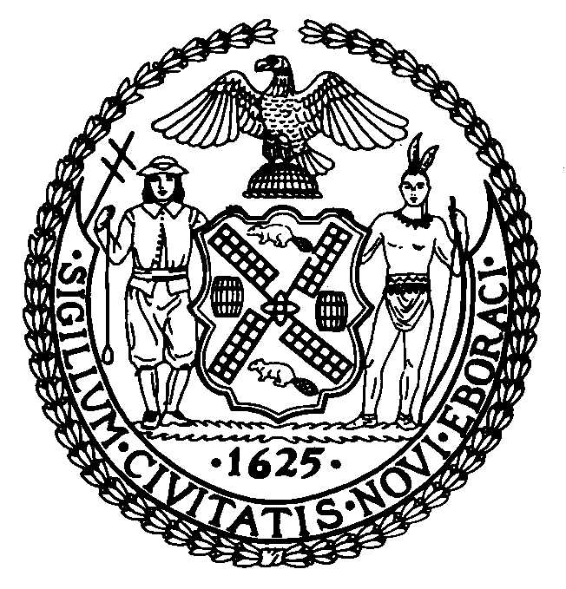

THE COUNCIL OF THE CITY OF NEW YORK

COMMITTEE REPORT OF THE

GOVERNMENTAL AFFAIRS DIVISION
Jeffrey Baker, Legislative Director
Rachel Cordero, Deputy Director, Governmental Affairs Division

COMMITTEE ON CIVIL AND HUMAN RIGHTS

Hon. Mathieu Eugene, Chair

January 23, 2020

RESOLUTION. NO._1225: By Council Members Deutsch and Kallos, and the Public Advocate (Mr. Williams)

TITLE: A Resolution recognizing January 27, 2020 as Holocaust Remembrance Day and the week beginning on January 27, 2020 as a citywide week of Holocaust Education in New York City

- INTRODUCTION

On January 22, 2020, the Committee on Civil and Human Rights, chaired by Council Member Mathieu Eugene, held a vote on Resolution Number 1225 (Res. 1225), recognizing January 27, 2020 as Holocaust Remembrance Day and the week beginning on January 27, 2020 as a citywide week of Holocaust Education in New York City. The Committee passed Res. 1225 by a vote of four in the affirmative, zero in the negative, with zero abstentions.

- BACKGROUND
On November 1, 2005, the United Nations General Assembly adopted a resolution to designate January 27 as International Day of Commemoration in memory of the victims of the Holocaust. This date represents the day that Auschwitz-Birkenau, one of the largest of the 40 concentration camps that comprised the Auschwitz complex, was finally liberated. By assigning an international day of remembrance, the United Nations aims to reaffirm “that the Holocaust, which resulted in the murder of one third of the Jewish people, along with countless members of other minorities, will forever be a warning to all people of the dangers of hatred, bigotry, racism and prejudice.”
The genocide of six million Jewish people and the killing crusade that resulted in the deaths of thousands of homosexuals and Jehovah’s Witnesses, hundreds of thousands of people with disabilities, Gypsy (Roma) heritage, and Serbian civilians, and millions of non-Jewish Polish and Soviet civilians and prisoners of war, at the hands of Nazi soldiers remains one of the most inhumane periods of modern history. Although there were millions of victims of Nazism who were not Jewish, anti-Semitism formed the basis of Nazi ideology that climaxed with the Holocaust. This brutal killing spree was referred to as the “Final Solution of the Jewish Question in Europe’ and its objective was total Jewish ethnic cleansing.
In spite of clear evidence of Nazi forced labor camps, prisons and death camps, of which there were nearly 40,000 across Germany and its occupied territories, there are still people who are ignorant of or willfully deny the facts of the Holocaust. For example, a recent survey conducted by the Conference on Jewish Material Claims Against Germany found that many Americans (41%) were unaware of the Auschwitz death camps. The survey also found that 41% of millennials believed that the Holocaust resulted in the deaths of less than two million Jews (the figure is actually more than six million), and 22% of millennials surveyed reported they had not even heard of the Holocaust.
These findings are shocking considering the enormous devastation caused by the Holocaust. However, more shocking are those that choose to deny or downplay the genocide. According to the Southern Poverty Law Center, Holocaust deniers, who sometimes refer to themselves as “historical revisionists,” deny the effects of the Holocaust in a number of ways. Some deny the existence of death camps and gas chambers, while others say the casualties were caused by disease, poverty or general war, rather than a targeted, anti-Semitic, Nazi assault. These groups rely on anti-Semitic stereotypes and hatred to “build on the claim that the Holocaust was invented or exaggerated by Jews as part of a plot to advance Jewish interests,” and such views mirror the “hateful charges that were instrumental in laying the groundwork for the Holocaust.”
In addition to the lack of awareness or deliberate denial of the Holocaust, America has seen an increase in anti-Semitic rhetoric and hate crimes in recent years. According to FBI data, there was a 17% increase of total hate crimes between 2016 and 2017, and incidents that specifically targeted Jewish people and institutions increased by 37%. These statistics also showed that more than half (58.1%) of the religious-based hate crimes were anti-Semitic. Similar trends were reported by the Anti-Defamation League (ADL). According to their data, there were nearly 2,000 cases of anti-Semitic harassment, vandalism, and physical assault in 2017, the highest number of incidents since 1994.
Anti-Semitic incidents have also dramatically increased across New York since the 2016 Presidential election. In 2017, anti-Semitic incidents in New York City increased by 90% compared to 2016, according to the ADL. In 2019, meanwhile, there were 234 anti-Semitic crimes, which is a 26 percent increase from 2018, according to data from NYPD. Increases have also been recorded at the New York State level, which saw a 90 percent increase in 2017, compared to 2016. During the 2018 midterm elections, ADL also reported that anti-Semitic harassment increased on social media and that two-thirds of this was driven by people, not bots.
Given the current climate of anti-Semitic activity, the lack of evidence-based knowledge regarding the facts of the Holocaust and its eternal relevance to the dangers of hate-driven ideology, now is a timely moment for the City of New York to officially recognize Holocaust Remembrance Day. Furthermore, dedicating a week to Holocaust education will help dispel some of the myths and denials about the Holocaust, which is in line with the United Nations resolution to use education “in order to help to prevent future acts of genocide.”

- RESOLUTION ANALYSIS
If passed, this resolution would recognize January 27, 2020 as Holocaust Remembrance Day. The resolution will also create a city-wide week of Holocaust education that would begin on January 27, 2020.
Res. No.

Resolution recognizing January 27, 2020 as Holocaust Remembrance Day and the week beginning on January 27, 2020 as a citywide week of Holocaust Education in New York City

By Council Members Deutsch and Kallos and the Public Advocate (Mr. Williams)
Whereas, The Holocaust was the systematic, bureaucratic, and state-sponsored persecution and murder of six million Jews by the Nazi regime and its collaborators; and
Whereas, In addition to wiping out a third of the global Jewish population, the Nazi regime also undertook the targeted murder of minority groups, opposition forces and specific ethnic populations; and,
Whereas, In total this killing resulted in the deaths of millions and included: homosexuals, people with disabilities, Jehovah’s Witnesses, resistance and opposition members, academics, and Gypsy (Roma), Serbian, non-Jewish Polish and Soviet civilians; and,
Whereas, While all of these groups were deliberately targeted by the Nazi eugenics program or for their political opposition, the Holocaust, which occurred from 1933 to 1945, was due to the intense anti-Semitism and hatred toward the Jewish people that were living in Nazi Germany; and
Whereas, In efforts to exterminate the Jewish population, the Nazi regime established concentration camps, such as Aushwitz-Birkenau and Majdanek, of which Jewish men, women and children, as well as opponents to the Nazis, were herded into, to experience terrible living conditions, inhumane medical experimentation, torture and mass killings; and
Whereas, Due to the atrocities committed by the Nazi regime during the Holocaust, there is no way in which the Jewish people and world can ever fully recover, however, in efforts to partially rectify the past, every possible positive effort should be made to ensure that all those who suffered as a result of the Holocaust be remembered and future generations learn from the past to prevent a similar event from ever occurring again; and
Whereas, In efforts to ensure this, dedicating January 27, 2020 as Holocaust Remembrance Day and the week beginning on January 27, 2020 as a citywide week of Holocaust Education in New York City would: commemorate the six million Jewish people who died during the Holocaust, effectively teach City residents about the past, encourage empathy towards others and ultimately improve the City’s future; and
Whereas, Recognizing January 27, 2020 as Holocaust Remembrance Day in New York City would also show international solidarity and encourage the preservation of humanity worldwide, as International Holocaust Remembrance Day occurs on the same day; and
Whereas, In addition, a citywide week of Holocaust Education beginning on January 27, 2020 throughout New York City’s schools would foster empathy between City residents, beginning with the children themselves, through the learning of this important historical event and the impacts it has had on the present-day world; and
Whereas, As there are about 40,000 Holocaust survivors living in New York City and Long Island, according to Selfhelp Community Services Inc., a nonprofit that cares for older adults through a specific Holocaust Survivor program, it is important to those survivors that the history Holocaust, specifically those who died as a result of this event, is remembered and taught within New York City; and
Whereas, Recognizing January 27, 2020 as Holocaust Remembrance Day and the week beginning January 27, 2020 as a citywide week of Holocaust Education in new York City would help make the city a better place by valuing humanity above all else, remembering those who have died and survived in the Holocaust and preventing similar event from ever happening again; now therefore, be it
Resolved, That the Council of the City of New York recognizes January 27, 2020 as Holocaust Remembrance Day and the week beginning on January 27, 2020 as a citywide week of Holocaust Education in New York City

KK
LS #13408
1/6/20

United Nations General Assembly, A/RES/60/7, 21 November, 2005, available at: http://www.un.org/en/ga/search/view_doc.asp?symbol=A/RES/60/7.
Memorial and Museum Auschwitz-Birkenau “Auschwitz II-Birkenau”, available at: http://auschwitz.org/en/history/auschwitz-ii/.
United States Holocaust Memorial Museum “International Holocaust Remembrance Day”, available at: https://www.ushmm.org/information/exhibitions/online-exhibitions/special-focus/international-holocaust-remembrance-day.
United Nations General Assembly, A/RES/60/7, 21 November, 2005, available at: http://www.un.org/en/ga/search/view_doc.asp?symbol=A/RES/60/7.
Jewish Virtual Library “Documenting numbers of victims of the Holocaust and Nazi persecution”, available at: https://www.jewishvirtuallibrary.org/documenting-numbers-of-victims-of-the-holocaust; and “The Holocaust: Facts and figures”, Haaretz, July 24, 2013, available at: https://www.haaretz.com/jewish/holocaust-remembrance-day/.premium-the-holocaust-facts-and-figures-1.5298803.
Dr. Steve Paulsson “A view of the Holocaust”, BBC, February 17, 2011, available at: http://www.bbc.co.uk/history/worldwars/genocide/holocaust_overview_01.shtml.
“The Holocaust: Facts and figures”, Haaretz, July 24, 2013, available at: https://www.haaretz.com/jewish/holocaust-remembrance-day/.premium-the-holocaust-facts-and-figures-1.5298803.
Scott Simon “The startling statistics about people’s Holocaust knowledge”, NPR, April 14, 2018, available at: https://www.npr.org/2018/04/14/602443782/the-startling-statistics-about-peoples-holocaust-knowledge.
Southern Poverty Law Center “Holocaust denial”, available at: https://www.splcenter.org/fighting-hate/extremist-files/ideology/holocaust-denial.
United States Holocaust Memorial Museum “Holocaust denial and distortion”, available at: https://www.ushmm.org/confront-antisemitism/holocaust-denial-and-distortion.
Erin Donaghue “New FBI data shows rise in anti-Semitic hate crimes”, CBS News, November 13, 2018, available at: https://www.cbsnews.com/news/fbi-hate-crimes-up-new-data-shows-rise-in-anti-semitic-hate-crimes/.
Oliver Holmes “Antisemitic incidents in US soar to highest levels in two decades”, The Guardian, February 27, 2018, available at: https://www.theguardian.com/society/2018/feb/27/antisemitism-us-rises-anti-defamation-league.
Anti-Defamation League, “Anti-Semitic incidents surged in New York State in 2017, according to new ADL report”, February 26, 2018, available at: https://nynj.adl.org/news/anti-semitic-incidents-surged-in-new-york-state-in-2017-according-to-new-adl-report/.
Craig McCarthy and Tina Moore “Anti-Semitic hate crimes spiked by more than 25 percent in 2019”, New York Post, January 6, 2020, available at: https://nypost.com/2020/01/06/anti-semitic-hate-crimes-spiked-by-more-than-25-percent-in-2019/.
Anti-Defamation League, “Anti-Semitic incidents surged in New York State in 2017, according to new ADL report”, February 26, 2018, available at: https://nynj.adl.org/news/anti-semitic-incidents-surged-in-new-york-state-in-2017-according-to-new-adl-report/.
Erin Donaghue “New FBI data shows rise in anti-Semitic hate crimes”, CBS News, November 13, 2018, available at: https://www.cbsnews.com/news/fbi-hate-crimes-up-new-data-shows-rise-in-anti-semitic-hate-crimes/.
United Nations General Assembly, A/RES/60/7, 21 November, 2005, available at: http://www.un.org/en/ga/search/view_doc.asp?symbol=A/RES/60/7.

