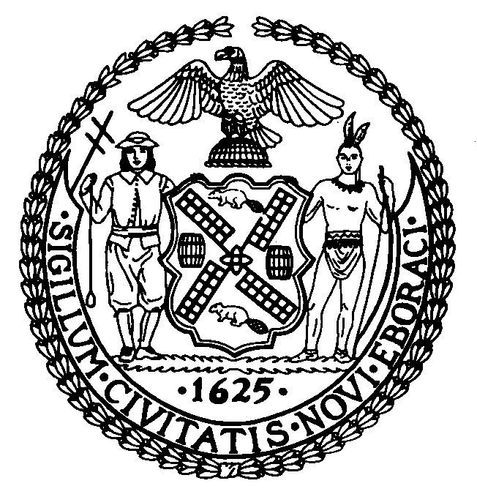

THE COUNCIL
THE CITY OF NEW YORK
FINANCE DIVISION
250 BROADWAY, 15TH FLOOR
NEW YORK, N.Y. 10007-2594
(212) 788-6921

TO: Honorable Corey Johnson
Speaker

Honorable Daniel Dromm
Chair, Finance Committee

FROM: Latonia McKinney, Director, Finance Division
Raymond Majewski, Deputy Director/Chief Economist, Finance Division
Rebecca Chasan, Senior Counsel
Nashia Roman, Economist

DATE: February 25, 2021

SUBJECT: A Budget Modification (MN-4) for Fiscal 2021 that will appropriate $1.89 billion in new revenues.
------------------------------------------------------------------------------------------------------------

INITIATION: By letter dated February 12, 2021, the Director of the Office of Management and Budget submitted to the Council, pursuant to section 107(e) of the New York City Charter, a request to appropriate $1.89 billion in new revenues. These new revenues, combined with additional resources of $421 million of Prior Year Payables, and a $418 million adjustment to the General Reserve, plus other resources, will be used for prepayments of $2.73 billion to increase the Budget Stabilization Account.

BACKGROUND: This modification (MN-4) seeks to recognize $1.89 billion in new revenues, and combines $421 million of Prior Year Payables, $418 million from the General Reserve, and other resources, implementing changes reflected in the January 2021 Financial Plan. Of these funds, the total amount of $2.73 billion is added to the Budget Stabilization Account, which will prepay debt service for Fiscal 2022.

FISCAL IMPACT: This modification represents a net increase in the Fiscal 2021 budget of $1.89 billion.

