Committee Staff
James DiGiovanni, Counsel
Elliott Lynn, Counsel
Kris Sartori, Legislative Attorney
Agatha Mavropoulos, Legislative Analyst
Emily Rooney, Policy Analyst
Rick Arbelo, Policy Analyst
Chima Obichere, Finance Unit Head
John Basile, Finance Analyst

THE COUNCIL OF THE CITY OF NEW YORK

COMMITTEE REPORTOF THE INFRASTURCTURE DIVISION
Jeffrey Baker, Legislative Director

COMMITTEE ON TRANSPORTATON

Hon. Ydanis Rodriguez, Chair

May 28, 2019

PROPOSED INT. NO. 322-A: By Council Members Rodriguez, Constantinides, The Speaker (Council Member Johnson), Cornegy, Levine, Rivera, Powers, Rose, Ayala, Koo, the Public Advocate (Mr. Williams), Dromm, Cabrera, Torres, Richards, Lancman, Van Bramer, Kallos, Cohen, Reynoso, Vallone, Rosenthal, Moya, Koslowitz, Deutsch, Treyger, Perkins, Espinal, Lander, Ampry-Samuel, Eugene, Adams, Levin, Chin, Menchaca, Gjonaj, King, Grodenchik, Maisel, Barron, Cumbo, Salamanca, Brannan and Ulrich
TITLE: A Local Law to amend the administrative code of the city of New York, in relation to a street design checklist
ADMINISTRATIVE CODE: Amends Subchapter 3 of Chapter 1 of Title 19 by adding a new §19-182.2

PROPOSED INT. NO. 1163-A: By Council Members Rivera, Lander, Rosenthal, Adams, Reynoso, Levin, Menchaca, Kallos, Ayala, Powers, Van Bramer, Richards, Levine and Chin

TITLE: A Local Law to amend the administrative code of the city of New York, in relation to temporary bicycle lanes

ADMINISTRATIVE CODE: Amends Subchapter 1 of Chapter 1 of Title 19 by adding new §19-159.3

INTRODUCTION
On May 28, 2019, the Committee on Transportation chaired by Council Member Ydanis Rodriguez will hold a hearing on Proposed Int. No. 322-A, a Local Law to amend the administrative code of the city of New York, in relation to a street design checklist, and Proposed Int. No. 1163-A, a Local Law to amend the administrative code of the city of New York, in relation to temporary bicycle lanes. This is the second hearing that the committee has held on both items. The first hearing on Int. No. 322 was held on August 15, 2018, and the first hearing on Int. No. 1163 was held on January 23, 2019. At both hearings the committee heard testimony from the Department of Transportation (DOT) and various other stakeholders.

BACKGROUND
Street Design
Traditionally, streets were designed with the primary goal of creating efficiency for vehicles. However, there are a variety of street design elements that New York City incorporates into the arrangement of our streets that safeguard pedestrians and cyclists.
ADA Accessibility
Utilizing sidewalks that are ADA accessible provides safer streets for pedestrians with disabilities. Some examples include:
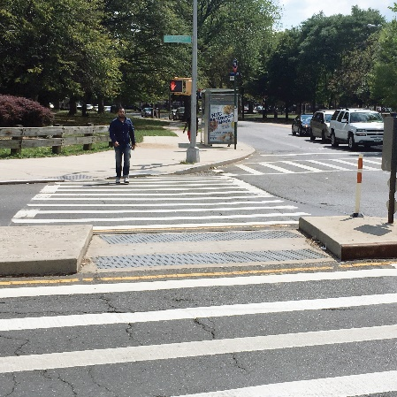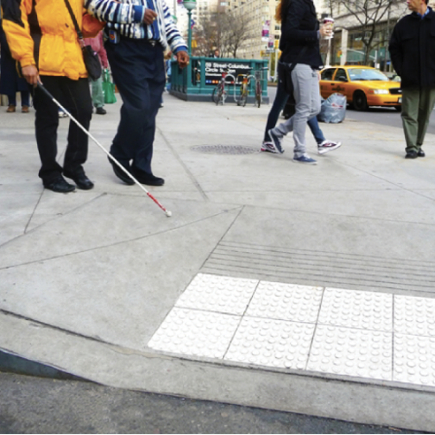
ADA accessible crosswalk on Claremont ADA accessible crosswalk in Columbus
Parkway & Crotona Avenue, Bronx Circle, Manhattan

Public Amenities
Public amenities such as wayfinding, benches, bus stops and shelters, make the streets more pedestrian-friendly and help promote public transportation over single-occupancy vehicles. Greenery and bioswales help manage flooding by absorbing rainwater that the City’s sewer system cannot handle. Some examples of public amenities include:
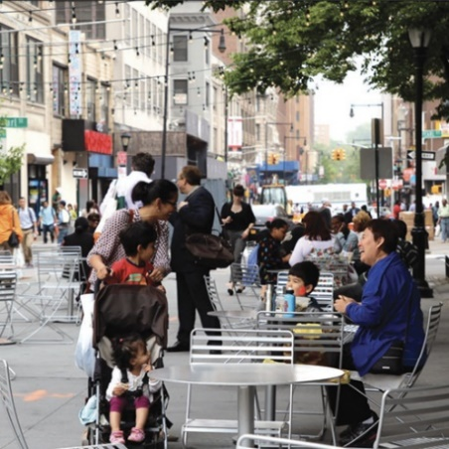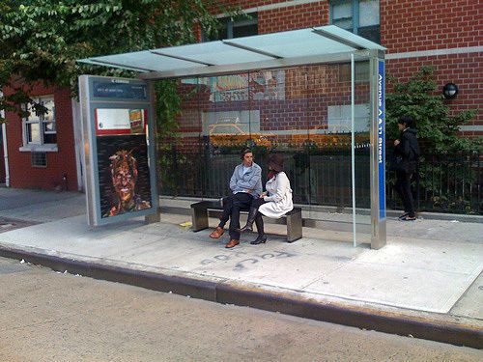
Willoughby Pedestrian Plaza, Brooklyn Bus shelter at Avenue A & 11th Street, Manhattan

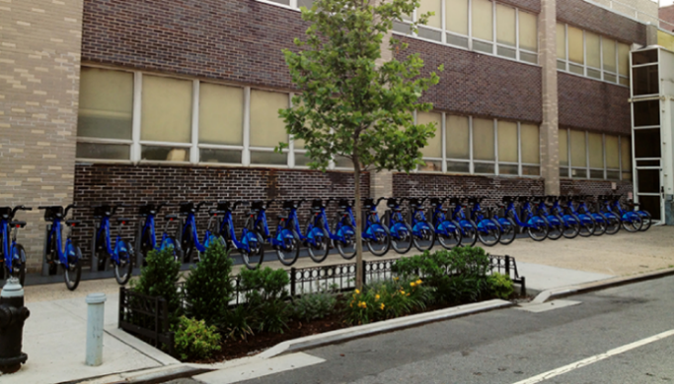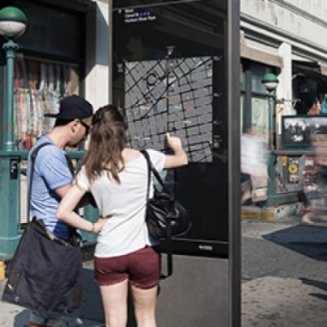
Bioswale on Dean Street, Brooklyn Wayfinding on Canal Street, Manhattan

Protected Bicycle Lanes
Protected bicycle lanes are paths for cyclists that are separated from the roadway by an open space or physical barrier. Some physical barriers include a line of parked cars or a line of poles. Examples include:
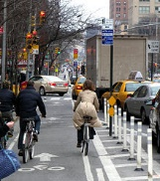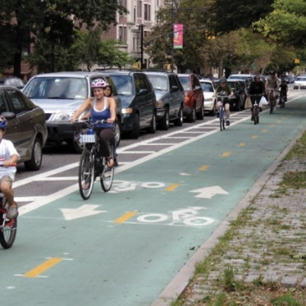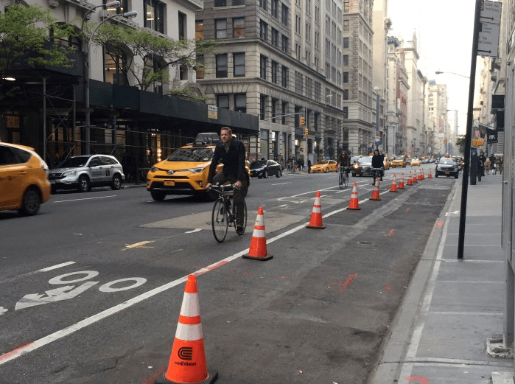
Pole barriers in Chelsea, Parked cars as barrier on Prospect Unprotected bicycle lane on Fifth Avenue,
Manhattan Park West, Brooklyn Manhattan

Dedicated Mass Transit Facilities
Dedicated mass transit facilities prioritize mass transit and encourage the public to use more efficient transit options than single-occupancy vehicles. Dedicated bus lanes are lanes in which only buses are permitted to drive during certain specified hours of the day. This helps buses move more efficiently through traffic. Bus bulbs are widened sidewalks to meet an offset bus lane. Bus bulbs allow buses to travel straight into and out of the bus stop without pulling over. These stops also have a high curb wherever possible making it easier and faster for all passengers to get on and off the bus. Example of a bus bulb:
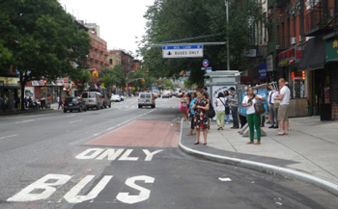
Bus bulb in New York City

Dedicated Unloading Zones
Dedicated unloading zones reduce double-parking. Double-parking reduces visibility and stalls traffic.

Narrow Vehicle Lanes
Narrowing the width of each traffic lane to 10 feet causes vehicles to slow down. Here is an example of narrowed vehicle lanes on Columbus Avenue in Manhattan:
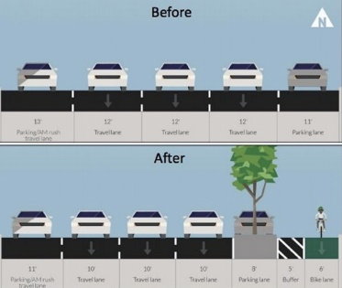

Pedestrian Safety Islands
A pedestrian safety island is a raised area located at a crosswalk that serves as pedestrian refuge separating traffic lanes or directions. These devices allow pedestrians to safely wait for the light to change before proceeding to cross the street. Here are some examples of pedestrian safety islands:
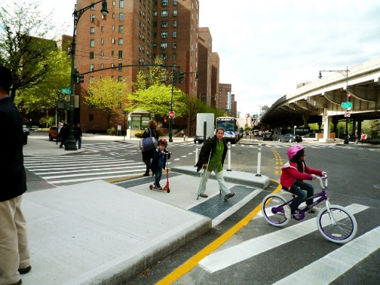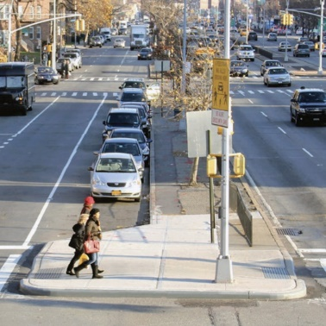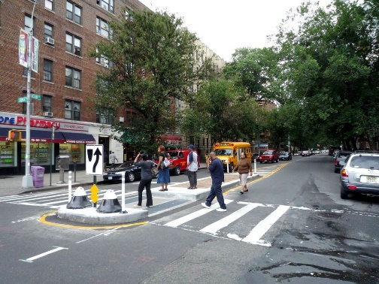
Avenue C and 18th Street, Manhattan Queens Boulevard, Queens Ocean Avenue and Church Street, Brooklyn

Signal-Protected Pedestrian Crossing
A signal-protected pedestrian crossing gives pedestrians the ability to cross the street when no vehicles have the right of way. This allows pedestrians to safely cross, as well as reduce vehicles attempting fast turns before pedestrians enter the cross walk. Some examples include:
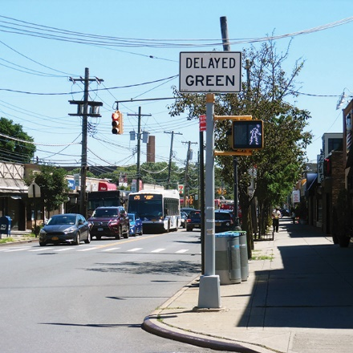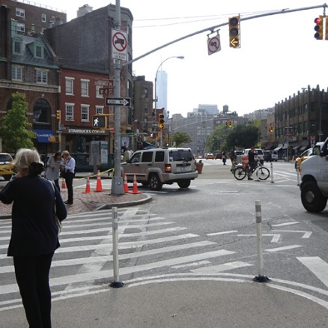
New Dorp Lane and Clawson Street, Staten Island West 4th Street and 7th Avenue, Manhattan

Signal Retiming
Signal retiming is the coordination of traffic signals to ensure that vehicles are not driving above the speed limit, as well as aid in reducing traffic congestion.

Wide Sidewalk
Wide sidewalks are sidewalks that are at least eight feet wide. Wide sidewalks promote walking and reduce speeding by narrowing traffic lanes. Some examples of wide sidewalks include:
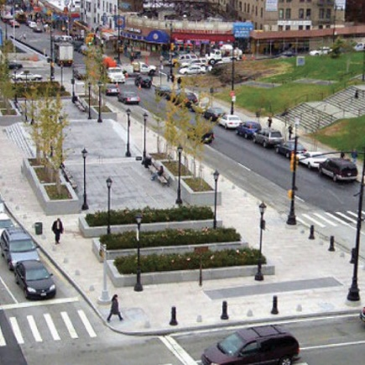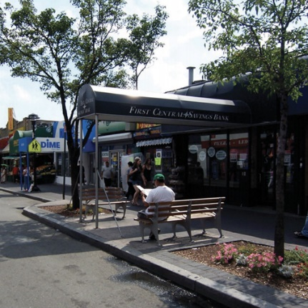
Lou Gehrig Plaza, Bronx 46th Street, Queens

Proposed Int. No. 322-A would require DOT to develop a standard checklist of safety-enhancing street design elements that the department must consider for all major transportation projects and to post such standard checklist on its website.

Bike Infrastructure and Bike Safety
The popularity of cycling has increased in New York City. From 2006 to 2015, annual bicycle trips rose from 66 million trips to 164 million trips, an increase of approximately 150%. The most recent available data shows that about 825,000 New Yorkers regularly ride a bike several times a month, with 86,000 adults commuting to either work or school. Contributing to the rise in cycling has been the introduction of bike sharing programs like Citi Bike. Launched in May 2013, Citi Bike was a joint venture between DOT and Motivate International (now Lyft). As of December 2018, Citi Bike had more than 147,000 annual memberships and their users logged more than 41,000 trips per day totaling 1.8 million traveled miles.
Over the last several years, the city has made efforts to accommodate the growth in cycling by increasing bicycle safety. Currently, there are more than 1,200 miles of bike lanes in the city, the most of any major city in the nation. Since 2013 alone, the city has added 330 bicycle miles including 68 miles of protected bike lanes. Protected bicycle lanes are paths for cyclists that are separated from the roadway by an open space or physical barrier. Some physical barriers include a line of parked cars or a line of poles. Currently, there are 119.5 miles of protected bike lanes and the city’s goal is to continue to add at least ten miles of protected lanes each year.
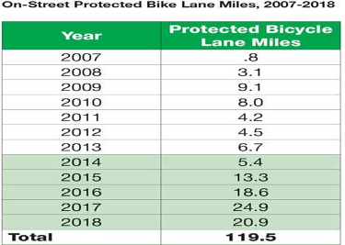
Source: Office of the Mayor

It appears as though the city’s effort to increase safety for cyclists has been effective. In 2017, there were 4,397 cyclists injured with 24 of those injuries resulting in death. The latest initial figures released by DOT indicate that there were only 10 cyclist deaths in 2018, a record low that bested the previous low of 12 cyclist deaths, achieved in 2009 and 2013. However, if the city wants to maintain these low numbers, additional steps must be taken to ensure that both cyclists and pedestrians are kept safe. It is important to note that the Center for Disease Control reported that in 2015 more than 33,000 people in the United States died from motor vehicle crashes.
Proposed Int. No. 1163-A would require temporary bikes lanes to be available regardless of any street work taking place.

ANALYSIS OF PROPOSED INT. NO. 322-A

Proposed Int. No. 322-A would amend subchapter 3 of chapter 1 of title 19 of the Administrative Code by adding a new section 19-182.2. Subdivision a of the new section defines several terms used in the bill. “ADA accessibility” is defined as compliance with part 36 of title 28 of the code of federal regulations implementing the Americans with disabilities act of 1990. “Daylighting” is defined to mean street design elements for enhancing visibility of cross traffic and pedestrians for motorists approaching an intersection. “Major transportation project” is defined as having the same meaning as in section 19-101.2 of the Administrative Code, which defines the term as any project that after construction will alter four or more consecutive blocks, or 1,000 consecutive feet of street, whichever is less, involving a major realignment of the roadway, including either removal of a vehicular lane or full time removal of a parking lane or the addition of a vehicular travel lane. “Narrow vehicle lane” is defined as a vehicular lane that is not greater than 10 feet wide. “Pedestrian safety island” is defined as an area located at a crosswalk that serves as a pedestrian refuge separating traffic lanes or directions, particularly on wide roadways. And, it also defines “wide sidewalk” as a sidewalk that is at least eight feet wide.
Subdivision b of section 19-182.2 would require that the Department of Transportation (“DOT”) develop a standard checklist of safety-enhancing design elements for all major transportation projects. The checklist would be required to include as elements: ADA accessibility, protected bicycle lanes, dedicated mass transit facilities such as bus lanes and bus bulbs, dedicated vehicle loading and unloading zones, narrow vehicle lanes, pedestrian safety islands, signal-protected pedestrian crossings, signal retiming, wide sidewalks and daylighting. Subdivision b would also allow DOT to amend the checklist by rule to promote vehicular, pedestrian and bicycle safety.
Subdivision c of section 19-182.2 would require that DOT post the standard checklist on its website. Subdivision c would also require that for each major transportation project to be implemented after November 1, 2019, DOT must post a completed checklist on its website, including an explanation if any elements from the checklist were not included as part of the project’s street design.
Subdivision d would require other agencies that implement major transportation projects to consider, in consultation with DOT, whether design elements such as those listed on the checklist should be included in any project.
Proposed Int. 322-A would take effect immediately.

ANALYSIS OF PROPOSED INT. NO. 1163-A
Proposed Int. 1163-A would amend subchapter 1 of chapter 1 of title 19 of the Administrative Code to add a new section 19-159.3. Subdivision a of section 19-159.3 would define “bicycle lane” to mean a portion of the roadway that has been marked off or separated for the preferential or exclusive use of bicycles, and “temporary bicycle lane” to mean a bicycle lane intended to be used for a limited period of time during which construction or other work prevents or otherwise affects use of a bicycle lane on a roadway, street segment or intersection.
Subdivision b of section 19-159.3 would require that any permit issued by the Department of Transportation for work affecting a street segment or intersection with a bicycle lane include a stipulation that the permit holder maintain a temporary bicycle lane, and specify the specific manner in which the lane is to be maintained. Subdivision b would allow the commissioner to make a determination that a temporary bicycle lane is not feasible on a street segment or intersection, and would require that any such permit issued upon this determination stipulate other measures the permit holder must take to protect the safety of persons riding bicycles.
Subdivision c of section 19-159.3 would require that the Department of Transportation provide electronic notice to the affected Council Member, Community Board and Borough President upon the approval of any permit authorizing work affecting a street segment or intersection with a bicycle lane.
Subdivision d would provide that the commissioner of the Department of Transportation may revoke or refuse to renew a permit in the event of a violation of any stipulation required by subdivision b of this section.
Proposed Int. 1163-A would take effect immediately.
Proposed Int. No. 322-A

By Council Members Rodriguez, Constantinides, The Speaker (Council Member Johnson), Cornegy, Levine, Rivera, Powers, Rose, Ayala, Koo, the Public Advocate (Mr. Williams), Dromm, Cabrera, Torres, Richards, Lancman, Van Bramer, Kallos, Cohen, Reynoso, Vallone, Rosenthal, Moya, Koslowitz, Deutsch, Treyger, Perkins, Espinal, Lander, Ampry-Samuel, Eugene, Adams, Levin, Chin, Menchaca, Gjonaj, King, Grodenchik, Maisel, Barron, Cumbo, Salamanca, Brannan and Ulrich

A Local Law to amend the administrative code of the city of New York, in relation to a street design checklist

Be it enacted by the Council as follows:

Section 1. Subchapter 3 of chapter 1 of title 19 of the administrative code of the city of New York is amended by adding a new section 19-182.2 to read as follows:
§ 19-182.2 Street design checklist. a. As used in this section, the following terms have the following meanings:
ADA accessibility. The term “ADA accessibility” means compliance with part 36 of title 28 of the code of federal regulations implementing the Americans with disabilities act of 1990.
Daylighting. The term “daylighting” means street design elements for enhancing visibility of cross traffic and pedestrians for motorists approaching an intersection.
Major transportation project. The term “major transportation project” has the same meaning as such term is defined in section 19-101.2.
Narrow vehicle lane. The term “narrow vehicle lane” means a vehicular lane that is not greater than 10 feet wide.
Pedestrian safety island. The term “pedestrian safety island” means an area located at a crosswalk that serves as pedestrian refuge separating traffic lanes or directions, particularly on wide roadways.
Protected bicycle lane. The term “protected bicycle lane” means a portion of a street or intersection intended for the preferential or exclusive use of bicycles separated from motorized vehicle traffic by vertical delineation or physical barriers in accordance with department design standards.
Wide sidewalk. The term “wide sidewalk” means a sidewalk that is at least eight feet wide.
b. Notwithstanding any inconsistent provision of law or rule, the department shall develop a standard checklist of safety-enhancing street design elements for all major transportation projects. Such checklist shall include but need not be limited to the following elements: (i) ADA accessibility; (ii) protected bicycle lanes; (iii) dedicated mass transit facilities such as bus lanes and bus bulbs; (iv) dedicated vehicle loading and unloading zones; (v) narrow vehicle lanes; (vi) pedestrian safety islands; (vii) signal-protected pedestrian crossings; (viii) signal retiming; (ix) wide sidewalks; and (x) daylighting. The department may amend the standard checklist by rule to promote vehicular, pedestrian, and bicycle safety.
c. The department shall post the standard checklist required by subdivision b of this section on its website. For each major transportation project to be implemented on or after November 1, 2019, the department shall post on its website, prior to implementation, a checklist for such project and, if any element on such checklist has not been included in the project, an explanation why such element was not applicable or otherwise not included.
d. If an agency other than the department implements a major transportation project, such agency shall consider, in consultation with the department, if safety-enhancing street design elements, including those on the checklist, should be included in such project.
§ 2. This local law takes effect immediately.
FM/ACK/JJD/EL
LS #3127
5/21/2019 8:00pm

Proposed Int. No. 1163-A

By Council Members Rivera, Lander, Rosenthal, Adams, Reynoso, Levin, Menchaca, Kallos, Ayala, Powers, Van Bramer, Richards, Levine and Chin

A Local Law to amend the administrative code of the city of New York, in relation to temporary bicycle lanes

Be it enacted by the Council as follows:

Section 1. Subchapter 1 of chapter 1 of title 19 of the administrative code of the city of New York is amended by adding a new section 19-159.3 to read as follows:
§ 19-159.3 Temporary bicycle lanes. a. Definitions. As used in this section, the following terms have the following meanings:
Bicycle lane. The term “bicycle lane” means a portion of the roadway that has been marked off or separated for the preferential or exclusive use of bicycles.
Temporary bicycle lane. The term “temporary bicycle lane” means a bicycle lane intended to be used for a limited period of time during which construction or other work prevents or otherwise affects use of a bicycle lane on a roadway, street segment or intersection.
b. Requirements. Any permit issued by the commissioner authorizing work affecting a street segment or intersection that has a bicycle lane shall include a stipulation requiring that the applicant maintain a temporary bicycle lane, and shall specify the particular manner in which the applicant shall maintain the temporary bicycle lane for such street segment or intersection. Notwithstanding the foregoing, in the event the commissioner determines that maintenance of a temporary bicycle lane is not feasible on such street segment or intersection, such determination shall not prohibit issuance of the permit, provided however that the permit shall set forth such other measures the applicant must take to protect public safety, including persons utilizing bicycles on such street segment or intersection.
c. Notice requirement for work affecting a street segment or intersection that has a bicycle lane. Upon approving an application for a permit authorizing work affecting a street segment or intersection that has a bicycle lane, the department shall provide notice, through electronic means, to the affected borough president, the council member of the affected council district and the district manager of the affected community board. Such notice shall include the following information:
1. The name and contact information of the applicant;
2. The anticipated start and end dates of the work;
3. The location, nature and extent of the work to be performed;
4. The permit type;
5. Any permit stipulations related to the maintenance of a temporary bicycle lane; and
6. Contact information for a department office where questions may be directed.
d. In the event a permittee violates any stipulation required by subdivision b of this section, the commissioner may revoke or refuse to renew such permit pursuant to subdivision e of section 19-103 or take any other action authorized by law.
§ 2. This local law takes effect immediately.

NC/JJD/EL
LS 6945, 7642
5/21/19 9:30am

Safer Cycling: Bicycle Ridership and Safety in New York City, 2017, available for download at http://www.nyc.gov/html/dot/downloads/pdf/bike-safety-study-fullreport2017.pdf
Cycling in the City, Cycling Trends in NYC 2018, available for download at http://www.nyc.gov/html/dot/downloads/pdf/cycling-in-the-city.pdf
Press Release, Office the Mayor, Vision Zero: Mayor de Blasio Announces New York City Added Over Twenty Miles of Protected Bicycle Lanes in 2018, December 19, 2018, available at https://www1.nyc.gov/office-of-the-mayor/news/604-18/vision-zero-mayor-de-blasio-new-york-city-added-twenty-miles-protected-bicycle
Cycling in the City, Cycling Trends in NYC 2018, available for download at http://www.nyc.gov/html/dot/downloads/pdf/cycling-in-the-city.pdf
Press Release, Office the Mayor, Vision Zero: Mayor de Blasio Announces New York City Added Over Twenty Miles of Protected Bicycle Lanes in 2018, December 19, 2018, available at https://www1.nyc.gov/office-of-the-mayor/news/604-18/vision-zero-mayor-de-blasio-new-york-city-added-twenty-miles-protected-bicycle
See Safer Cycling: Bicycle Ridership and Safety in New York City, 2017, p.9.
Bicycle Crash Data Report 2017, New York City Department of Transportation, available for download at http://www.nyc.gov/html/dot/downloads/pdf/bicycle-crash-data-report-2017.pdf
Press Release, Office the Mayor, Vision Zero: Mayor de Blasio Announces New York City Added Over Twenty Miles of Protected Bicycle Lanes in 2018.
See Key Injury and Violence Data, Center for Disease Control, available at https://www.cdc.gov/injury/wisqars/overview/key_data.html

