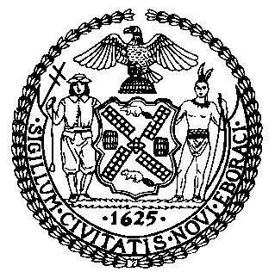 | The Council of the City of New York  Finance Division  Latonia McKinney, Director  Fiscal Impact Statement  Proposed Intro. No.: 672-A  Committee: Education
Title: A Local Law to amend the administrative code of the city of New York, in relation to requiring the department of education to provide information about the department of citywide administrative services civil service examinations to students. | Sponsors: Council Members Treyger, Chin, Miller, Torres, Adams, Rose, Levin, Lander, Ampry-Samuel, Rivera, Kallos, Yeger and Rosenthal
Summary of Legislation: Proposed Intro. 672-A would require the Department of Citywide Administrative Services (DCAS) to provide the Department of Education (DOE) with information about the civil service exams administered by DCAS. Proposed Intro. 672-A would also require DOE to distribute to students graduating from high school information including the title of the exam, application and testing periods, application fees, and a link to the DCAS exam information page.
Effective Date: This local law would take effect 120 days after it becomes law.

Fiscal Year in Which Full Fiscal Impact Anticipated: Fiscal 2020
Fiscal Impact Statement:

 | Effective FY19 | FY Succeeding Effective FY20 | Full Fiscal Impact FY20
Revenues | $0 | $0 | $0
Expenditures | $0 | $0 | $0
Net | $0 | $0 | $0

Impact on Revenues: It is estimated that there would be no impact on revenues resulting from the enactment of this legislation.
Impact on Expenditures: It is anticipated that this legislation would have no impact on expenditures as DCAS and DOE can use existing resources to implement the requirements of the legislation.
Source of Funds to Cover Estimated Costs: N/A
Source of Information: New York City Council Finance Division; New York City Department of Education
Estimate Prepared by: Elizabeth Hoffman, Principal Financial Analyst
Legislative History: This legislation was introduced to the Council on March 7, 2018 as Intro. No. 672 and was referred to the Committee on Education. The legislation was considered by the Committee on Education and the Committee on Youth Services at a joint hearing on June 13, 2018, and the bill was laid over. The legislation was subsequently amended, and the amended version, Proposed Intro. 672-A, will be voted on by the Committee on Education on September 26, 2018. Upon successful vote by the Committee on Education, Proposed Intro. 672-A will be submitted to the full Council for a vote on September 26, 2018.
Date Prepared: September 20, 2018

