THE COUNCIL OF THE CITY OF NEW YORK
RESOLUTION NO. 1505

Resolution approving the decision of the City Planning Commission on Application No. N 200057 ZRK, for an amendment of the text of the Zoning Resolution (Preconsidered L.U. No. 700).

By Council Members Salamanca and Moya

WHEREAS, Bridge Rockaway Housing Development Fund Company, Inc., filed an application pursuant to Section 201 of the New York City Charter, for an amendment of the text of the Zoning Resolution of the City of New York, modifying Article XII Chapter 3 for the purpose of amending restrictions for certain uses in MX-19 and modifying Appendix F for the purpose of establishing a Mandatory Inclusionary Housing area utilizing Option 1, which in conjunction with the related action would facilitate the development of a new seven-story, approximately 183,000-square-foot, mixed-use building with 174 units of supportive and affordable housing and ground floor light manufacturing and community facility space at 803 Rockaway Avenue in the Brownsville neighborhood of Brooklyn, Community District 16 (Application No. N 200057 ZRK) (the “Application”);

WHEREAS, the City Planning Commission filed with the Council on November 10, 2020, its decision dated November 4, 2020 (the “Decision”), on the Application;

WHEREAS, the Application is related to application C 200056 ZMK (Pre. L.U. No. 701), a Zoning map amendment to change an M1-1 zoning district to M1-4/R7A and M1-4/R6A zoning districts and to map Special Mixed Use District (MX-19);

WHEREAS, the Decision is subject to review and action by the Council pursuant to Section 197-d of the City Charter;

WHEREAS, upon due notice, the Council held a public hearing on the Decision and Application on November 18, 2020;

WHEREAS, the Council has considered the land use implications and other policy issues relating to the Decision and Application; and

WHEREAS, the Council has considered the relevant environmental issues, including the negative declaration issued February 3rd, 2020 (CEQR No. 19DCP220K ) which includes an (E) designation to avoid the potential for significant adverse impacts related to hazardous materials and air quality (E-561) (the “Negative Declaration”).

RESOLVED:

The Council finds that the action described herein will have no significant impact on the environment as set forth in the (E) Designation (E-561) and Negative Declaration.

Pursuant to Sections 197-d and 200 of the City Charter and on the basis of the Decision and Application, and based on the environmental determination and consideration described in the report, N 200057 ZRK, incorporated by reference herein, and the record before the Council, the Council approves the Decision of the City Planning Commission.

Matter underlined is new, to be added;
Matter struck out is to be deleted;
Matter within # # is defined in Section 12-10;
* * * indicates where unchanged text appears in the Zoning Resolution

* * *
ARTICLE XII
SPECIAL PURPOSE DISTRICTS

* * *

Chapter 3
Special Mixed Use District

* * *

123-20
SPECIAL USE REGULATIONS

* * *

123-22
Modification of Use Groups 16, 17 and 18

* * *

123-222
Uses permitted with restrictions

* * *
Any #use# from Use Group 16 or 17, listed in this Section, may only locate in a #building enlarged# or #developed# after December 10, 1997, containing a #use# listed in Section 123-21 (Modification of Use Groups 2, 3 and 4), or share a common wall with such #building#,:
(a) upon certification by a licensed architect or engineer to the Department of Buildings that any such #use# listed in Use Group 16 or 17:
(a)(1) does not have a New York City or New York State environmental rating of “A”, “B” or “C” under Section 24-153 of the New York City Administrative Code for any process equipment requiring a New York City Department of Environmental Protection operating certificate or New York State Department of Environmental Conservation state facility permit; and
(b)(2) is not required, under the City Right-to-Know Law, to file a Risk Management Plan for Extremely Hazardous Substances.; or
(b) in MX-19, upon the submission to the Department of Buildings of a copy of a restrictive declaration, in a form acceptable to the Department of Environmental Protection, that has been executed and recorded in the Office of the City Register against all tax lots with such #use#, binding the owners, successors, and assigns to provide any building design requirements consistent with the underlying zoning as may be approved by the Department of Environmental Protection to protect residents of such #building# from air contaminants, odors, vibrations, or noise.
* * *

123-60
SPECIAL BULK REGULATIONS

* * *

123-63
Maximum Floor Area Ratio and Lot Coverage Requirements for Zoning Lots Containing Only Residential Buildings in R6, R7, R8 and R9 Districts

* * *

 | #Special Mixed Use District# |  | Designated #Residence District#
 | MX-1 – Community District 1, The Bronx |  | R6A R7D
 | MX 2 – Community District 2, Brooklyn |  | R7A R8A R8X
 | MX 4 – Community District 3, Brooklyn |  | R6A
 | MX 8 – Community District 1, Brooklyn |  | R6 R6A R6B R7A
 | MX 11 – Community District 6, Brooklyn |  | R7-2
 | MX 13 – Community District 1, The Bronx |  | R6A R7A R7X R8A
 | MX 14 – Community District 6, The Bronx |  | R7A R7X
 | MX 16 – Community Districts 5 and 16, Brooklyn |  | R6A R7A R7D R8A
 | MX-18 – Community District 1, The Bronx |  | R7X
 | MX 19 – Community District 16, Brooklyn |  | R6A R7A
 | MX 20 – Community District 8, Brooklyn |  | R7A

* * *
123-90
SPECIAL MIXED USE DISTRICTS SPECIFIED

The #Special Mixed Use District# is mapped in the following areas:

* * *
#Special Mixed Use District# - 18: (10/17/19)
Mott Haven, The Bronx
The #Special Mixed Use District# - 18 is established in Mott Haven in The Bronx as indicated on the #zoning maps#.

#Special Mixed Use District# - 19: [date of adoption]
Brownsville, Brooklyn
The #Special Mixed Use District# - 19 is established in Brownsville in Brooklyn as indicated on the #zoning maps#.
#Special Mixed Use District# - 20: (5/8/19)
Crown Heights West, Brooklyn
The #Special Mixed Use District# - 20 is established in Crown Heights West in Brooklyn as indicated on the #zoning maps#.
* * *
APPENDIX F
Inclusionary Housing Designated Areas and Mandatory Inclusionary Housing Areas
* * *
BROOKLYN
* * *
Brooklyn Community District 16
* * *
Map 4 – [date of adoption]
[EXISTING MAP]
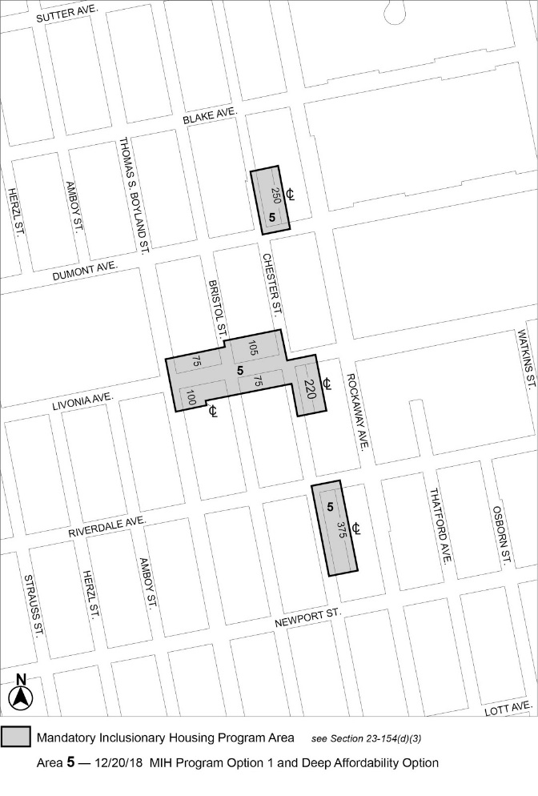

[PROPOSED MAP]
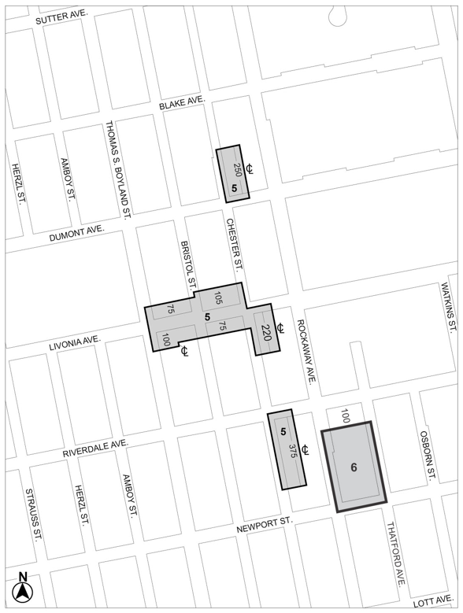
Mandatory Inclusionary Housing Program Area see Section 23-154(d)(3)
Area 5 – 12/20/18 MIH Program Option 1 and Deep Affordability Option
Area 6 – [date of adoption] MIH Program Option 1

Portion of Community District 16, Brooklyn
* * *
Adopted.

Office of the City Clerk, }
The City of New York, } ss.:

I hereby certify that the foregoing is a true copy of a Resolution passed by The Council of The City of New York on ___________, 2020, on file in this office.

.....................................................
City Clerk, Clerk of The Council

