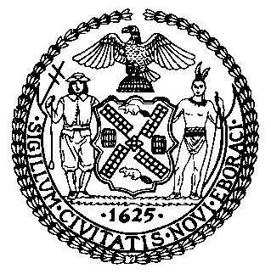 | The Council of the City of New York  Finance Division  Latonia Mckinney, Director  Fiscal Impact Statement  Proposed Intro. No.: 1075-A  Committee: Health
Title: A local law to amend the administrative code of the city of New York, in relation to requiring signage warning of the health risks associated with smoking shisha | Sponsor(S): Council Members Rodriguez and Vacca
Summary of Legislation: The proposed legislation would require every non-tobacco hookah establishment to prominently and conspicuously display at its entrance, and in any room or area where non-tobacco smoking products are smoked, a sign warning of the health risks associated with smoking non-tobacco smoking products. Regarding the size, style, and content of such signs, the bill would require these establishments to adhere to rules promulgated by the commissioner of the Department of Health and Mental Hygiene (DOHMH).

Effective Date: This legislation would take effect 180 days after becoming law, except that DOHMH may take such measures as are necessary for the implementation of the law prior to such date, including the promulgation of rules.

Fiscal Year In Which Full Fiscal Impact Anticipated: Fiscal 2018
Fiscal Impact Statement:

 | Effective FY18 | FY Succeeding Effective FY19 | Full Fiscal Impact FY18
Revenues | $0 | $0 | $0
Expenditures | $0 | $0 | $0
Net | $0 | $0 | $0

Impact on Revenues: It is anticipated that this legislation would not have an impact on revenues.

Impact on Expenditures: It is estimated that this bill would not have an impact on expenditures because DOHMH would utilize existing resources to implement the legislation.

Source of Funds To Cover Estimated Costs: N/A
Source of Information: New York City Council Finance Division
New York City Department of Health and Mental Hygiene
Estimate Prepared By: Jeanette Merrill, Legislative Financial Analyst

Estimate Reviewed By: Nathan Toth, Deputy Director, NYC Council Finance Division
Crilhien R. Francisco, Unit Head, NYC Council Finance Division
Eric Bernstein, Counsel, NYC Council Finance Division
Legislative History: This legislation was introduced to the full Council on February 5, 2016 and was referred to the Committee on Health (Committee). The Committee held a hearing on February 25, 2016 and the bill was laid over. The bill was subsequently amended, and the Committee will vote on the amended legislation, Proposed Int. No. 1075-A, at a hearing on September 26, 2017. Upon successful vote by the Committee, the full Council will vote on the legislation on September 27, 2017.
Date Prepared: September 12, 2017

