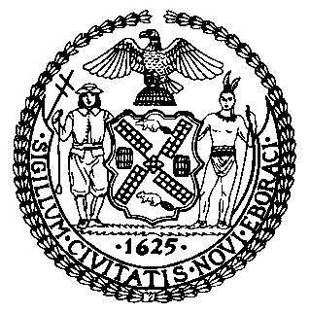 | The Council of the City of New York  Finance Division  Latonia Mckinney, Director  Fiscal Impact Statement  Proposed Intro. No: 2225-A  Committee: Health
Title: A Local Law in relation to the establishment of a plan for COVID-19 vaccination of homebound seniors, reporting on such plan, and providing for the repeal of such provisions upon the expiration thereof | Sponsors: Council Members Treyger, Yeger, Kallos, Holden and Lander
Summary of Legislation: Proposed Intro. No. 2225-A would require the Commissioner of Health and Mental Hygiene, or another designated agency, to establish a plan to vaccinate homebound seniors for COVID-19. That plan would be posted on the department’s website and provided to the Council. The Commissioner of Health and Mental Hygiene, or another designated agency, would also be required to report to the Council on implementation of the plan.

Effective Date: This local law would take effect immediately.

Fiscal Year In Which Full Fiscal Impact Anticipated: Fiscal 2022
Fiscal Impact Statement:

 | Effective FY21 | FY Succeeding Effective FY22 | Full Fiscal Impact FY22
Revenues | $0 | $0 | $0
Expenditures | $0 | $0 | $0
Net | $0 | $0 | $0

Impact on Revenues: It is anticipated that the proposed legislation would have no impact on revenues.

Impact on Expenditures: It is anticipated that there would be no impact on expenditures resulting from the enactment of Intro No. 2225-A as the designated agency would utilize existing resources to comply with the requirements of this legislation.

Source of Funds To Cover Estimated Costs: N/A
Source of Information: New York City Council Finance Division
Department of Health and Mental Hygiene
Estimate Prepared By: Lauren Hunt, Financial Analyst

Estimate Reviewed By: Nathan Toth, Deputy Director, NYC Council Finance Division
Crilhien R. Francisco, Unit Head, NYC Council Finance Division
Noah Brick, Assistant Counsel, NYC Council Finance Division
Legislative History: This legislation was introduced to the full Council on February 11, 2021 and was referred to the Committee on Health (Committee). A hearing was held by the Committee, jointly with the Committee on Aging and the Committee on Technology on February 17, 2021, and the bill was laid over. The legislation was subsequently amended and the amended version, Proposed Intro. No. 2225-A, will be considered on February 25, 2021. Upon a successful vote by the Committee, Proposed Intro. No. 2225-A will be submitted to the full Council for a vote on February 25, 2021.
Date Prepared: February 18, 2021

