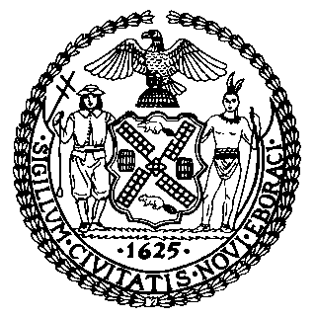 | The Council of the City of New York  Finance Division  Latonia McKinney, Director  Fiscal Impact Statement  Proposed Int. No.: 2359-A  Committee: Small Business
Title: A Local Law to amend the administrative code of the city of New York, in relation to extending the limitation on fees charged to food service establishments by third-party food delivery services | Sponsors: By Council Members Moya and Gjonaj
Summary of Legislation: Proposed Int. No. 2359-A would amend an existing law that prohibits third-party food delivery services - entities that provide food service establishments with online order and delivery services - from charging such establishments more than 15 percent per order for delivery and more than 5 percent per order for all other fees only when certain conditions apply. This bill would instead prohibit such charges from the anticipated end date of those conditions until February 17, 2022. It would also clarify the types of transaction fees exempted from these limits on charges.

Effective Date: This local law would take effect immediately, except that if it becomes law after August 17, 2021, it shall be retroactive to and deemed to have been in effect on and after August 17, 2021.
Fiscal Year In Which Full Fiscal Impact Anticipated: Fiscal 2023
Fiscal Impact Statement:

 | Effective FY22 | FY Succeeding  Effective FY23 | Full Fiscal  Impact FY23
Revenues (+) | $0 | $0 | $0
Expenditures (-) | $0 | $0 | $0
Net | $0 | $0 | $0

Impact on Revenues: It is estimated that there will be no revenue generated from the implementation of this legislation.
Impact on Expenditures: It is estimated that there will be no cost from the implementing this legislation.
Source of Funds To Cover Estimated Costs: N/A
Source of Information: New York City Council Finance Division

Estimate Prepared by: Aliya Ali, Principal Financial Analyst

Estimate Reviewed by: Stephanie Ruiz, Assistant Counsel
Nathan Toth, Deputy Director
Crilhien Francisco, Unit Head

Legislative History: This legislation was introduced to the full Council as Int. No. 2359 on June 30, 2021 and was referred to the Committee on Small Business (Committee). A hearing was held by the Committee on July 1, 2021, and the legislation was laid over. The legislation was subsequently amended and the amended version, Proposed Int. No. 2359-A, will be voted on by the Committee at a hearing on July 29, 2021. Upon successful vote by the Committee, Proposed Int. No. 2359-A will be submitted to the full Council for a vote on July 29, 2021.

Date Prepared: July 22, 2021

