Staff:
Committee on Sanitation & Solid Waste Management
Nicole Abene, Senior Legislative Counsel
Nadia Johnson, Senior Policy Analyst
Ricky Chawla, Policy Analyst
Jonathan Seltzer, Senior Finance Analyst

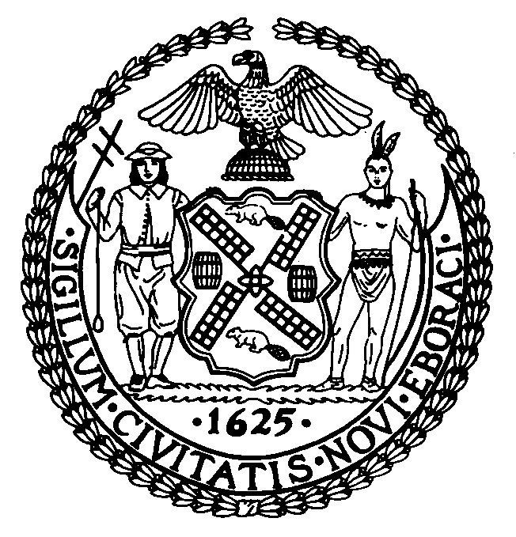

The New York City Council
Jeffrey Baker, Legislative Director

Committee Report of the Infrastructure Division
Terzah Nasser, Deputy Director

Committee on Sanitation & Solid Waste Management
Hon. Antonio Reynoso, Chair

June 17, 2021

Int. No. 2353: By Council Member Reynoso

TITLE: A Local Law to amend the administrative code of the city of New York, in relation to trade waste industry unions

Administrative Code: Amends section 16-503, subdivision i of section 16-504, subdivision c of section 16-505, subdivision g of section 16-509, and subdivision k of section 16-509

I. Introduction
On June 17, 2021 the Committee on Sanitation and Solid Waste Management (the Committee), chaired by Council Member Antonio Reynoso held a hearing on Int. No 2353, which would make various amendments to Local Law 55 of 2019 (Local Law 55). Local Law 55 was enacted on March 18, 2019.

II. Int. No. 2353

Local Law 55 authorized the Business Integrity Commission (BIC) to establish standards for the registration of unions representing drivers and helpers in the private carting industry. Local Law 55 currently allows BIC to regulate all trade waste unions. This bill would limit the unions in the private carting industry that are subject to BIC’s regulation to those unions that represent employees in the putrescible trade waste industry. This bill would take effect immediately.

III. Update
On June 17, 2021, the Committee held a vote on Int. No. 2353. Int. No. 2353 passed with 7 in the affirmative, 0 in the negative, and 0 abstentions. Thus, the Committee recommends adoption.

Int. No. 2353
By Council Member Reynoso
A LOCAL LAW
To amend the administrative code of the city of New York, in relation to trade waste industry unions

Be it enacted by the Council as follows:
Section 1. Section 16-503 of the administrative code of the city of New York, as amended by local law number 55 for the year 2019, is amended to read as follows:
§ 16-503 Functions. The commission shall be responsible for the licensing, registration and regulation of businesses that remove, collect or dispose of trade waste[,] and trade waste brokers[, and]. The commission shall also be responsible for the registration and regulation of labor unions or labor organizations that represent or seek to represent employees directly involved in the collection, removal, transportation or disposal of putrescible trade waste. The commission shall not be responsible for the registration and regulation of labor unions or labor organizations that represent or seek to represent employees directly involved only in the collection, removal, transportation or disposal of one or more of the following: non-putrescible waste, including construction and demolition debris; medical waste; electronic waste; textiles; yard waste collected by landscapers; waste removed by junk haulers or one-time bulk waste services; grease; paper that is collected for the purpose of shredding or destruction; or organic waste that is collected exclusively by a micro-hauler licensee, as that term is defined in rules promulgated by the commission.
§ 2. Subdivision i of section 16-504 of the administrative code of the city of New York, as added by local law number 55 for the year 2019 and relettered by local law number 199 for the year 2019, is amended to read as follows:
i. To issue and establish standards for the registration of labor unions or labor organizations [representing or seeking to represent employees directly involved in the collection, removal, transportation or disposal of trade waste] subject to the jurisdiction of the commission pursuant to section 16-503 and for suspending or disqualifying officers of such unions or organizations.
§ 3. Subdivision c of section 16-505 of the administrative code of the city of New York, as added by local law number 55 for the year 2019, is amended by to read as follows:
c. A labor union or labor organization [representing or seeking to represent employees directly involved in the collection, removal, transportation or disposal of waste] subject to the jurisdiction of the commission pursuant to section 16-503 shall, within the time period prescribed by the commission, register with the commission and shall disclose information to the commission as the commission may by rule require, including but not limited to the names of all officers and agents of such union or organization; provided, however, that no labor union or labor organization shall be required to furnish information pursuant to this section which is already included in a report filed by such labor union or labor organization with the secretary of labor pursuant to 29 U.S.C. § 431, et seq., or § 1001, et seq., if a copy of such report, or of the portion thereof containing such information, is furnished to the commission; and provided further that this section shall not apply (i) to a labor union or labor organization representing or seeking to represent clerical or other office workers, or (ii) to affiliated national or international labor unions of local labor unions that are required to register pursuant to this provision. In addition, notwithstanding any inconsistent provision of this chapter, including the provisions of section 16-503, if the commission inquires in writing of a labor union or labor organization that represents employees involved in the collection, removal, transportation or disposal of trade waste as to whether that labor union or labor organization represents employees at any company that collects, removes, transports or disposes of putrescible trade waste, such labor union or labor organization must respond to the commission within 30 days in a sworn, written statement, and, if the labor union or labor organization represents employees at any company that collects, removes, transports or disposes of putrescible waste, identify the company or companies.
§ 4. Subdivision g of section 16-509 of the administrative code of the city of New York, as added by local law number 55 for the year 2019, is amended by to read as follows:
g. The commission may, after notice and the opportunity to be heard, disqualify an officer of a labor union or labor organization subject to the jurisdiction of the commission pursuant to section 16-503 from holding office when such person: (i) has failed, by the date prescribed by the commission, to be fingerprinted or to provide truthful information in connection with the reporting requirements of subdivisions c and d of section 16-505; (ii) is the subject of a pending indictment or criminal action against such officer for a crime which bears a direct relationship to the trade waste industry, in which case the commission may defer a determination until a decision has been reached by the court before which such action is pending; (iii) has been convicted of a crime which, under the standards set forth in article 23-A of the correction law, bears a direct relationship to the trade waste industry, in which case the commission shall also consider the bearing, if any, that the criminal offense or offenses will have on the fitness of the officer to perform his or her responsibilities, the time which has elapsed since the occurrence of the criminal offense or offenses; the seriousness of the offense or offenses, and any information produced by the person, or produced on his or her behalf, in regard to his or her rehabilitation or good conduct; (iv) has been convicted of a racketeering activity or associated with a person who has been convicted of a racketeering activity, including but not limited to the offenses listed in subdivision one of section nineteen hundred sixty-one of the Racketeer Influenced and Corrupt Organizations statute (18 U.S.C. § 1961, et seq.) or of an offense listed in subdivision one of section 460.10 of the penal law, as such statutes may be amended from time to time, when the officer knew or should have known of such conviction; or (v) has associated with any member or associate of an organized crime group, as identified by a federal, state or city law enforcement or investigative agency, when the officer knew or should have known of the organized crime associations of such person. An officer required to disclose information pursuant to subdivisions c and d of section 16-505 may submit to the commission any material or explanation which such officer believes demonstrates that such information does not reflect adversely upon the officer's good character, honesty and integrity. If the commission determines pursuant to this subdivision that there are sufficient grounds to disqualify a person from holding office in a labor union or labor organization, the commission shall suspend such person from holding office pending a final determination and, in the event such person is disqualified, such suspension shall continue pending resignation or vacatur of or removal from office.
§ 5. Subdivision k of section 16-509 of the administrative code of New York, as added by local law 55 for the year 2019, is amended to read as follows:
k. Notwithstanding any other provision of this chapter to the contrary, the provisions of this section shall apply to any labor union or labor organization otherwise subject to the jurisdiction of the commission pursuant to section 16-503 and representing or seeking to represent employees of businesses required to be licensed or registered pursuant to this chapter.
§ 6. This local law takes effect immediately.

NKA
6/9/2021
11:05PM
LS 13641

