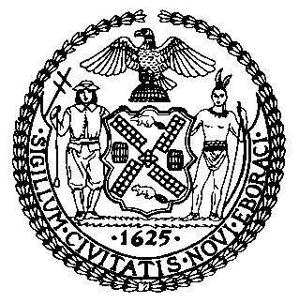 | The Council of the City of New York  Finance Division  Latonia McKinney, Director  Fiscal Impact Statement  Intro. No. 1851  Committee: Environmental Protection
Title: A Local Law to amend the administrative code of the city of New York, the New York city plumbing code and the New York city building code in relation to city-wide stormwater management controls | Sponsors: Council Members Constantinides, Lander, Levin, Reynoso, Ayala, Brannan and Kallos (by request of the Mayor)
Summary of Legislation: Intro. No. 1851 amends the administrative code, the plumbing code and the building code as it pertains to construction projects intended to reduce the flow of stormwater and waterborne pollutants into sewers that empty directly into the waters of the State or overflow into such waters due to rain or snowmelt events that exceed the capacity of the wastewater treatment plants. Furthermore, this local law would address the City’s Municipal Separate Storm Sewer System (MS4). For MS4 projects, this local law would ensure that the rules for such projects are not less stringent than the City’s MS4 permit and the New York State Department of Environmental Conservation (NYSDEC) construction general permit.

Effective Date: This local law would take effect 180 days after enactment and applies to development activity on the site of a covered development project on and after such date, except that this local law shall not apply to development activity on the site of a covered development project, other than a MS4 project, where an application for construction document approval for such project is filed with the Department of Buildings (DOB) or with the Department of Small Business Services and Workforce Development (SBSWD) prior to the effective date.

Fiscal Year in which Full Fiscal Impact Anticipated: Fiscal 2022
Fiscal Impact Statement:
 | Effective FY21 | FY Succeeding  Effective FY22 | Full Fiscal Impact FY22
Revenues (+) | $0 | $0 | $0
Expenditures (-) | $0 | $0 | $0
Net | $0 | $0 | $0

Impact on Revenues: It is estimated that there would be no impact on revenues resulting from the enactment of this legislation.

Impact on Expenditures: It is estimated that there would be no impact on expenditures resulting from the enactment of this legislation as the agency would use existing resources to implement the requirements of the legislation.

Source of Funds to Cover Estimated Costs: N/A

Sources of Information: New York City Council Finance Division
Mayor’s Office of City Legislative Affairs

Estimate Prepared by: Jonathan Seltzer, Senior Financial Analyst

Estimate reviewed by: Crilhien Francisco, Unit Head
Stephanie Ruiz, Assistant Counsel
Nathan Toth, Deputy Director

Legislative History: This legislation was introduced to the Council as Intro. No. 1851 on January 23, 2020 and referred to the Committee on Environmental Protection (Committee). The Committee heard the legislation on August 14, 2020 and it was laid over. Intro. No. 1851 will be considered by the Committee at a hearing on August 27, 2020. Upon a successful vote by the Committee, Intro. No. 1851 will be submitted to the full Council for a vote on August 27, 2020.

Date Prepared: August 26, 2020

