Oversight and Investigation Unit
Heather L. Shaffer, Senior Investigative Counsel
Elizabeth Trinder, Special Investigative Analyst
Zachary E. Meher, Investigator
Ximena Fernandez, Head Data Analyst

Committee on Housing and Buildings
Austen Brandford, Counsel
Genan Zilkha, Counsel
Audrey Son, Counsel
Jose Conde, Senior Legislative Policy Analyst
Sarah Gastelum, Principal Financial Analyst
Luke Zangerle, Financial Analyst

THE COUNCIL OF THE CITY OF NEW YORK

Briefing Paper of the Oversight AND Investigations COMMITTEE and infrastructure division
Steve Pilnyak, Chief of the Oversight & Investigations Unit
Jeffrey Baker, Legislative Director
Terzah Nasser, Deputy Director of the Infrastructure Division

COMMITTEE ON OVERSIGHT AND INVESTIGATIONS
Hon. Ritchie J. Torres, Chair

COMMITTEE ON HOUSING AND BUILDINGS
Hon. Robert E. Cornegy, Jr., Chair

July 22, 2019

Oversight—Taking Stock: A Look into the Third Party Transfer Program in Modern Day New York

INTRODUCTION
On July 22, 2019, the Committees on Oversight and Investigations and Housing and Buildings (collectively, the “Committees”), respectively chaired by Council Member Ritchie J. Torres and Council Member Robert E. Cornegy, Jr., will hold a joint oversight hearing entitled Taking Stock: A Look Into the Third Party Transfer Program in Modern Day New York. The hearing will examine the Third Party Transfer Program (“TPT” or the “Program”), focusing on the processes by which New York City agencies (the “City”) selected and ultimately foreclosed upon certain properties in connection with the latest round of the Program. The Committees expect to receive testimony from representatives of the Department of Housing Preservation and Development (“HPD”), the Department of Finance (“DOF”), and interested members of the public.

BACKGROUND
In the 1960s and 1970s, many New York City neighborhoods experienced impoverishment and depopulation, leading to a surge of housing abandonment. The City took ownership of these abandoned properties, as well as other residential properties in financial and physical decline, through the mechanism of in rem foreclosure. By 1994, the City owned and managed nearly 5,500 buildings, most of which were dilapidated, multi-family housing units. Despite its efforts, the City lacked sufficient capital resources to address the needs of these buildings and their residents.
In response, the New York City Council (the “Council”) and the Mayoral Administration created TPT with the enactment of Local Law 37 in 1996 (“Local Law 37”), which granted the City the authority to convey tax delinquent residential properties directly to a third party without the City itself taking ownership and managing the foreclosed-upon properties. Tax delinquent properties are those properties that have accrued taxes, assessments, or other charges, which have subsequently become liens on the property. Tax delinquent properties foreclosed upon through TPT are transferred to third party owners for rehabilitation and management to be added to the City’s affordable housing stock.
Since the enactment of Local Law 37, the City has completed ten TPT rounds, including the most recent round, which ended in 2018 (“Round X”). Round X has generated significant attention from the press and from elected officials, who raised a number of concerns, such as that some of the properties selected for inclusion in the Program appeared to be in fine physical and financial condition. Homeowners of properties included in Round X also expressed concerns, including that the City provided them with little notice and opportunity to redeem their properties from the Program.
The Committees expect that this hearing will address these and other issues related to Round X.

OVERVIEW OF TPT PROCESS

The TPT Property Selection Process
Local Law 37 sets forth the City’s ability to foreclose upon tax delinquent properties in connection with TPT, allowing the City to foreclose upon 1) non-cooperative and non-condominium residential properties with a tax lien outstanding for at least one year, and 2) cooperative and condominium properties with a tax lien outstanding for at least three years.
In selecting properties for TPT, HPD “carries out a comprehensive analysis of eligible buildings to determine which ones are [sic] exhibit the highest level of physical and financial distress,” focusing on properties that meet the tax lien requirements set forth in local law and that are active in enforcement programs and/or are statutorily distressed. When Round X began in 2015, a statutorily distressed property was defined as any class one or class two real property that was subject to a tax lien with a lien to value ratio, as determined by DOF, equal to or greater than 15% and that met at least one of the following criteria:
- the property had an average of five or more hazardous (Class B) or immediately hazardous violations (Class C) per dwelling unit; or
- the property was subject to a lien or liens for $1,000 or more for any expenses incurred by HPD under its Emergency Repair Program (“ERP”).
DOF works with HPD to select properties for in rem foreclosure actions. Throughout Round X, on its website, DOF stated that a property may be subject to an in rem foreclosure action if:
- “Property Taxes and other property-related charges are late for an extended period of time.
- [The] property is in an area that the City considers to be ‘blighted’ and has been targeted for improvements.”
At the same time, HPD has maintained that it is authorized to foreclose on properties with outstanding tax lien(s) of $1,000 or more irrespective of whether they are distressed.

Filing an In Rem Foreclosure Action
To initiate an in rem foreclosure action in State court, the Administrative Code requires the DOF Commissioner to prepare a list of properties with tax liens subject to foreclosure that are within a particular borough or section of a tax map, provided that none of the areas specified are smaller than a tax block. The City interprets this provision to mean that once it commences an in rem foreclosure action, it is required to include in the foreclosure action all tax delinquent properties in a particular tax class on the same tax block as any other property selected. This means that a property does not have to meet the statutory definition of “distressed” to be included in a foreclosure action; rather, all that is necessary is that the property have a tax lien and be located on the same block as another property designated for foreclosure. In rem foreclosure actions are filed in the Supreme Court of each borough and each action encompasses all properties designated for foreclosure in that borough.

Homeowner Notice and the Property Redemption Process

The City claims that it sends tax bills and warning notices to homeowners whose properties have been included in TPT and thus are at risk of foreclosure, prior to the filing of a foreclosure action. Owners of properties facing foreclosure can pay the full amount of taxes outstanding or enter into an installment payment agreement to have their properties removed from TPT.
Once an in rem foreclosure action has been filed, the City is required to mail additional foreclosure notices to all homeowners whose properties have been included in the action, as well as to publish the notices of foreclosure in newspapers and post them in courthouses and other conspicuous places in the boroughs in which the properties are located. At this point, an owner can still remove their property from the Program by either paying the full amount of taxes outstanding or entering into an installment payment agreement. The terms of such agreements become more onerous as time passes in the TPT process.

Court Entry of Foreclosure Judgment and Four Month Redemption Period

A court will ultimately issue a final judgment of foreclosure awarding possession of the properties remaining in the in rem action and authorizing DOF to convey the property deeds to a third-party owner.
Once a court enters a judgment of foreclosure, a homeowner has four months in which to redeem their property by paying all outstanding taxes. DOF, in consultation with HPD, also has the discretion to allow a homeowner to enter into an installment payment agreement at this time, if the homeowner has not previously defaulted on a payment agreement for that property.

The Council Reviews the Proposed Transfers
Prior to transferring title of foreclosed upon properties to a third party, DOF notifies the Council of the proposed transfers. The Council has 45 days to disapprove any transfers by local law. If the Council does not act, the property is deemed approved for transfer. If the Council passes a local law disapproving a transfer, the property remains with the original homeowner and all taxes on the property remain due and owing.

The City Transfers Title to a Third Party
For properties that are not removed by the Council, the next step in the process is the ownership transfer of a foreclosed upon property to Neighborhood Restore Housing Development Fund Corporation (“Neighborhood Restore”), “a nonprofit organization that oversees a variety of affordable housing development programs . . . [which] focus on transitioning properties from financial and physical abandonment to third party ownership.” This transfer extinguishes all tax liens on the transferred property and must take place between four and eight months after a court renders a final judgment of foreclosure against the property.
Neighborhood Restore works with non-profit and for-profit developers—selected by HPD through a Request for Qualifications process—to stabilize and plan for the properties’ rehabilitation. Neighborhood Restore will ultimately transfer ownership to the selected developer. The developer is then required to rehabilitate the building, if necessary, and continue to manage the property as affordable rental housing.

ROUND X
Round X of TPT began in 2015 when the City selected 420 properties for the Program, and ended in the fall of 2018 when the City transferred 65 of those properties to Neighborhood Restore. Round X generated a significant amount of attention due to 1) the types of properties selected, 2) the neighborhoods in which the properties were located, and 3) the lack of notice and opportunity to redeem properties reported by many homeowners.

Properties Selected

Condition of Properties

HPD has stated that the Program focuses on distressed properties with bad actor landlords. However, half of the properties selected for Round X (210 out of 420) were not statutorily distressed because they were not subject to a tax lien with a lien to value ratio greater than or equal to 15%. Specifically, the average lien to value ratio for these 210 properties was only 3%, far below the 15% required to meet the statutory definition of distressed. Moreover, 155 of these 210 properties did not have five or more B or C violations per dwelling unit. Ultimately, four of the 65 properties transferred to Neighborhood Restore had lien to value ratios below 15% and were therefore not statutorily distressed.
The City also claims that the Administrative Code permits it to foreclose upon non-statutorily distressed properties in situations where a property has a lien that makes it subject to foreclosure and is located on the same tax block as another property selected for TPT. This may serve to explain why certain non-statutorily distressed properties were included in the most recent TPT Round. However, 33 non-statutorily distressed properties included in Round X were not located on the same tax block as another property selected for the Program. This raises questions as to why they were designated for inclusion.
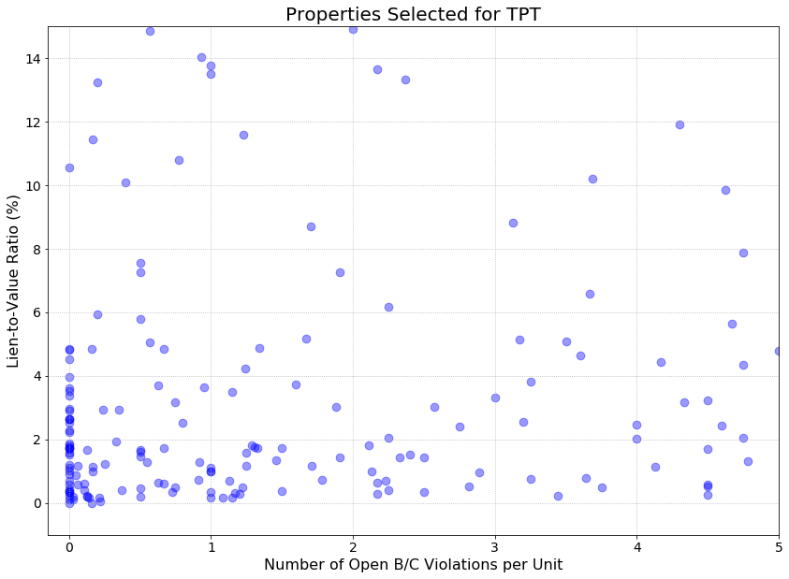
Figure 1. Non-Distressed Properties Selected for TPT shown by Lien to Value Ratio and Number of B & C Violations per Dwelling Unit
A large portion of the properties selected for Round X were worth far more than the amounts owed to the City, as evidenced by the low lien to value ratios, and lacked a significant number of B and C violations per dwelling units, as shown in Figure 1. According to HPD’s records, while the total market value of the 210 non-statutorily distressed properties was nearly $152 million, the total amount of arrears owed on such properties was just over $4.5 million. For example, one property selected had a market value in 2015 of approximately $6 million, only 0.16 violations per dwelling unit, and owed $0 in arrears. Another property selected had a market value in 2015 of approximately $2.2 million, 0 violations per dwelling unit, and only $2,200 in arrears. This is significant because owners of properties selected for TPT face the possibility of losing the equity that has accumulated over time without receiving any compensation in return. Consequently, the transfer of a property to a third party through TPT can lead to a loss of a significant intergenerational asset.
Inclusion of HDFCs in Round X
During the financial crisis of the 1970s, the City foreclosed upon, and acquired, multifamily buildings that were abandoned by homeowners. Ultimately, the City created Housing Development Fund Corporation cooperatives (“HDFCs”) as a way to sell City-owned multifamily buildings to the tenants of those buildings and provide affordable home ownership opportunities to lower income New Yorkers. Residents of these buildings, which were primarily concentrated in the Lower East Side, Upper Manhattan, Brooklyn, and the South Bronx, were able to purchase shares in the stock of their buildings at a reduced price in exchange for taking care of such dilapidated building. In exchange for ongoing tax benefits, these HDFCs became subject to owner income restrictions and high re-sale flip-tax provisions intended to keep the buildings affordable. On February 26, 2017, the New York Post reported that there were approximately 30,000 HDFC units in 1,200 buildings across New York City.
The current New York City tax lien sale process specifically exempts HDFCs, and HPD has acknowledged that the only enforcement option available to the City with respect to HDFCs with outstanding arrears is to put the buildings through the TPT process. HDFCs comprised 118 of the properties that the City selected for Round X and 27 of the 65 properties that were foreclosed upon. The practical implication of an HDFC’s inclusion in TPT is that the HDFC converts from a cooperative to a rental building post-transfer. This meant that the economically vulnerable New Yorkers who were shareholders in such properties—and may have spent years rehabilitating and maintaining such properties when the City no longer wished to do so—stood to lose ownership of their units as a result of TPT. Figure 2 provides a side-by-side comparison of the locations of the properties selected for TPT (left) with the locations of all HDFCs in New York City (right).
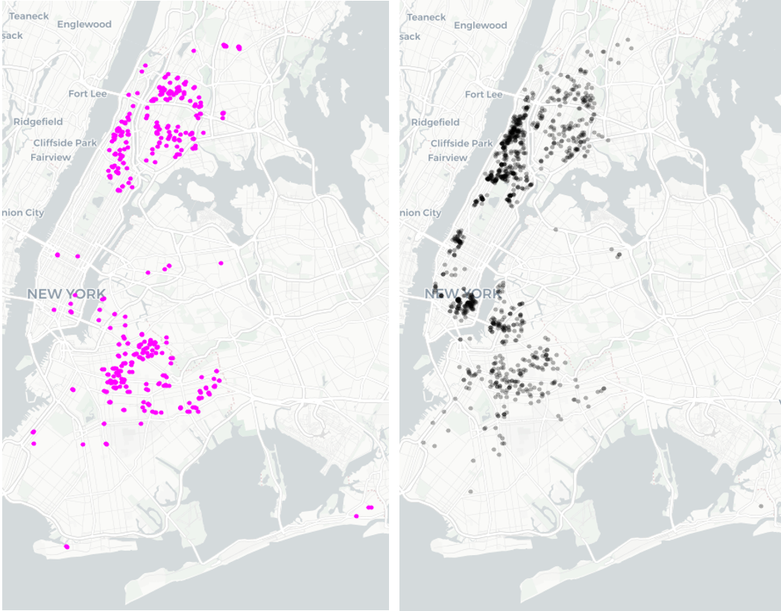
Figure 2. TPT Round X Selected Properties vs. All HDFC Cooperatives in NYC
While the vast majority of the HDFCs selected for Round X were statutorily distressed, it is unclear whether the City pursued other options short of foreclosure with respect to HDFCs. The City’s approach to rehabilitating HDFCs is of particular importance, as HPD has stated that it “anticipate[s] Round 11 of TPT will include even more HDFC coops.”
Round X Concentration of Properties in Certain Neighborhoods
The City selected properties in every borough other than Staten Island for Round X.

Borough | Number of Properties Selected
Bronx | 132
Brooklyn | 192
Manhattan | 86
Queens | 10
Staten Island | -
Total | 420
Figure 3. TPT Round X Properties Selected by Borough
Within these four boroughs, there was a large concentration of properties in just 11 neighborhoods. The properties selected in these 11 neighborhoods accounted for approximately 50% of the total properties selected for Round X (213 out of 420).
Neighborhood | Number of Properties Selected
Mount Hope, Bronx | 16
University Heights-Morris Heights, Bronx | 16
Bedford, Brooklyn | 17
Bushwick North, Brooklyn | 22
Bushwick South, Brooklyn | 18
Crown Heights North, Brooklyn | 32
East New York, Brooklyn | 19
Stuyvesant Heights, Brooklyn | 18
Central Harlem North-Polo Grounds, Manhattan | 19
Central Harlem South, Manhattan | 15
Hamilton Heights, Manhattan | 21
Total | 213
Figure 4. TPT Round X Neighborhoods with Greatest Property Concentration

Homeowners’ Experiences with Round X
In order for a homeowner to have the ability to remove their property from the Program, that homeowner must receive notice that their property is about to be lost to foreclosure, and be provided a real and meaningful opportunity to redeem that property.
Notice
According to the City, “[e]ach building with outstanding property taxes and water and sewer charges [in Round X was] proactively contacted by the city, a minimum of 70 times since the beginning of the rounds in 2015, including notices, letters, bills, robocalls and direct . . . outreach.” Specifically, the City has stated that, “[i]n addition to the standard property tax and water or sewer bills, each owner received multiple letters that indicated that their property was subject to transfer through TPT” and that “HPD also made robocalls in English and Spanish and offered homeowner clinics to provide further information and assistance.”
However, some homeowners involved in Round X have alleged that they did not receive notice that their properties were in danger of foreclosure. For example, in a lawsuit filed in Brooklyn, a homeowner claimed that she was not aware that the City had foreclosed upon her property until she was sent a copy of a flyer posted at the property stating that it had been transferred to Neighborhood Restore as part of TPT.
Opportunity to Redeem
As described above, a homeowner has up to four months post-foreclosure to redeem their property by paying all outstanding arrears or entering into an installment payment plan to do so. Some of the homeowners whose properties were included in Round X claimed in legal filings that the City inhibited their efforts to redeem their properties when they were ready, willing, and able
to do so. For example, one homeowner has asserted that she could not pay her taxes because the City incorrectly listed the former owner of her property on the assessment roll, despite numerous attempts on the homeowner’s part to resolve the issue. Other homeowners have claimed that they entered into payment agreements with the City but the City failed to honor such agreements and foreclosed upon their properties anyway. In some instances, the City continued to accept payments from owners of properties already foreclosed upon. For example, the City admitted that it accepted approximately $72,000 in payments from an HDFC after a foreclosure judgment was issued against the property. This amount included $21,000 in payments that were made after the HDFC could no longer legally redeem its property.
In light of issues faced by certain homeowners, additional information is needed from the City regarding the redemption opportunities made available to homeowners with properties in TPT, including the types of installment payment plans offered, the terms of such plans, and the circumstances under which homeowners who were making installment payments may have still lost their properties.

CONCLUSION
New York City today is a very different place than it was 23 years ago when TPT was created, especially with respect to housing and economics. This hearing provides an opportunity to not only evaluate the issues that occurred in connection with the latest round of TPT, but also to consider the viability and purpose of the Program going forward.

Christopher J. Allred, Breaking the Cycle of Abandonment: Using a Tax Enforcement Tool to Return Distressed Properties to Sound Private Ownership, Pioneer Institute 1-3 (2000), https://www1.nyc.gov/assets/hpd/downloads/pdf/bgc_winner.pdf.
Id. An in rem foreclosure action is the type of legal proceeding that allows the City to take title to a property for non-payment of taxes. Steven Siegel, Review and Analysis of the City of New York’s Proposed Changes to the HDFC Program, The HDFC Coalition 15, https://www.hdfccoalition.org/wp-content/uploads/2018/01/HDFC-paper-for-HDFC-Coalition-by-Steven-Siegel-12.20.17-Public.pdf.
Christopher J. Allred, Breaking the Cycle of Abandonment: Using a Tax Enforcement Tool to Return Distressed Properties to Sound Private Ownership, Pioneer Institute 1-3 (2000), https://www1.nyc.gov/assets/hpd/downloads/pdf/bgc_winner.pdf.
Id.
N.Y.C. Indep. Budget Office, Saving Homes: City Spending on Housing Preservation Grows 6 (2003), https://ibo.nyc.ny.us/iboreports/antiabandonment.pdf.
A tax lien is a “lien arising . . . as a result of the nonpayment of taxes, assessments, sewer rents, sewer surcharges, water rents, any other charges . . .” N.Y.C. Admin. Code § 11-301.
N.Y.C. Dep’t of Hous. Pres.& Dev., Request for Qualifications: Third Party Transfer Program Round X, MultiFamily Preservation Loan Programs & Rental Special Projects (2017), http://www1.nyc.gov/assets/hpd/downloads/pdf/developers/Round-10-TPT-RFQ.pdf.
See e.g., Joe Mauceri New Yorkers in debt losing their homes as part of program designed to preserve quality affordable housing, PIX11 (December 12, 2018, 6:00 PM), https://pix11.com/2018/12/11/new-yorkers-in-debt-losing-their-homes-as-part-of-program-designed-to-preserve-quality-affordable-housing/; N.Y.C. Council, City Council Housing Chair Expresses Concern Over Mayor’s Plan to Expand Seizure of Private Residential Properties (January 10, 2019), https://council.nyc.gov/robert-cornegy/2019/01/10/housing-chair-concerned-by-expansion-of-property-seizures/.
See e.g., In Rem Tax Foreclosure Action No. 53, Index No. 8700/15, slip op. at 8-12 (N.Y. Sup. Ct. Mar. 28, 2019).
Specifically, the Administrative Code states that class one and class two properties with unpaid taxes can be subject to foreclosure. N.Y.C. Admin. Code §§ 11-401(3); 11-404. Class one properties include “most residential property of up to three units and most condominiums that are not more than three stories,” whereas class two properties are comprised of “[a]ll other property that is not in Class [one] and is primarily residential.” N.Y.C. Dep’t of Fin., https://www1.nyc.gov/site/finance/taxes/definitions-of-property-assessment-terms.page (last visited May 24, 2019).
N.Y.C. Admin. Code § 11-404.
“How a Property Can End Up in TPT,” document attached to an email from N.Y.C. Dep’t of Hous. Pres. & Dev. to the N.Y.C. Council (Oct. 26, 2018 3:27 PM). On file with the Council.
According to HPD’s website, “residential buildings in severe distress, or at risk of becoming distressed, may be subject to one or more of the following Housing Quality Enforcement Programs.” These programs include the 7A Management Program, the Alternative Enforcement Program (“AEP”), and the Emergency Repair Program (“ERP”). N.Y.C. Dep’t of Hous. Pres. & Dev., https://www1.nyc.gov/site/hpd/owners/compliance-housing-quality-enforcement-programs.page (last visited May 24, 2019).
“How a Property Can End Up in TPT,” document attached to an email from N.Y.C. Dep’t of Hous. Pres. & Dev. to the N.Y.C. Council (Oct. 26, 2018 3:27 PM). On file with the Council.
Class B violations are considered “hazardous, such as public area doors not self-closing, inadequate lighting in public areas, or vermin.” N.Y.C. Dep’t of Hous. Pres.& Dev., https://hpdonline.hpdnyc.org/HPDonline/help_glossary.aspx (last visited May 24, 2019).
Class C violations are considered “immediately hazardous, such as inadequate fire exits, rodents, lead-based paint, lack of heat, hot water, electricity, or gas.” N.Y.C. Dep’t of Hous. Pres.& Dev., https://hpdonline.hpdnyc.org/HPDonline/help_glossary.aspx (last visited May 24, 2019).
N.Y.C. Admin. Code § 11-401(4). As of May 1, 2019, the statutory definition of “distressed” was expanded to include “[a]ny parcel of class one or class two real property that is subject to a tax lien or liens that result from an environmental control board judgment against the owner of such parcel for a building code violation with a lien or liens to value ratio . . . equal to or greater than 25 percent.” Local Law 152 (2017), available at https://legistar.council.nyc.gov/LegislationDetail.aspx?ID=2473908&GUID=E14F6E26-C4A4-4AEC-9BC4-02E6C0F38E85.
N.Y.C. Dep’t of Fin., https://www1.nyc.gov/site/finance/taxes/property-in-rem-forclosure.page (last visited June 14, 2019). Throughout Round X, DOF’s website did not provide a definition for “blighted.” Note that DOF’s website has since changed and no longer contains the language referencing blight.
How a Property Can End Up in TPT,” document attached to an email from N.Y.C. Dep’t of Hous. Pres. & Dev. to the N.Y.C. Council (Oct. 26, 2018 3:27 PM). On file with the Council.
N.Y.C. Admin. Code § 11-405(a). A “tax map” includes “the block map of taxes and assessments to the extent that the territory within the city of New York is or shall be embraced in such map . . .” N.Y.C. Admin. Code § 11-203(a). A “block” is defined as a “plot or parcel of land such as is commonly so designated in the city, wholly embraced within the continuous lines of streets, or streets and waterfront taken together where water forms one of the boundaries of a block, and such other parcels of land or land under water as may be indicated by the department of finance upon such tax maps by block numbers as constituting blocks.” N.Y.C. Admin. Code § 11-204(d).
Dec. 3, 2018 Letter from the N.Y.C. Law Dep’t at 2, In Rem Tax Foreclosure Action No. 52, Index No. 40000/2015 (N.Y. Sup. Ct.) (citing N.Y.C. Admin. Code § 11-405 and stating, “[T]he law does not . . . prevent properties that are not ‘distressed’ from being forced in in rem proceedings . . . [U]pon commencement of an in rem tax foreclosure action, the City is required to include all tax delinquent properties in a particular tax class in the same tax block as any property selected.”) (emphasis in original).
N.Y.C. Admin. Code § 11-405(d).
N.Y.C. Dep’t of Fin., https://www1.nyc.gov/site/finance/taxes/property-in-rem-forclosure.page (last visited May 24, 2019); Hearing Before the N.Y.C. Council Comm. on Hous. and Bldgs., 26 (N.Y.C. Apr. 2018) (statement of Associate Commissioner of HPD).
N.Y.C. Admin. Code § 11-405(c); N.Y.C. Dep’t of Fin., https://www1.nyc.gov/site/finance/taxes/property-in-rem-forclosure.page (last visited May 24, 2019).
N.Y.C. Admin Code § 11-406(b).
N.Y.C. Admin. Code §§ 11-407, 11-409.
N.Y.C. Dep’t of Fin., https://www1.nyc.gov/site/finance/taxes/property-in-rem-forclosure.page (last visited May 24, 2019).
N.Y.C. Admin. Code § 11-412.1(b).
N.Y.C. Admin. Code § 11-412.1(d).
N.Y.C. Dep’t of Fin. Rules § 13-02(b),(c). This prohibition on owners who have defaulted on prior payment plans does not apply to Housing Development Fund Corporations. N.Y.C. Dep’t of Fin. Rules § 13-02(c). Housing Development Fund Corporation cooperatives are described in more detail below.
N.Y.C. Admin. Code § 11-412.2.
Id.
Neighborhood Restore Hous. Dev. Fund Corp, http://www.neighborhoodrestore.org/ (last visited May 24, 2019).
N.Y.C. Admin. Code § 11-401(4).
N.Y.C. Admin. Code § 11-412.1(c).
Neighborhood Restore Hous. Dev. Fund Corp, http://www.neighborhoodrestore.org/work/#affordable (last visited May 24, 2019); N.Y.C. Dep’t of Hous. Pres.& Dev., Request for Qualifications: Third Party Transfer Program Round X, MultiFamily Preservation Loan Programs & Rental Special Projects (2017), http://www1.nyc.gov/assets/hpd/downloads/pdf/developers/Round-10-TPT-RFQ.pdf.
N.Y.C. Dep’t of Hous. Pres.& Dev., Request for Qualifications: Third Party Transfer Program Round X, MultiFamily Preservation Loan Programs & Rental Special Projects (2017), http://www1.nyc.gov/assets/hpd/downloads/pdf/developers/Round-10-TPT-RFQ.pdf. These properties are generally subject to a regulatory agreement with the City pursuant to section of 8-05 HPD’s Rules.
N.Y.C. Dep’t of Hous. Pres.& Dev., https://www1.nyc.gov/site/hpd/developers/development-programs/multifamily-disposition-and-finance-programs.page (last visited May 24, 2019) (“HPD’s [TPT Program] designate[s] qualified sponsors to purchase and rehabilitate distressed vacant and occupied multi-family properties in order to improve and preserve housing affordable to low-to moderate-income households.”).
The data analyzed was contained in a document HPD provided to the Council (“HPD Data on TPT Properties Selected for Round X”). On file with the Council.
Dec. 3, 2018 Letter from N.Y.C. Law Dep’t at 2, In Rem Tax Foreclosure Action No. 52, Index No. 40000/2015 (N.Y. Sup. Ct.) (citing N.Y.C. Admin Code § 11-405).
HPD Data on TPT Properties Selected for Round X. On file with the Council.
Id.
Id.
Christopher J. Allred, Breaking the Cycle of Abandonment: Using a Tax Enforcement Tool to Return Distressed Properties to Sound Private Ownership, Pioneer Institute 1-3 (2000), https://www1.nyc.gov/assets/hpd/downloads/pdf/bgc_winner.pdf.
N.Y. Private Hous. Fin. Law §§ 570-582. See also Siegel, Teitelbaum & Evans LLP, BROKEN PROMISE: New York City’s Tenant Interim Lease Program and Those Left Behind, PA’LANTE Harlem, Inc. 13 http://stellp.com/TIL%20report.pdf.
See N.Y.C. Dep’t of Hous. Pres.& Dev., https://www1.nyc.gov/site/hpd/owners/homeowner-hdfc.page (last visited May 24, 2019).
Michelle Higgins, Bargains with a ‘But’, N.Y. Times, June 27, 2014, https://www.nytimes.com/2014/06/29/realestate/affordable-new-york-apartments-with-a-catch.html.
“The sales of apartments in almost all HDFC cooperatives are subject to a ‘flip tax.’ This means that, when a shareholder sells his or her apartment, the sale profits must be divided between the selling shareholder and the Board (and, in some cases, the City).” N.Y.C. Dep’t of Hous. Pres.& Dev., https://www1.nyc.gov/assets/hpd/downloads/pdf/Owners/hdfc-coop-fact-sheet.pdf (last visited May 24, 2019).
Michelle Higgins, Bargains with a ‘But’, N.Y. Times, June 27, 2014, https://www.nytimes.com/2014/06/29/realestate/affordable-new-york-apartments-with-a-catch.html.
Isavel Vincent and Melissa Klein. Inside de Blasio’s land grab; aimed at boosting affordable housing data. N.Y. Post, February 26, 2017, https://nypost.com/2017/02/26/inside-de-blasios-land-grab-aimed-at-boosting-affordable-housing-data/.
N.Y.C. Admin. Code § 11-319(b)(10); N.Y.C. Admin. Code § 11-401.1(a).
Correspondence between N.Y.C. Council and N.Y.C. Dep’t of Hous. Pres. & Dev. (Jan. 2017). On file with the Council.
Correspondence between N.Y.C. Council and N.Y.C. Dep’t of Hous. Pres. & Dev. (Jan. 2017). On file with the Council.
HPD Data on TPT Properties Selected for Round X. On file with the Council.
Id.
Id.
N.Y.C. Admin. Code §§ 11-406(b), 11-407, 11-409.
Hearing Before the N.Y.C. Council Comm. on Hous. and Bldgs., 26 (N.Y.C. Apr. 2018) (statement of Associate Commissioner of HPD).
See, e.g., In Rem Tax Foreclosure Action No. 53, Index No. 8700/15, slip op. at 33 (N.Y. Sup. Ct. Mar. 28, 2019).
N.Y.C. Admin. Code §11-412.1(d).
N.Y.C. Rules § 13-02(b), (c).
See, e.g., In Rem Tax Foreclosure Action No. 53, Index No. 8700/15, slip op. at 29 (N.Y. Sup. Ct. Mar. 28, 2019). “[T]his is not a case where a landlord has made no effort to maintain the property. Rather, the shareholders and board [of the property] are desperately seeking to maintain and rehabilitate the . . . . property and to pay all outstanding sums due, obviating the need for any transfer under [TPT].”
Id. at 33.
Id. at 10-12.
Id. at 54-55.
Id.

