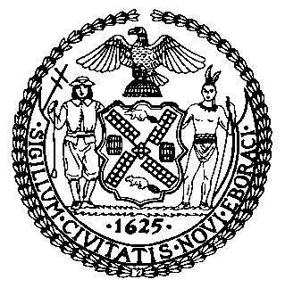 | The Council of the City of New York  Finance Division  Latonia Mckinney, Director  Fiscal Impact Statement  Proposed Intro. No: 2294-A  Committee: Consumer Affairs and Business Licensing
Title: A Local Law to amend the administrative code of the city of New York, in relation to establishing minimum per trip payments to third-party food delivery service and third-party courier service workers | Sponsor(s): Council Member Lander, Menchaca, Chin, Ayala, Van Bramer, Rosenthal, Reynoso, Rivera, Gjonaj and the Public Advocate (Mr. Williams)
Summary of Legislation: Proposed Intro. No.2294-A would guarantee a consistent and suitable wage for food delivery work. This bill would require the Department of Consumer and Worker Protection (DCWP) to promulgate rules establishing a method of determining minimum payments for food delivery workers by January 1, 2023, after first conducting a study of their working conditions, and authority request or issue subpoenas for data, documents or information from food delivery apps or couriers. Beginning February 1, 2024 and each year by February 1 thereafter, DCWP would be required to announce any update to the minimum payment method it has established. Any changes would go into effect on April 1 of that same year. DCWP would also be required to issue a report to the Speaker of the Council and the Mayor on the minimum payment standard, any amendments to the standard, and the effect of such minimum payment standard on food delivery workers and the food delivery industry. The first such report would have to be issued by September 30, 2024, and then by September 30 every two years thereafter.

Effective Date: The bill would take effect immediately after becoming law, except that DCWP may promulgate rules or take any other necessary measures to implement the bill before it takes effect.

Fiscal Year In Which Full Fiscal Impact Anticipated: Fiscal 2023
Fiscal Impact Statement:

 | Effective FY22 | FY Succeeding  Effective FY23 | Full Fiscal  Impact FY23
Revenues | $0 | $0 | $0
Expenditures | $0 | $0 | $0
Net | $0 | $0 | $0

Impact on Revenues: It is anticipated that the enactment of this legislation would not generate any revenue.

Impact on Expenditures: It is estimated that there would be no impact on expenditures resulting from the enactment of this legislation because agencies responsible for implementing this legislation would be able to use existing resources and any mandated wage increases would be paid by private parties.

Source of Funds To Cover Estimated Costs: N/A

Source of Information: New York City Council Finance Division

Estimate Prepared by: Florentine Kabore, Financial Analyst

Estimate Reviewed by: John Russell, Unit Head
Noah Brick, Assistant Counsel
Nathan Toth, Deputy Director

Legislative History: This legislation was introduced to the Council on April 29, 2021 as Int. No. 2294 and was referred to the Committee on Consumer Affairs and Business Licensing (Committee). The Committee heard the legislation on June 8, 2021 and the legislation was laid over. The bill was subsequently amended, and the amended version, Proposed Int. No. 2294-A, will be heard by the Committee on September, 23 2021. Upon successful vote by the Committee, the bill will be submitted to the full Council for a vote on September 23, 2021.
Date Prepared: September 20, 2021

