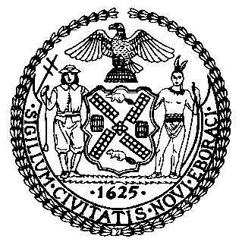 | The Council of the City of New York  Finance Division  Latonia McKinney, Director  Fiscal Impact Statement  Proposed Intro. No: 405-A  Committee: Housing and Buildings
Title: A Local Law to amend the administrative code city of New York, in relation to foldable bicycle access in passenger elevators | Sponsor(s): Council Members Rosenthal, Mendez, Rodriguez, Lander, Menchaca, Reynoso, Levin, Miller, Levine, Cohen, and Vallone (by request of the Manhattan Borough President)
Summary of Legislation: The proposed legislation would require that office buildings, in addition to providing bicycle access in freight elevators, provide foldable bicycle access in passenger elevators except in emergencies that require an evacuation of the building.

Effective Date: This local law would take effect on the same date as a local law of the city of New York for the year 2016 amending the administrative code of the city of New York, in relation to bicycle access in office buildings, as proposed in introduction number 795-A, takes effect.

Fiscal Year In Which Full Fiscal Impact Anticipated: Fiscal 2018
Fiscal Impact Statement:

 | Effective FY17 | FY Succeeding Effective FY18 | Full Fiscal Impact FY18
Revenues | $0 | $0 | $0
Expenditures | $0 | $0 | $0
Net | $0 | $0 | $0

Impact on Revenues: It is estimated that there would be no impact on revenues resulting from the enactment of this legislation.
Impact on Expenditures: It is anticipated that there would be no impact on expenditures resulting from the enactment of this legislation because the proposed legislation largely codifies existing passenger elevator practices where compliance can be accomplished utilizing existing resources.
Source of Funds To Cover Estimated Costs: Not applicable.
Source of Information: New York City Council Finance Division

Estimate Prepared by: Sarah Gastelum, Senior Legislative Financial Analyst

Estimate Reviewed by: Rebecca Chasan, Counsel
Chima Obichere, Unit Head

Legislative History: This legislation was introduced to the full Council on June 26, 2014 as Intro. 405 and was referred to the Committee on Housing and Buildings. A hearing was held by the Committee on Housing and Buildings on October 13, 2015 and the bill was laid over. The legislation was amended, and the amended version, Proposed Intro. 405-A, will be considered by the Committee on Housing and Buildings on September 14, 2016. Following a successful Committee vote, the bill would be submitted to the full Council for a vote on September 14, 2016.
Date Prepared: September 9, 2016

