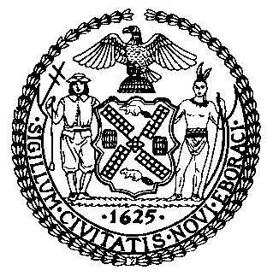 | The Council of the City of New York  Finance Division  Latonia Mckinney, Director  Fiscal Impact Statement  Proposed Intro. No: Int. 1257-A  Committee: Transportation
Title: A Local Law to amend the administrative code of the city of New York, in relation to requiring an annual school safety implementation report, and providing for the repeal of such report | Sponsors: Council Members Van Bramer, Cohen, Richards, Chin, Vallone, Menchaca, Salamanca, Gibson, Deutsch, Koo, Mealy, Koslowitz, Kallos, Ulrich and Borelli
Summary of Legislation: Proposed Intro. No. 1257-A would require that, by March 30, 2018 and every two years thereafter until March 30, 2024, the Department of Transportation (the Department) develop strategies for enhancing pedestrian and traffic safety within a half mile radius of a minimum of 50 City schools and, where practicable, more than 50 schools. These strategies include traffic calming treatments and traffic control signals. Additionally, the Department would be required to provide a report on a biennial basis describing such strategies, including information on whether the safety strategies have been implemented and their implementation status, as applicable.

Effective Date: This local law would take effect immediately, and is deemed repealed after the posting and submission of the report due March 30, 2024 as required by the local law.

Fiscal Year In Which Full Fiscal Impact Anticipated: Fiscal 2019
Fiscal Impact Statement:
 | Effective FY18 | FY Succeeding Effective FY19 | Full Fiscal Impact FY19
Revenues | $0 | $0 | $0
Expenditures | $0 | $0 | $0
Net | $0 | $0 | $0
Impact on Revenues: It is anticipated that there would be no impact on revenues resulting from the enactment of this legislation.

Impact on Expenditures: It is estimated that this legislation would have no impact on expenditures since existing resources would be used by the Department to comply with this local law.
Source of Funds to Cover Estimated Costs: N/A
Source of Information: New York City Council Finance Division
Mayor’s Office of Legislative Affairs
Estimate Prepared by: John Basile, Financial Analyst

Estimate Reviewed by: Nathan Toth, Deputy Director
Chima Obichere, Unit Head
Eric Bernstein, Counsel
Legislative History: This legislation was introduced to the full Council as Intro. No. 1257 on August 16, 2016 and was referred to the Committee on Transportation (Committee). A joint hearing was held by the Committee with the Committee on Public Safety on January 26, 2017, and the legislation was laid over. The legislation was subsequently amended and the amended version, Proposed Intro. No. 1257-A, will be considered by the Committee on November 15, 2017. Upon a successful vote by the Committee, Proposed Intro. No. 1257-A will be submitted to the full Council for a vote on November 16, 2017.
Date Prepared: November 9, 2017

