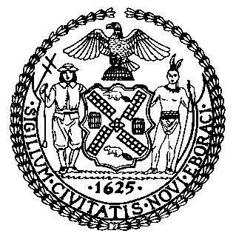 | The Council of the City of New York  Finance Division  Latonia Mckinney, Director  Fiscal Impact Statement  Proposed Intro. No: 1242-A  Committee: Housing and Buildings
Title: A Local Law to amend the administrative code of the city of New York, in relation to expanding available data in the online property owner registry | Sponsors: Council Members Ayala, Lander, Brannan, Ampry-Samuel, Lancman, Kallos, Rosenthal and Perkins
Summary of Legislation: Proposed Intro. No. 1242-A would expand the Department of Housing Preservation and Development’s (HPD) online property owner registry to include rent overcharge information from New York State Homes and Community Renewal, as well as Department of Buildings violations pertaining to harassment, including violations of work without a permit and work in violation of a stop work order.
Effective Date: This legislation would take effect May 1, 2021, except that the Commissioner of the Department of Housing Preservation and Development may take such measures as are necessary for its implementation, including the promulgation of rules, prior to such effective date.

Fiscal Year In Which Full Fiscal Impact Anticipated: Fiscal 2022
Fiscal Impact Statement:

 | Effective FY21 | FY Succeeding Effective FY22 | Full Fiscal Impact FY22
Revenues | $0 | $0 | $0
Expenditures | $0 | $0 | $0
Net | $0 | $0 | $0
Impact on Revenues: It is estimated that there would be no impact on revenues resulting from the enactment of this legislation.
Impact on Expenditures: It is estimated that there would be no impact on expenditures resulting from the enactment of this legislation because existing resources would be used by HPD to implement the provisions of this local law.
Source of Funds To Cover Estimated Costs: N/A
Source of Information: New York City Council Finance Division
Estimate Prepared by: Luke Zangerle, Financial Analyst

Estimate Reviewed by: Noah Brick, Assistant Counsel
Chima Obichere, Unit Head
Legislative History: This legislation was introduced to the Council on November 28, 2018 as Intro. No. 1242 and was referred to the Committee on Housing and Buildings (Committee). The Committee heard the legislation on December 13, 2018, and the legislation was laid over. The legislation was subsequently amended and the amended version, Proposed Intro. No. 1242-A, will be considered by the Committee on May 7, 2019. Upon a successful vote by the Committee, the legislation will be submitted to the full Council for a vote on May 8, 2019.
Date Prepared: May 1, 2019

