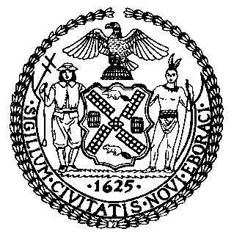 | The Council of the City of New York  Finance Division  Latonia McKinney, Director  Fiscal Impact Statement  Preconsidered Int. No. 2403:  Committee: Housing and Buildings
Title: A Local Law in relation to extending the certification of no harassment pilot | Sponsors: Council Member Lander

Summary of Legislation: This Preconsidered Introduction would extend the Certificate of No Harassment (CONH) pilot created by local law number 1 for the year 2018 which is slated to expire on September 27, 2021 to October 31, 2021.

Effective Date: This local law would take effect immediately.

Fiscal Year In Which Full Fiscal Impact Anticipated: Fiscal 2022
Fiscal Impact Statement:

 | Effective FY22 | FY Succeeding Effective FY22 | Full Fiscal Impact FY22
Revenues | $0 | $0 | $0
Expenditures | $0 | $0 | $0
Net | $0 | $0 | $0

Impact on Revenues: It is estimated that there would be no impact on revenues resulting from the enactment of this legislation.
Impact on Expenditures: It is anticipated that there would be no impact on expenditures resulting from the enactment of this legislation.
Source of Funds To Cover Estimated Costs: N/A
Source of Information: New York City Council Finance Division Mayor’s Office of City Legislative Affairs

Estimate Prepared by: Luke Zangerle, Financial Analyst

Estimate Reviewed by: Stephanie Ruiz, Assistant Counsel
Nathan Toth, Deputy Director

Legislative History: The Committee on Housing and Buildings (Committee) will hold a public hearing and vote on this Preconsidered Introduction on September 23, 2021. Upon a successful vote by the Committee, this Preconsidered Introduction will be introduced to the full Council and be submitted to the full Council for a vote on September 23, 2021.
Date Prepared: September 21, 2021

