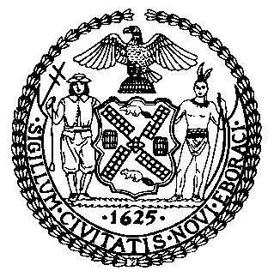 | The Council of the City of New York  Finance Division  Latonia McKinney, Director  Fiscal Impact Statement  Proposed Intro. No.: 136-A  Committee: Health
title: A local law to amend the administrative code of the city of New York, in relation to the spaying, neutering and licensing of animals sold in pet shops. | Sponsor(S): Council Members Crowley, Arroyo, Dickens, Johnson, Koo, Levine, Palma, Rose, Vallone, Mendez, Koslowitz, Cornegy, Rosenthal and Ulrich
Summary of Legislation:
Proposed Intro. No. 136-A would amend the Animal Shelters and Sterilization Act to prohibit the sale of any dog or cat in any pet store unless such animal has been spayed or neutered. It would require that such procedures be performed by a licensed veterinarian and that the animals be no younger than eight weeks and weigh no less than two pounds.

In addition, the bill requires that pet shops ensure that customers purchasing any dog must first complete a dog license application and tenders to the pet store the dog license application fee. Pet shops would also be required to report information about all dogs sold to the Department of Health and Mental Hygiene on a monthly basis.

A pet shop that violates the provisions of this law related to sterilization and dog licensing, or the provisions of law added by Proposed Int. No. 146-A related to microchipping, would be subject to a civil penalty of $500 per violation.

Effective Date: This local law would take effect on June 1, 2015, except that the commissioner shall take such measures as are necessary for its implementation, including the promulgation of rules, prior to such effective date.

Fiscal Year In Which Full Fiscal Impact Anticipated: Fiscal 2016
Fiscal Impact Statement:

 | Effective FY15 | FY Succeeding  Effective FY16 | Full Fiscal  Impact FY16
Revenues | $0 | $0 | $0
Expenditures | $0 | $0 | $0
Net | $0 | $0 | $0

Impact on Revenues: It is estimated that there would be no impact on revenues resulting from this legislation.
Impact on Expenditures: It is estimated that there would be no impact on expenditures resulting from this legislation because the portion of the legislation that requires City resources to be implemented, specifically the collection of reports by the Department of Health and Mental Hygiene from pet shops, would be covered using existing resources.
Source of Funds To Cover Estimated Costs: N/A

Source of Information: New York City Council Finance Division

Estimate Prepared By: Crilhien R. Francisco, Senior Legislative Financial Analyst

Estimated Reviewed By: Regina Poreda Ryan, Deputy Director, New York City Council Finance Division
Rebecca Chasan, Assistant Counsel, New York City Council Finance Division
Legislative History: Intro. 136 was introduced to the Council on February 26, 2014 and referred to the Committee on Health. The Committee on Health held a hearing on Intro. No. 136 on April 30, 2014 and the legislation was laid over. The legislation was subsequently amended and the amended legislation, Proposed Intro. No.136-A, was considered by the Committee on Health on November 24, 2014 and laid over. Proposed Intro. No.136-A will be voted on by the Committee on Health on December 16, 2014. Upon successful vote by the Committee, Proposed Intro. No. 136-A will be submitted to the full Council for a vote on December 17, 2014.
Date prepared: December 16, 2014

