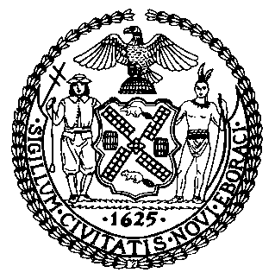 | The Council of the City of New York  Finance Division  Latonia McKinney, Director  Fiscal Impact Statement  Proposed Intro. No. 1828-A  Committee: Women and Gender Equity
Title: A local law to amend the administrative code of the city of New York, in relation to establishing a committee on female genital mutilation and cutting, and technical amendments in connection therewith | Sponsors: By Council Members Ampry-Samuel, Rosenthal, Cumbo, Chin, Koslowitz, Ayala, Louis, Kallos, Adams, Gjonai, and Rivera (by request of the Brooklyn Borough President)
Summary of Legislation: Proposed Intro. No. 1828-A would require the establishment of an advisory committee on female genital mutilation and cutting (FGM/C) within the Mayor’s Office to End Domestic and Gender-Based Violence (ENDGBV). The committee, headed by the ENDGBV commissioner or their designee, would make recommendations to engage communities and agencies in decreasing, with the goal of eventually eliminating, the practice of female genital mutilation and cutting in the city, and would identify supportive community-based and culturally-responsive resources for people who have undergone female genital mutilation and cutting. The mayor or their designee would appoint advisory committee members from various fields, including City government, healthcare, and non-profit organizations, among others. The advisory committee would be required to meet a minimum of two times per year for two years, after which time ENDGBV would assess the continued need for such advisory committee. ENDGBV would also be required to report on the advisory committee’s activities in its annual report, or if the advisory committee were dissolved, continue to include a description of the office’s work in relation to FGM/C in its annual report.

Effective Date: This local law would take effect 90 days after becoming law.
Fiscal Year In Which Full Fiscal Impact Anticipated: Fiscal 2023
Fiscal Impact Statement:

 | Effective FY22 | FY Succeeding  Effective FY23 | Full Fiscal  Impact FY23
Revenues (+) | $0 | $0 | $0
Expenditures (-) | $0 | $0 | $0
Net | $0 | $0 | $0

Impact on Revenues: It is anticipated that there would be no impact on revenues resulting from the enactment of this legislation.
Impact on Expenditures: It is anticipated that there would be no expenses resulting from the enactment of this legislation. ENDGBV already has sufficient resources to support the committee meetings and the submission of the required report.
Source of Information: New York City Council Finance Division
Source of Funds to Cover Estimated Costs: N/A
Estimate Prepared by: Nevin Singh, Financial Analyst
Estimate Reviewed by: Eisha Wright, Unit Head
Regina Poreda Ryan, Deputy Director
Noah Brick, Assistant Counsel
Legislative History: This legislation was introduced to the Council on December 19, 2019 as Intro. No. 1828 and was referred to the Committee on Women and Gender Equity (Committee). The Committee heard the legislation in a joint hearing with the Committee on Health on October 28, 2020, and the legislation was laid over. The legislation was subsequently amended and the amended version, Proposed Intro. No. 1828-A, will be considered by the Committee at a hearing on September 9, 2021. Upon successful vote by the Committee, Proposed Intro. No. 1828-A will be submitted to the full Council for a vote on September 9, 2021.
Date Prepared: September 8, 2021

