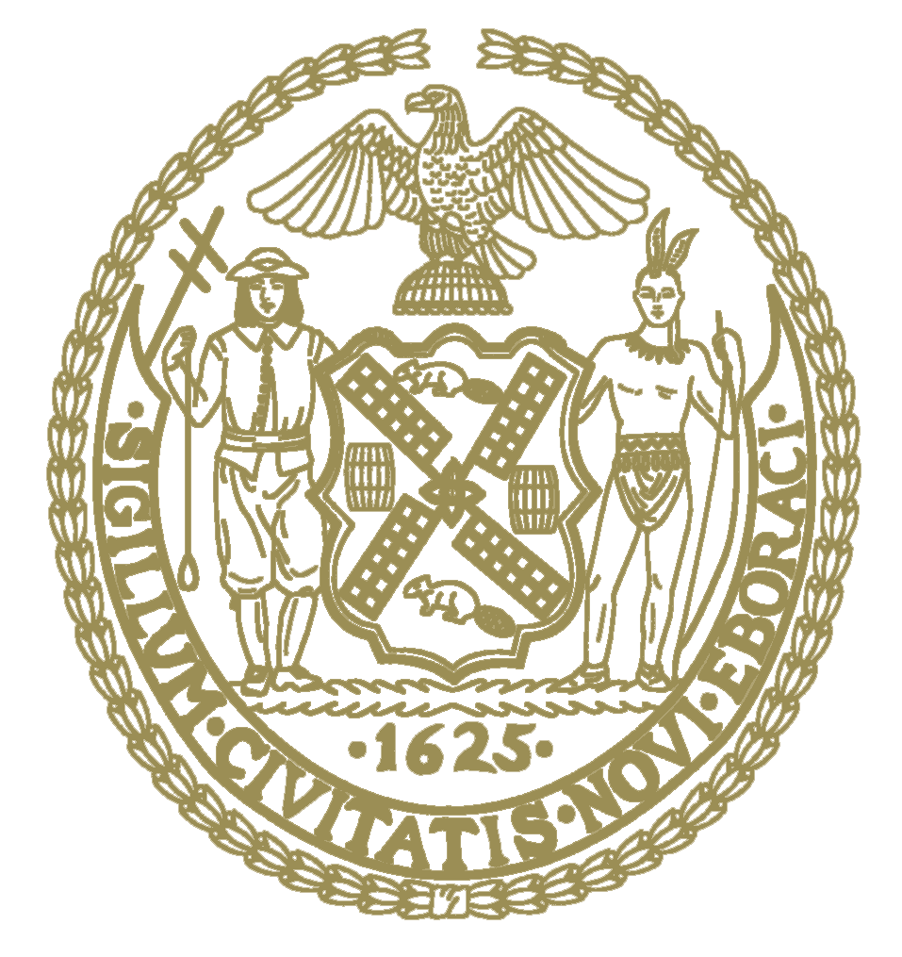

THE COUNCIL OF
THE CITY OF NEW YORK
CITY HALL
NEW YORK, NY 10007

June 16, 2022
Dear Fellow New Yorkers:

Pursuant to New York City Council’s remote attendance policy, Council Member Kagan is authorized to participate remotely by the Speaker’s Office for all meetings of the Council held on June 16, including the Stated Meeting, due to the Council’s COVID Policy Protocols.
Sincerely,
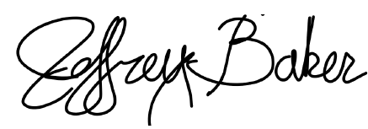
Jeffrey T. Baker
Deputy Chief of Staff for Legislation & Policy

