Staff: Kris Sartori
Counsel to the Committee on Parks and Recreation

Patrick Mulvihill
Senior Policy Analyst

Chima Obichere
Monika Bujak
Financial Analysts

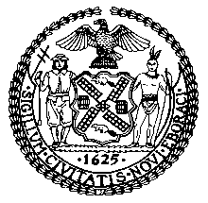

THE COUNCIL

BRIEFING PAPER OF THE INFRASTRUCTURE DIVISION
Jeffrey Baker, Legislative Director

COMMITTEE ON PARKS AND RECREATION
Hon. Peter Koo, Chairperson

September 26, 2019

Oversight: Examining the Parks Department’s Maintenance Practices

INTRODUCTION
On September 26, 2019, the Committee on Parks and Recreation, chaired by Council Member Peter Koo, will hold an oversight hearing, entitled “Examining the Parks Department’s Maintenance Practices.” Representatives from the New York City Department of Parks and Recreation (DPR), as well as parks conservancies and alliances, parks advocates and community organizations have been invited to testify.

BACKGROUND
DPR maintains one of the oldest and largest municipal park systems in the country. The agency maintains over 30,000 acres of developed, natural, and undeveloped parkland, which constitutes 14 percent of the City’s landmass, including 5,000 facilities that encompass nearly 1,000 playgrounds, 800 athletic fields, 550 tennis courts, 65 swimming pools, 51 recreational facilities and 14 miles of beaches. These facilities are visited and used by millions of individuals every year.
The maintenance of parks and other types of property under its jurisdiction is a major part of DPR’s responsibilities. Maintenance activities typically include basic repairs and upkeep, garbage collection and depending on the weather, snow plowing. More specifically, common maintenance practices will typically involve changing playground swings as seats and bearings begin to wear and “winterizing” spray showers, drinking fountains and some of the comfort stations by turning off their water supply each autumn. In order to maintain parks, DPR employs a variety of professionals, including landscape architects, architects and engineers who design parks, forestry staff who plant and maintain trees, gardeners, recreation professionals who organize DPR programming, park rangers, enforcement officers and outreach staff who work with volunteers and friends of groups who also assist in maintaining parks. Daily park maintenance and staff size can vary depending on the size of the park and the amount of required maintenance.
Some maintenance work is performed by more specialized staff who work with specialized equipment, including full-size tractors or roll-off container trucks. Other park maintenance work often includes more specialized work, including seasonal preparation of pools, maintenance of heating, ventilation, and air conditioning systems, maintenance of synthetic turf fields, operation of sewer trucks and fabrication of signage.
In order to determine what more focused maintenance may be needed in certain properties, DPR conducts inspections through its Parks Inspection Program (PIP). Through PIP, inspectors use handheld computers and digital cameras to document conditions and collect data while performing nearly 6,000 inspections each year. Each inspected park is given a rating for overall condition and for cleanliness, which includes numerous ratable park features. The data is disseminated to the boroughs through the DPR’s intranet on a daily basis, so that management can react to problems. Data from this program has indicated that the number of parks rated as acceptable for overall conditions rose from a low of 36 percent in 1994 to 82 percent in 2012, while the citywide cleanliness rating rose from 73 percent in 1994 to 88% in 2012. The most recent data from the beginning of Fiscal Year 2019 indicates that the ratings for overall condition and cleanliness were respectively as follows: Citywide, 85.7% and 90.4%; the Bronx, 81.6% and 86.7%; Brooklyn, 76.2% and 83.6%; Manhattan, 90.5% and 94.3%; Queens, 91.3% and 94.5%; and Staten Island, 93.5% and 95.7%. Though improvements have been made over time, many parks are still maintained inadequately and those that were not deemed adequate were often found in lower income neighborhoods.

ISSUES AND CONCERNS
During the late 1970’s, New York City experienced a financial crisis that led to massive budget cuts for all city agencies including DPR. As a result, many of the City’s Parks were left in a state of disrepair. In order to continue providing upkeep, DPR began to initiate agreements with not-for-profit organizations to take on the responsibilities of maintaining certain parks. These public-private partnerships helped to lessen the direct public investment required for such parks. Over time, this practice has expanded to other parks and has resulted in a structure where the parks system in New York City is funded by a mix of public and private dollars and cared for by public employees, private sector workers and many volunteers. This model of funding for City parks has led many to question whether a disparity has been created between the quality of maintenance in large well-known parks that have access to private funding and those that do not.
Part of the concern raised by the reliance on private dollars is whether such reliance has dampened the will to commit the necessary amount of public funds to support and maintain parks. Throughout the last few decades, as the trend of privately funding part of the parks system has grown, public spending has remained mostly stagnant and even decreased when accounting for inflation. For example, park spending represented about 1.4 percent of the City budget in 1960, 0.86 percent in 1986, 0.65 in 1991 and 0.52 in 2000. Currently, DPR’s expense budget for fiscal year 2019 is $563.6 million, which only represents less than one percent of the City’s budget.
Part of the maintenance and equity concerns may relate to DPR’s dependence on other entities to even fund its capital process. For the vast majority of capital projects, DPR is reliant on discretionary allocations from various elected officials whose priorities might differ with those of DPR, leading some to argue that DPR should have its own discretionary capital budget to enable it to better plan and budget for capital projects over the long term, which would make it easier for the agency to plan ahead and address larger scale maintenance issues more efficiently. The current process makes it difficult to assess what the specific maintenance needs are for specific parks, how to address them and what the immediate staffing needs are.
A 2018 report by the Center for an Urban Future entitled, A New Leaf, Revitalizing New York City’s Aging Parks Infrastructure, highlighted the fact that the parks system is aging rapidly and pointed to numerous maintenance deficiencies that have affected City parks for decades. The average City park is approximately 73 years old, with roughly 40 percent of city pools having been built before 1950, with half of DPR’s 53 recreation centers similarly built before that time. Additionally, DPR’s waterfront facilities, including piers, bulkheads, marinas and docks are on average 76 years old. The report further highlights that the average City park has not had any major renovations since 1997.
Stagnant budgets and poor staffing levels have directly resulted in an inability for DPR to properly maintain its parks over the years. Per DPR’s own maintenance requests, recommended maintenance needs went up 143 percent between FY 2006 and FY 2016 from $14 million to almost $34 million. In FY 2016, only 12 percent of that request was actually funded. According to the Trust for Public Land, the City spends less on parks per capita when compared to other large cities. For instance, as of 2017, the City spent about $178 per capita, while other cities like Washington D.C. and Minneapolis spent $270 and $233 per capita, respectively.
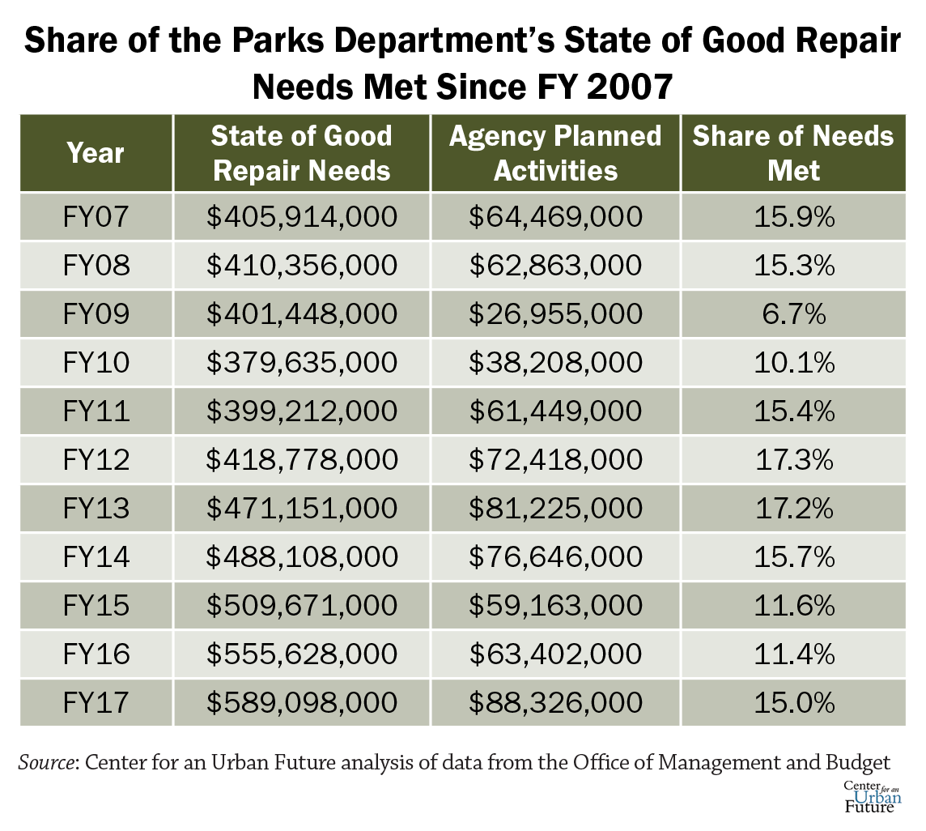 Understaffing at DPR has played a major role in maintenance deficiencies. From a high in 1976 of about 11,000 full time positions, the full time staff dropped to an average of about 7500 recently, with some slight increases recently of about 11% from 2014 to 2016. DPR has approximately 150 gardeners citywide for nearly 20,000 acres of parkland, which equals one gardener for every 133 acres. Comparatively, the San Francisco Recreation and Parks Department has over 200 gardeners for 4,113 acres of parkland, which equals one gardener to 20 acres. According to the report, experts who were interviewed stated that such staffing levels are insufficient to meet the needs of the aging parks system.
The report also focused on the harm done to park infrastructure that experience flooding due to old drainage systems and highlighted that many park retaining walls, along with twenty percent of inspected bridges (within parks) are deteriorating. In fact, in August 2018, a bridge that was being utilized along the Hudson River Greenway in Fort Washington Park was ailing for years before enough park users complained that the bridge was unsafe. Though the $5.7 million capital project was first announced in September 2009, DPR completed the new design of the bridge last year.
Notably, several park bridges that were constructed during the 1930’s and 1960’s were only inspected recently. An annual bridge survey conducted by the City’s Department of Transportation revealed that 20.8 percent of all bridges operated in conjunction with DPR received ratings below 4, which implies “serious deterioration, or not functioning as originally designed.” A pedestrian bridge in Flushing Meadows received a 1 rating for its condition which means it’s “potentially hazardous.”
Further, DPR also does not have a formal system of maintenance for streets, sidewalks and stairs. Issues, such as paving, dangerous cracks and degradation were observed at many DPR parks and trails. Stair maintenance issues observed included uneven steps, missing stones and general disrepair. The report stated that a single stairway reconstruction in parks at a minimum can cost $500,000.
The condition of facilities and structures within parks has also been a longstanding concern. In June 2019, the Office of the Comptroller released a report on the conditions and availability of DPR’s comfort stations in city parks. The report stated that many of DPR’s comfort stations are in disrepair. Among the 1,428 DPR bathrooms, nearly 400 sinks, toilets, walls, ceilings, changing tables, among other features were damaged or missing during their latest inspection. Over 50 hazards were identified that could result in injuries to park users and construction of new comfort stations have been very slow to accommodate park users. According to the Comptroller’s report, throughout the City’s parks and playgrounds, there are approximately 16 bathrooms for every 100,000 residents ranking New York City as 93rd among the country’s 100 largest cities. Additionally, only 31 percent of comfort stations throughout the boroughs are ADA accessible, 11 percent are not open year-round and 73 percent do not have changing stations for infants. The Comptroller recommends that DPR should increase investment in maintenance and operations, install changing stations in all of its public comfort stations and develop a comprehensive plan to upgrade existing bathrooms and build out new ones.
Residents and advocates have also expressed that playgrounds in low- and middle-income neighborhoods often feature “broken” or “decaying” equipment and lack of modern play surfaces and equipment unlike higher-income neighborhoods. For example, Thomas Jefferson Park located in East Harlem had one of the highest playground injury rated throughout the city as a result of general disrepair to DPR play equipment.
Efforts to Improve Maintenance Practices
One way the current Administration has tried to enhance neighborhood parks with the greatest needs is through the Community Parks Initiative (CPI). The CPI identifies parks that have received little capital investment and are located in areas of high need, determined based on higher-than-average poverty, density and recent population growth, so that they can receive capital funding to improve their overall condition. CPI is the first phase of a series of immediate and long-term initiatives to address park equity issues by improving the distribution of resources in the City’s park system. As part of the initiative, DPR is investing capital funds in 35 small parks with the input of local residents across 24 community districts. In September 2017, Mayor de Blasio and Commissioner Mitchell J. Silver announced that another set of parks were being added to CPI raising the initiative’s funding to $318 million and expanded CPI’s work to 67 community parks.
As part of the effort to use City resources to rebuild and renovate certain parks, DPR launched the “Parks Without Borders” initiative (PWB) to build upon the work of CPI. This initiative will redesign various parks throughout the City in order to better integrate them into their surrounding neighborhoods and communities. Through PWB, park entrances, edges, and adjacent spaces will be redesigned to meet the initiative’s stated goals of making parks more accessible and welcoming to everyone, improving neighborhoods by extending the beauty of parks out into communities and creating vibrant public spaces by transforming underused areas.
The Anchor Parks initiative is recently implemented initiative where the City is funding about $150 million in major improvements to five large parks. The five parks included in the Anchor Parks initiative were Saint Mary’s Park in the Bronx, Highbridge Park in Manhattan, Betsy Head Park in Brooklyn, Astoria Park in Queens and Freshkills Park in Staten Island. Under the initiative, each park was selected based on high surrounding population, historical underinvestment and potential for park development. Each park received approximately $30 million in major improvements, including new soccer fields, comfort stations, running tracks and hiking trails.
Most recently, advocates and policy makers came together to announce the multi-year “Play Fair” initiative to directly advocate for the need to vastly increase public funding to the parks system. Through this initiative, $44 million in new funding was added to the Fiscal Year 2020 DPR expense budget. The new funding is expected to provide more resources to hire more park maintenance workers, including 200 park workers and 100 gardeners, an additional 50 Urban Park Rangers, an additional 80 Parks Enforcement Patrol (PEP) officers, more funding for forestry management, and additional $8.2 million for all 550 GreenThumb community gardens and additional funds for extending the beach and pool season and tree stump removal.
CONCLUSION
At this hearing, the Committee will examine how DPR maintains its 30,000 acres of parkland and whether New York City’s structure for funding and maintaining its open space has resulted in inequalities among various parks. Additionally, the Committee will examine and hear testimony on what DPR should do to provide maintenance for all of the City’s parks.

See, DPR Website, About the New York City Department of Parks and Recreation, available at: https://www.nycgovparks.org/about
See, Annual Report on Park Maintenance Fiscal Year 2018, available at: https://www.nycgovparks.org/pagefiles/142/Annual-Report-on-Park-Maintenance-FY18__5d5476bb9d1b7.pdf
Id.
Id.
Id.
Id.
See, DPR Website, About the New York City Department of Parks and Recreation, available at: https://www.nycgovparks.org/park-features/parks-inspection-program
Id.
See Report, Making the Most of Our Parks, Citizens Budget Commission, September 2007, p 10, http://www.ny4p.org/research/other-reports/makingthemost.pdf; see also http://www.nyc.gov/html/unccp/gprb/downloads/pdf/NYC_Environment_PIP.pdf.
See, DPR Website, About the New York City Department of Parks and Recreation, available at: https://www.nycgovparks.org/park-features/parks-inspection-program
See survey, “the 2012 Report Card on Large Parks,” New Yorkers for Parks, March 2013; see also Lisa W. Foderaro, “B-Plus for City’s Parks, but Problems Remain,” The New York Times, March 10, 2013.
Katrina Shakarian, “For Richer and For Poorer: Tying the Park Equity Knot,” The Gotham Gazette, May 26, 2014, available at: https://www.gothamgazette.com/government/5052-richer-poorer-park-equity-new-york-city
Id.
Id.
Id.
Lisa W. Foderaro, “Focusing on Lesser-Known Open Spaces in New York,” The New York Times, May 6, 2014.
Id.
Dan Rosenblum, “Park Angst,” Capital New York, June 24, 2010; see also Testimony, State Senator Daniel Squadron before the New York City Council Committee on Parks and Recreation, March 27, 2014; see also Article, “Inside the Budget: End of the Green for Parks? After a Four Year Rise, Funding May Tumble, New York City Independent Budget Office, May 9, 2002.
According to New York City Council Finance Division, September 24, 2019.
See, New Yorkers For Parks, “Supporting Our Parks, A Guide to Alternative Revenue Strategies,” June 2010 available at: http://www.ny4p.org/client-uploads/pdf/Other-reports/NY4P_Guide_to_Alternative_Revenue_Strategies.pdf
http://www.ny4p.org/advocacy/ParksPlatform2013/Parks%20Platform%202013%20-%20White%20Paper%20.pdf
Id.
Center for an Urban Future, A New Leaf, Revitalizing New York City’s Aging Parks Infrastructure, June 2018, available at: https://nycfuture.org/pdf/CUF_A_New_Leaf_.pdf.
Id.
Id.
Id.
Id.
Id.
Id.
Id.
Id.
Id.
Id.
Id.
Id at p. 7.
Id.
David Meyer, This Greenway Bridge is Falling Apart – And Should Have Been Replaced By Now, StreetsBolg NYC, August 23, 2018.
Id.
Center for an Urban Future, A New Leaf, Revitalizing New York City’s Aging Parks Infrastructure, June 2018, available at: https://nycfuture.org/pdf/CUF_A_New_Leaf_.pdf
Id.
Id.
Id.
Id.
Id.
See, Dis-comfort Stations: The Conditions and Availability of NYC Parks Bathrooms, June 2019, available at: https://comptroller.nyc.gov/wp-content/uploads/documents/Discomfort_Stations_The_Conditions_and_Availability_of_NYC_Parks_Bathrooms.pdf
Id.
Id.
Id.
Id.
Id.
Id.
Center for an Urban Future, A New Leaf, Revitalizing New York City’s Aging Parks Infrastructure, June 2018, available at: https://nycfuture.org/pdf/CUF_A_New_Leaf_.pdf
Id.
https://www1.nyc.gov/office-of-the-mayor/news/468-14/de-blasio-administration-launches-community-parks-initiative-build-more-inclusive-equitable#/0
See, DPR Website, Community Parks Initiative, https://www.nycgovparks.org/about/framework-for-an-equitable-future/community-parks-initiative
See, NYC Parks: Framework for an Equitable Future, New York City Department of Parks and Recreation, Fall 2014.
Report, One New York: The Plan for a Strong and Just City, City of New York, p 208.
Press Release, “Mayor de Blasio Announces 11 Sites Added to Community Parks Initiative,” September 25, 2017.
See, DPR Website, Parks Without Borders, http://www.nycgovparks.org/planning-and-building/planning/parks-without-borders.
Id.
Press Release of the Office of Mayor Bill De Blasio, “Mayor de Blasio, Council Speaker Mark-Viverito, Parks Commissioner Silver Announce $150 Million in Funding for Five Anchor Parks,” August 18, 2016, http://www1.nyc.gov/office-of-the-mayor/news/685-16/mayor-de-blasio-council-speaker-mark-viverito-parks-commissioner-silver-150-million-in#/0.
Id.
Id.
Id.
See New Yorkers for Parks Play Fair Coalition webpage, http://www.ny4p.org/what-we-do/play-fair#overview
Id.
Id.

