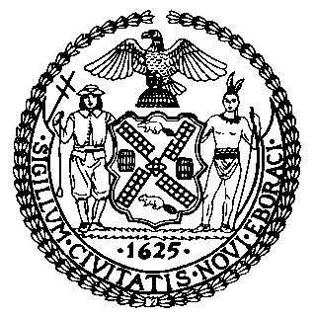 | The Council of the City of New York  Finance Division  Latonia McKinney, Director  Fiscal Impact Statement  Proposed Intro. No. 514-A  Committee: Governmental Operations
Title: A Local Law to amend the administrative code of the city of New York, in relation to expiration of variances granted by the board of standards and appeals. | Sponsors: Council Members Matteo, Ulrich, Johnson, Koo, Rosenthal, Vacca, Gentile and Kallos.
Summary of Legislation: This bill would require the Board of Standards and Appeals (BSA) to provide a notification to the owner of record when a variance is about to expire. Use of such property after the expiration of such term may be a violation of the certificate of occupancy and such notice would inform the owner that the BSA may not approve an application to extend the term of the variance until any penalties for such a violation are paid.
Effective Date: This local would take effect 90 days after becoming law.
Fiscal Year in which Full Fiscal Impact Anticipated: Fiscal 2018
Fiscal Impact Statement:
 | Effective FY18 | FY Succeeding  Effective FY19 | Full Fiscal Impact FY18
Revenues (+) | $0 | $0 | $0
Expenditures (-) | $0 | $0 | $0
Net | $0 | $0 | $0

Impact on Revenues: It is anticipated that there would be no impact on revenues resulting from the enactment of this legislation.

Impact on Expenditures: It is anticipated that there would not be an impact on expenditures resulting from the enactment of this legislation. BSA would use Outlook to send property owners an automated notice six months before their variance is about to expire.

Source of Funds to Cover Estimated Costs: N/A

Sources of Information: New York City Council Finance Division
Mayor’s Office of Legislative Affairs
Board of Standards and Appeals

Estimate Prepared by: Zachary Harris, Legislative Financial Analyst

Estimate Reviewed by: Nathaniel Toth, Deputy Director
John Russell, Unit Head
Eric Bernstein, Counsel

Legislative History: This legislation was introduced to the Council as Intro. No. 514 on October 22, 2014 and referred to the Committee on Governmental Operations. A hearing was held by the Committee on December 14, 2016 and the legislation was laid over. The legislation was subsequently amended and the amended legislation, Proposed Intro. No. 514-A, will be considered by the Committee on May 23, 2017. Upon a successful vote by the Committee, Proposed Intro. No. 514-A will be submitted to the full Council for a vote on May 24, 2017.

Date Prepared: May 24, 2017

