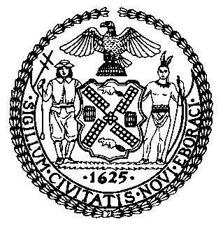 | The Council of the City of New York  Finance Division  Latonia McKinney, Director  Fiscal Impact Statement  Proposed Intro. No. 1573-A  Committee: Sanitation and Solid Waste Management
Title: A Local Law to amend the administrative code of the city of New York, in relation to regulating the trade waste industry | Sponsors: By Council Members Reynoso, Rosenthal, Menchaca, Kallos, Lancman and Lander (by the request of the Mayor)
Summary of Legislation: Proposed Intro. No. 1573-A would add enforcement of environmental, safety and health standards to the powers and duties of the Business Integrity Commission (BIC). Furthermore, it would add violation of law relating to the safety of the general public to the reasons a trade waste license could be suspended.

Effective Date: This local law would take effect immediately.
Fiscal Year in which Full Fiscal Impact Anticipated: Fiscal 2021
Fiscal Impact Statement:
 | Effective FY20 | FY Succeeding  Effective FY21 | Full Fiscal Impact FY21
Revenues (+) | $0 | $0 | $0
Expenditures (-) | $609,199 | $713,873 | $713,873
Net | $609,199 | $713,873 | $713,813

Impact on Revenues: It is estimated that this legislation would have no impact on revenues because full compliance with the legislation is anticipated.

Impact on Expenditures: It is anticipated that there would be a fiscal impact of approximately $609,199 in Fiscal 2020, which includes $356,936 in personal services costs to hire five investigators, one data analyst, and one attorney (partial year salary and fringe due mid-year hiring) and one-time costs of $252,263 in other than personal services to train staff, purchase vehicles, and radio equipment for enforcement functions with commercial carters. In Fiscal 2021 and in the outyears, costs increase to $713,873 to reflect total salary and fringe benefit costs.

Source of Funds to Cover Estimated Costs: General Fund of New York City

Sources of Information: New York City Business Integrity Commission
New York City Council Finance Division

Estimate Prepared by: Jonathan Seltzer, Senior Financial Analyst

Estimate reviewed by: Crilhien Francisco, Unit Head
Noah Brick, Assistant Counsel
Nathan Toth, Deputy Director

Legislative History: This legislation was introduced to the Council as Intro. No. 1573 on May 29, 2019 and referred to the Committee on Sanitation and Solid Waste Management (Committee). The Committee heard the legislation on June 27, 2019 and it was laid over. The legislation was subsequently amended and the amended version, Proposed Intro. No. 1573-A, will be considered by the Committee at a hearing on October 29, 2019. Upon a successful vote by the Committee, Proposed Intro. No. 1573-A will be submitted to the full Council for a vote on October 30, 2019.

Date Prepared: October 24, 2019

