Committee on Consumer and Worker Protection
Sarah Swaine, Legislative Counsel
Glenn Martelloni, Finance Analyst

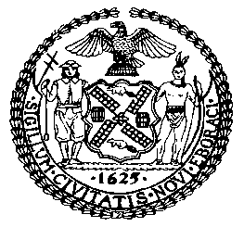

THE COUNCIL OF THE CITY OF NEW YORK
COMMITTEE REPORT OF THE GOVERNMENTAL AFFAIRS DIVISION
Andrea Vazquez, Legislative Director
Rachel Cordero, Deputy Director, Governmental Affairs Division

COMMITTEE ON CONSUMER AND WORKER PROTECTION
Hon. Marjorie Velázquez, Chair

November 22, 2022

INT. NO. 525-B: By Council Members Brewer, Brannan, Yeger, Restler, Holden, Dinowitz, De La Rosa, Sanchez, Williams, Nurse, Velázquez, Kagan, Menin, Farías, Schulman, Riley, Louis, Joseph, Ayala, Hanif, Moya, Krishnan, Gennaro, Narcisse, Hanks, Lee, Won and Ariola

TITLE: A Local Law to amend the administrative code of the city of New York, in relation to the purchase of second-hand catalytic converters

ADMINISTRATIVE CODE: Adds § 20-268.7; Amends § 20-275

- INTRODUCTION

On November 22, 2022, the Committee on Consumer and Worker Protection, chaired by Council Member Marjorie Velázquez, held a vote on Introduction Number 525-B (“Int. No. 525-B”), in relation to the purchase of second-hand catalytic converters. On October 20, 2022, the Committee held a hearing on this bill and heard from the Department of Consumer and Worker Protection (DCWP), the New York City Police Department (NYPD), and other interested stakeholders who provided testimony on the bill. Their feedback was considered in finalizing the latest version of the bill. Int. No. 525-B was approved by the Committee by a vote of eight in the affirmative and zero in the negative.
- BACKGROUND
  - Motor Vehicle Ownership and Theft in New York City
There were nearly two million passenger cars registered to New York City residents in 2018. In 2020, the number of registered passenger cars surged as city residents felt safer relying on private modes of transportation during the pandemic. New York City saw an 18 percent increase in car registrations in June and July of 2020. The result was 62,507 more car registrations in those months than the previous year. In 2021, vehicle registration rose by 579,811, and as of July of 2022, another 421,758 vehicles were already registered in the city. Given that residential properties throughout the five boroughs often lack personal garages, and the high cost of municipal and private parking garages, most car owners in the City are forced to park on the street, and therefore contend with a greater opportunity for theft.
Decreasing crime trends for certain crimes in New York exclude motor vehicle theft, which is on the rise. The volume of motor vehicle theft increased significantly in 2020. By the end of the year, New York saw a 54.3% increase in motor vehicle theft statewide, and a 67.7% increase in New York City. A significant share of this increase is attributable to New York City as motor vehicle theft outside the City rose to a lesser extent – 44%. Motor vehicle thefts continue to escalate, and remain substantially higher than pre-pandemic levels throughout the city.
b. Catalytic Converter Theft
Catalytic converters are a part of a vehicle’s exhaust system located between the engine and muffler, and a key component of the emissions control system, reducing the amount of pollution exuding from the tailpipe. All modern vehicles with internal combustion engines have a catalytic converter, as they have been required on new cars since 1975. New York State also requires yearly emission testing; if a car does not have a catalytic converter, it will fail the test, making it illegal to drive a vehicle in New York without a catalytic converter. To decrease the amount of smog that would otherwise release from the tailpipe, catalytic converters contain precious metals such as rhodium, palladium and platinum, which can be salvaged and sold at a high price. As such, individuals can sell a stolen catalytic converter for up to $300, or up to $1,400 if the part comes from a hybrid vehicle.
According to NYPD data, catalytic converter theft in New York City has risen exponentially this past year. Citywide, as of mid-August 2022, catalytic converter theft had increased by 269% as compared to figures from the same period last year.
Reported Catalytic Converter Theft in NYC
 | 2021 | 2022 | Percent Increase
Citywide | 1505 | 5548 | 269%
Brooklyn | 403 | 1534 | 281%
Manhattan | 195 | 584 | 199%
Queens | 574 | 2092 | 264%
Bronx | 286 | 976 | 241%
Staten Island | 47 | 362 | 670%
*Year-to-Date: 8/14/2021; 8/14/2022
A challenging aspect of preventing catalytic converter theft is that it takes little over a minute to remove such device from a vehicle, requiring readily available equipment such as a common jack lift and a saw. Thefts are rather simple endeavors, but reports show elaborate tactics employed to make theft more prevalent and widespread, such as arriving and exiting the scene in a getaway vehicle, and deploying lookouts along neighborhood blocks to observe parked vehicles.
The NYPD introduced an etching program that allows individuals to inscribe a code/number to their vehicle’s catalytic converter, and link that code to a website where it can be tracked. If NYPD or a potential buyer later comes across such catalytic converter, the number will be visible and can be tracked to the original vehicle, which permits an easy determination regarding the chain of custody of the catalytic converter and whether the part might have been stolen. Without such labeling, individuals may sell stolen catalytic converters to unknowing buyers, claiming the removed part was retrieved from a willing vehicle owner. The NYPD is also attempting to deter catalytic converter theft by expanding undercover investigations and inspections of auto body shops.
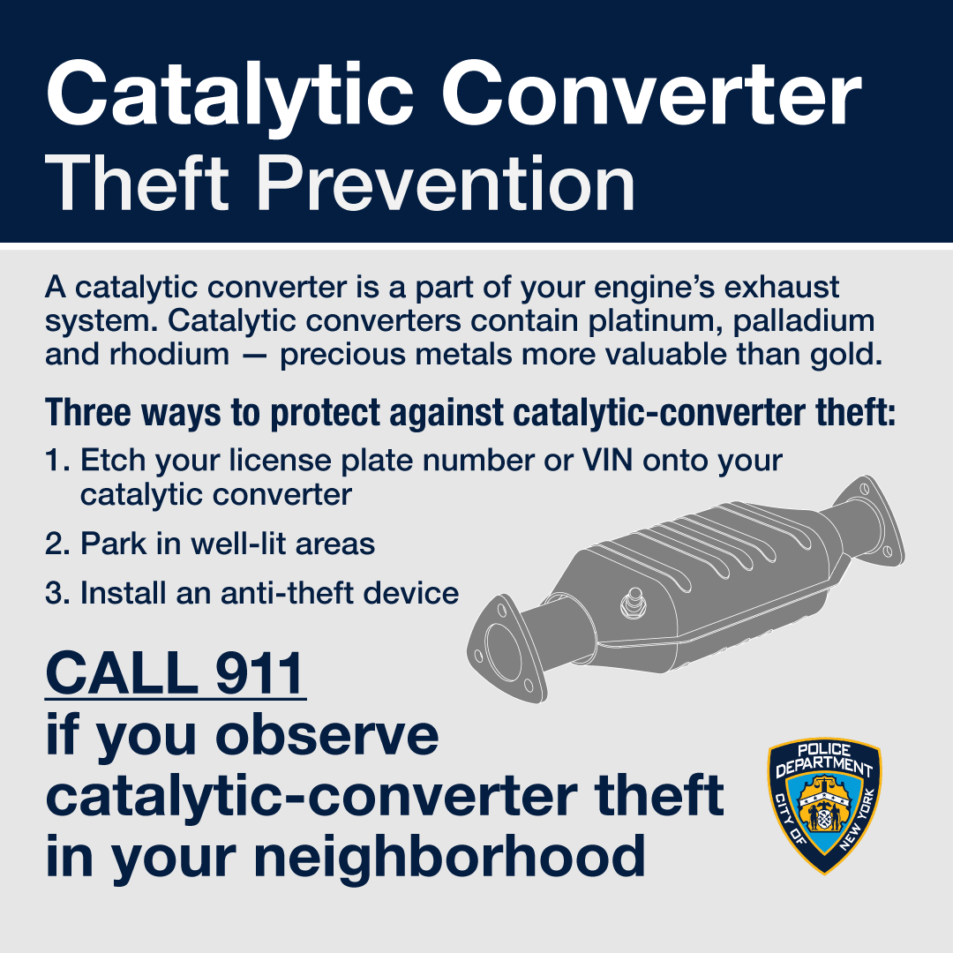
New York State responded to the growing concern over catalytic converter theft by passing legislation enhancing reporting requirements for sales of these parts by certain industries. On October 18, 2022, Governor Kathy Hochul signed State legislation that aims to impede the theft of catalytic converters by imposing restrictions on the purchase, sale and possession of catalytic converters by vehicle dismantlers, scrap processors and others. In addition to the maintenance of catalytic convertor ownership records, the law will require that all new motor vehicle dealers and qualified dealers offer kits to any consumer purchasing a new motor vehicle.
The Council is considering legislation to address the issue more directly at the local level. Specifically, Int. No. 525-B would expand record keeping requirements related to used catalytic converter purchases for dealers in second-hand articles. These additional requirements aim to address consumers’ particular vulnerability to catalytic converter theft in the City.
- LEGISLATIVE ANALYSIS
- Int. No. 525-B

This bill would amend subchapter 11 of title 20 of the Administrative Code (Ad Code) to add new section 20-268.7, which would create new requirements for the purchase of second-hand catalytic converters in the portion of the Ad Code containing licensing requirements for dealers in second-hand goods. It would require that when anyone licensed as a second-hand dealer purchases a second-hand catalytic converter, they must first obtain certain documents from the seller to show the catalytic converter is consistent with manufacturer specifications. Documentation would include: year, make and model of the vehicle from which the part was removed, as well as the unique identifying number on the catalytic converter if one exists; and a copy of certificate of title or other documentation for such vehicle to show the seller has rights to either the vehicle from which the part was removed or to the part itself. Such documentation would be subject to inspection in real time by the Department of Consumer and Worker Protection, the Fire Department and NYPD, and be maintained for at least six years after purchase. Violators would be subject to monetary penalties, as well as license suspension or revocation. This bill would take effect 120 days after enactment.
Since introduction, the bill has been amended as follows. First, provisions were amended to exclude vehicle dismantlers, and to confine the recording obligations to those licensed as dealers in second-hand articles. Second, provisions were amended to expand the recording requirement to include the unique identifying number of the second-hand catalytic converter should one exist. Third, provisions permitting a written record were removed to make the recording requirement exclusively electronic, so that inspecting agencies may access records in real time. Fourth, provisions were modified to extend the maintenance of the records from at least five years to at least six years. Finally, the effective date has doubled from 60 days to 120 days to allow ample time for notice and an opportunity to comply.

Int. No. 525-B

By Council Members Brewer, Brannan, Yeger, Restler, Holden, Dinowitz, De La Rosa, Sanchez, Williams, Nurse, Velázquez, Kagan, Menin, Farías, Schulman, Riley, Louis, Joseph, Ayala, Hanif, Moya, Krishnan, Gennaro, Narcisse, Hanks, Lee, Won and Ariola

A Local Law to amend the administrative code of the city of New York, in relation to the purchase of second-hand catalytic converters

Be it enacted by the Council as follows:
Section 1. Subchapter 11 of title 20 of the administrative code of the city of New York is amended by adding a new section 20-268.7 to read as follows:
§ 20-268.7 Purchase of second-hand catalytic converters. a. Before any dealer in second-hand articles as defined by this subchapter, other than a vehicle dismantler, as defined in section 415-a of the vehicle and traffic law, purchases a second-hand catalytic converter, such dealer must obtain from the seller the following information:
1. The year, make, model and vehicle identification number for the vehicle from which the second-hand catalytic converter was removed;
2. A copy of the certificate of title or other documentation indicating that the seller has an ownership interest in the vehicle described in paragraph 1, or where the seller is the owner of a motor vehicle repair shop, as defined in section 398-b of the vehicle and traffic law, and the second-hand catalytic converter was removed by such owner in connection with a repair of the vehicle, the name and address of the owner of such vehicle and copies of all invoices related to such repair; and
3. The unique identifying number of the second-hand catalytic converter, if any.
b. Such dealer must determine that the second-hand catalytic converter is consistent with the manufacturer’s specifications for a catalytic converter from the vehicle identified in the information provided pursuant to subdivision a and must document such determination.
c. Such dealer shall maintain an electronic record of the information provided pursuant to subdivision a for a minimum of six years from the date of the purchase of the second-hand catalytic converter. Such electronic record shall be created by the dealer at the time of each transaction. Such electronic record shall be maintained in a manner to be specified in rules of the police commissioner, which may include the real-time sharing or accessing of such records in an electronic format and/or through use of an internet website designated by the police commissioner. Such records shall be open to the inspection of officers and employees of the department and officers of the fire department or the police department during regular and usual business hours.
§ 2. Subdivision d of section 20-275 of the administrative code of the city of New York, as added by local law number 197 for the year 2017, is amended to read as follows:
d. The commissioner may suspend or revoke a second-hand automobile dealer license if the licensee violates section 20-268.1, 20-268.2, 20-268.3, 20-268.4, 20-268.5, 20-268.7, or 20-271 or any rule or regulation issued thereunder, provided, however, that the commissioner shall suspend or revoke a second-hand automobile dealer license upon the third violation by the licensee within three years of the first violation.
§ 3. This local law takes effect 120 days after it becomes law.

Warren, Tamara, “What Will New Yorkers Do With the Cars They Purchased During the Pandemic?” Car and Driver, 15 Aug. 2021; available at: https://www.caranddriver.com/features/a37293032/what-will-new-york-do-with-the-cars-they-purchased-during-the-pandemic/#
Ibid.
Kamer, Foster, “The Great Gotham Vroom Boom of 2020,” The New York Times, 12 Aug. 2020; available at: Buying Cars — and Parking Cars — in New York City - The New York Times (nytimes.com)
Sheinerman, Marie-Rose, “Car Owners Say It’s ‘Virtually Impossible’ to Find Street Parking in New York City,” Bloomberg, 16 Aug. 2022; available at: https://www.bloomberg.com/news/articles/2022-08-16/where-to-park-in-nyc-rise-in-new-cars-outdoor-dining-deepen-nightmare#:~:text=With%20some%20New%20Yorkers%20shunning,to%20eat%20up%20street%20space
Ibid.
“Crime in New York State 2020 Final Data,” Division of Criminal Justice Services, Dec. 2021; available at: https://www.criminaljustice.ny.gov/crimnet/ojsa/Crime-in-NYS-2020.pdf
Ibid.
Ibid.
Parascandola, Rocco, “NYPD Reports 51% Surge in Stolen Cars this Year,” Daily News, 12 June 2022; available at: https://www.nydailynews.com/new-york/nyc-crime/ny-car-vehicle-theft-surge-careless-motorists-nypd-20220612-eojbb2hhx5a3tn34vzhilc2fdq-story.html
Popely, Rick. “What Is a Catalytic Converter? - CARFAX.” CARFAX, 22 Sept. 2022, www.carfax.com/blog/catalytic-converters.
Id.
Sam, S. (2022, September 1). Know Everything about New York Catalytic Converter Laws. Way Blog. Retrieved October 14, 2022; available at: https://www.way.com/blog/new-york-catalytic-converter-laws/.
“What’s a Catalytic Converter and Why Do People Steal Them? | News | Cars.com.” Cars.com, 13 Feb. 2022; available at: www.cars.com/articles/whats-a-catalytic-converter-and-why-do-people-steal-them-446861.
“More Than 5000 Catalytic Converter Thefts Reported in NYC.” New York Post, 20 Aug. 2022; available at: www.nypost.com/2022/08/20/more-than-5000-catalytic-converter-thefts-reported-in-nyc.
Ibid.
Ibid.
“Catalytic-converter Thieves Work in Queens Robbery Video.” New York Post, 3 Sept. 2022; available at: www.nypost.com/2022/09/03/catalytic-converter-thieves-work-in-queens-robbery-video.
Ibid.
“NYPD Distributes New Tracking Device at Combat Catalytic Converter Theft Event - silive.com.” Silive, 15 July 2022, www.silive.com/news/2022/07/nypd-distributes-new-tracking-device-at-combat-catalytic-converter-theft-event.html.
Ibid.
Moses, Dean. “NYPD Is Cutting off Catalytic Converter Thieves With Anti-theft Label Enrollment | amNewYork.” amNewYork, 19 July 2022; available at: www.amny.com/news/nypd-is-cutting-off-catalytic-converter-thieves-with-anti-theft-label-enrollment .
Tremayne-Pengelly, Alexandra. “Thefts of Catalytic Converters Have Quadrupled in New York City This Year | Observer.” Observer, 20 July 2022; available at: www.observer.com/2022/07/thefts-of-catalytic-converters-have-quadrupled-in-new-york-city-this-year.
“NY State Senate Bill S9428.” NY State Senate, 26 May 2022; available at: www.nysenate.gov/legislation/bills/2021/S9428.

