THE COUNCIL OF THE CITY OF NEW YORK
RESOLUTION NO. 1166

Resolution approving with modifications the decision of the City Planning Commission on Application No. N 190364 ZRQ, for an amendment of the text of the Zoning Resolution (L.U. No. 551).

By Council Members Salamanca and Moya

WHEREAS, Peninsula Rockaway Limited Partnership, filed an application pursuant to Section 201 of the New York City Charter, for an amendment of the text of the Zoning Resolution of the City of New York, modifying the use provisions of Article VII, Chapter 4 and modifying APPENDIX F for the purpose of establishing a Mandatory Inclusionary Housing area utilizing Options 1 and 2, which in conjunction with the related actions would facilitate a new mixed-use development with affordable housing, commercial, and community facility uses within a large-scale general development (LSGD), on property generally bounded by Beach 50th Street, Beach Channel Drive, Beach 53rd Street, and Rockaway Beach Boulevard (Block 15843, Lot 1; Block 15842, Lots 1 and p/o Lot 100; and Block 15857, Lots 1 and p/o Lot 7) in the Edgemere neighborhood of Queens, Community District 14 (Application No. N 190364 ZRQ) (the "Application");
WHEREAS, the City Planning Commission filed with the Council on September 26, 2019 its decision dated September 25, 2019 (the "Decision"), on the application;
WHEREAS, the Application is related to applications C 190325 ZMQ (L.U. No. 550), a zoning map amendment to eliminate from an R5 district a C1-2 district, change an R5 district to a C4-4 district, and change a C8-1 district to a C4-3A district; C 190366 ZSQ (L.U. No. 552), a special permit to provide relief from regulations governing yard requirements, street wall location, maximum base height, maximum building height and number of stories; C 190375 ZSQ (L.U. No. 553), a special permit to modify surface area requirements for signage; and C 190251 MMQ (L.U. No. 554), a city map amendment to re-establish a portion of former Beach 52nd Street to connect from Rockaway Beach Boulevard to Shore Front Parkway
WHEREAS, the Decision is subject to review and action by the Council pursuant to Section 197-d of the City Charter;
WHEREAS, upon due notice, the Council held a public hearing on the Decision and Application on October 3, 2019;
WHEREAS, the Council has considered the land use implications and other policy issues relating to the Decision and Application; and
WHEREAS, the Council has considered the relevant environmental issues, including the positive declaration, issued on March 16, 2018 (CEQR No. 18DCP124Q) and a Final Environmental Impact Statement (FEIS) for which a Notice of Completion was issued on September 13, 2019 which identified significant adverse impacts with respect to community facilities (public schools and childcare), active open space, transportation (traffic, transit bus and pedestrians), mobile air quality, and construction activities related to noise and traffic and potential significant adverse impacts related to hazardous materials, stationary air quality and noise would be avoided through the placement of (E) designations (E-532) on the project site . In addition, the FEIS analyzed the revised application called the Flexibility Alternative as an alternative to the original application, and concluded that the modified application would result in the same or similar impacts as the original application and the identified significant adverse impacts and proposed mitigation measures are included in the Restrictive Declaration attached as Exhibit A to the decision for C 190366 ZSQ.
RESOLVED:
Having considered the FEIS with respect to the Decision and Application, the Council finds that:
- The FEIS meets the requirements of 6 N.Y.C.R.R. Part 617;
- Consistent with social, economic and other essential considerations, from among the reasonable alternatives thereto, the action is one which minimizes or avoids adverse environmental impacts to the maximum extent practicable; and
- The adverse environmental impacts disclosed in the FEIS will be minimized or avoided to the maximum extent practicable by incorporating, as conditions to the approval, pursuant to the restrictive declaration attached as Exhibit A to City Planning Commission report for C 190366 ZSQ, those project components related to environment and mitigation measures that were identified as practicable.
The Decision, together with the FEIS constitute the written statement of facts, and of social, economic and other factors and standards that form the basis of this determination, pursuant to 6 N.Y.C.R.R. §617.11(d).
Pursuant to Sections 197-d and 200 of the City Charter and on the basis of the Decision and Application, and based on the environmental determination and consideration described in the report, N 190364 ZRQ, incorporated by reference herein, and the record before the Council, the Council approves the Decision of the City Planning Commission with the following modifications:
Matter underlined is new, to be added;
Matter strikethrough is to be deleted;
Matter within # # is defined in Section 12-10;
Matter double struck out is old, deleted by the City Council;
Matter double-underlined is new, added by the City Council
* * * indicates where unchanged text appears in the Zoning Resolution

* * *
Article VII
ADMINISTRATION
Chapter 4
Special Permits by the City Planning Commission

* * *
74-74
Large-Scale General Development

* * *
74-744
Modification of use regulations

(a) #Use# modifications
(1) Waterfront and related #commercial uses#

* * *

(2) Automotive sales and service #uses#

* * *

(3) Retail establishments

* * *

(4) #Physical culture or health establishments#

For a #large-scale general development# located within an #MIH site#, in a C4 District within Queens Community District 14, #physical culture or health establishments# shall be permitted as-of-right. The special permit provisions of Section 73-36 (Physical Culture or Health Establishments) shall not apply.
* * *
APPENDIX F
Inclusionary Housing Designated Areas and Mandatory Inclusionary Housing Areas

* * *
Queens

* * *
QUEENS Community District 14

* * *

Map 3 – [date of adoption]

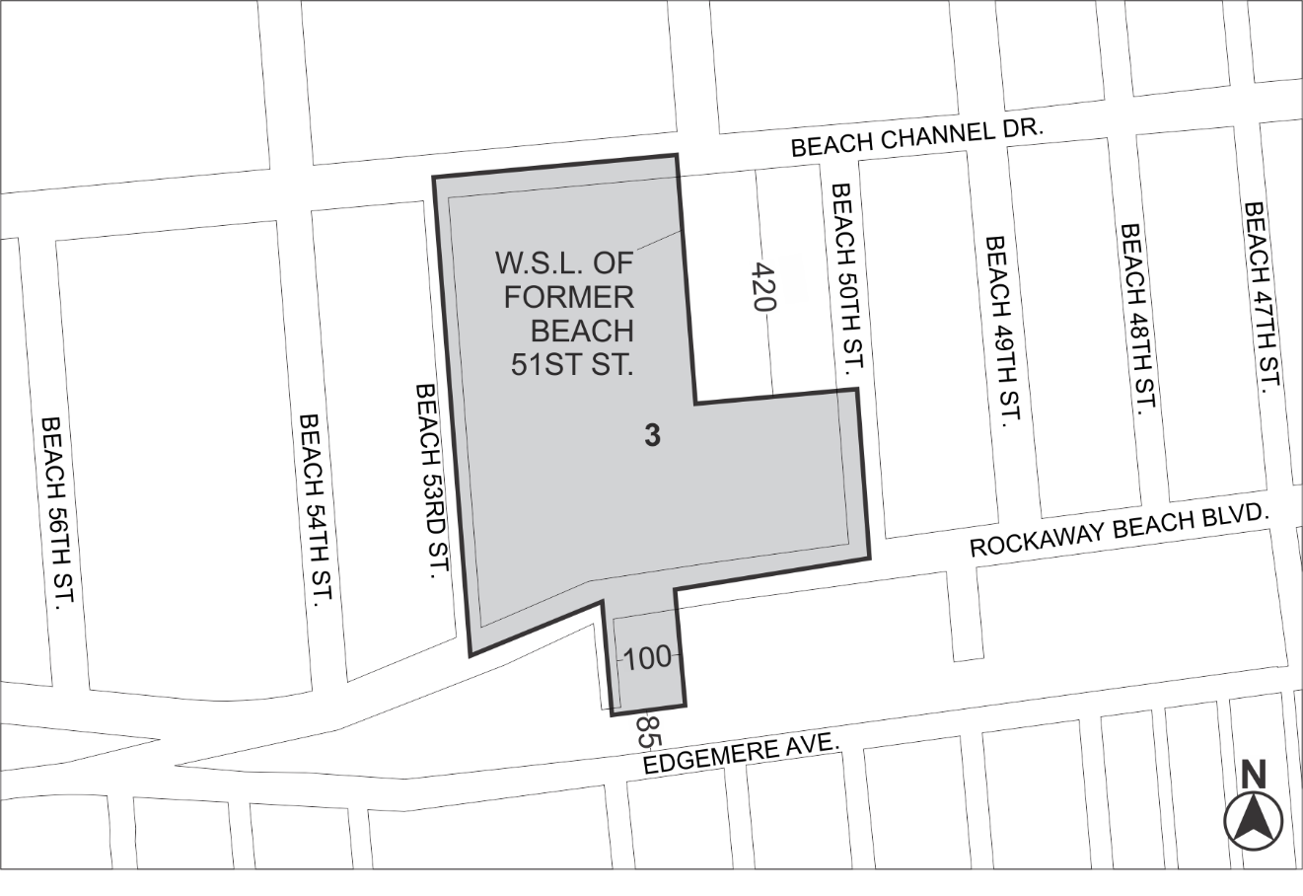

Mandatory Inclusionary Housing area (see Section 23-154(d)(3))
Area 3 ─ [date of adoption], MIH Program Option 1 and Option 2

Portion of Community District 14, Queens

* * *

Adopted.

Office of the City Clerk, }
The City of New York, } ss.:

I hereby certify that the foregoing is a true copy of a Resolution passed by The Council of The City of New York on November 14, 2019, on file in this office.

.....................................................
City Clerk, Clerk of The Council

