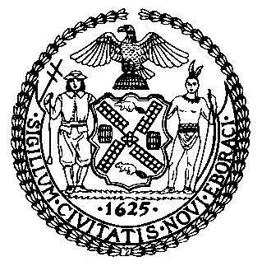 | The Council of the City of New York  Finance Division  Latonia Mckinney, Director  Fiscal Impact Statement  Intro. No: 484-A  Committee: Health
Title: A local law to amend the administrative code of the city of New York, in relation to prohibiting smoking and the use of electronic cigarettes in the common areas of all multiple dwellings. | Sponsor(S): Council Members Vacca, Barron, Constantinides, Gentile, Johnson, Kallos, Koo, Richards, Rodriguez, Vallone and Cohen

Summary of Legislation: Currently, smoking and the use of electronic cigarettes is prohibited in common areas of multiple dwellings containing ten or more units. The proposed legislation would additionally prohibit smoking and the use of electronic cigarettes in common areas in multiple dwellings with fewer than ten units.
Effective Date: This legislation would take effect 180 days after becoming law.

Fiscal Year In Which Full Fiscal Impact Anticipated: Fiscal 2018
Fiscal Impact Statement:

 | Effective FY18 | FY Succeeding Effective FY 19 | Full Fiscal Impact FY 18
Revenues | $0 | $0 | $0
Expenditures | $0 | $0 | $0
Net | $0 | $0 | $0

Impact on Revenues: It is anticipated that this legislation would not have an impact on revenues.

Impact on Expenditures: It is estimated that this bill would not have an impact on expenditures because the relevant agencies would use existing resources to enforce the legislation.

Source of Funds To Cover Estimated Costs: N/A
Source of Information: New York City Council Finance Division
New York City Department of Health and Mental Hygiene
Estimate Prepared By: Jeanette Merrill, Legislative Financial Analyst

Estimate Reviewed By: Nathan Toth, Deputy Director, NYC Council Finance Division
Crilhien R. Francisco, Unit Head, NYC Council Finance Division
Eric Bernstein, Counsel, NYC Council Finance Division
Legislative History: This legislation was introduced to the full Council on September 23, 2014 and was referred to the Committee on Health (Committee). The Committee held a hearing on April 27, 2017 and the bill was laid over. The bill was subsequently amended, and the Committee will vote on the amended legislation, Proposed Int. No. 484-A, at a hearing on August 8, 2017. Upon successful vote by the Committee, the full Council will vote on the legislation on August 9, 2017.
Date Prepared: August 2, 2017

