Committee Staff: | Brenda McKinney, Counsel  Chloë Rivera, Senior Policy Analyst  Eisha Wright, Finance Unit Head

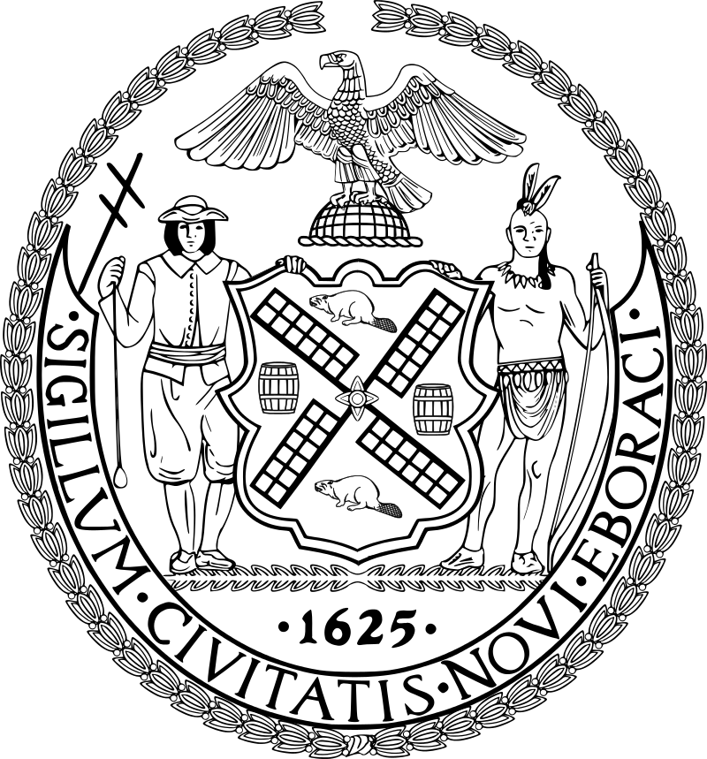

The Council of the City of New York

Briefing Paper of the Human Services Division
Jeffrey Baker, Legislative Director
Andrea Vazquez, Deputy Director

Committee on Women and Gender Equity

Hon. Darma V. Diaz, Chair

September 14, 2021

Oversight: Menstrual Equity in New York City

Introduction
On September 14, 2021, the Committee on Women and Gender Equity, chaired by Council Member Darma V. Diaz, will conduct an oversight hearing on Menstrual Equity in New York City (“NYC” or “City”). Witnesses invited to testify include representatives from the NYC Commission on Gender Equity (CGE), advocacy groups and organizations, community members and other interested stakeholders.
Background
Menstruation, Menstrual Products, and Menstrual Equity
Globally, approximately 52 percent of the female population (26 percent of the total population) is of reproductive age. Most of these women and girls will menstruate each month for between two and seven days. Menstruation is a natural part of the reproductive cycle, in which blood is lost through the vagina. However, in most parts of the world, it remains taboo and is rarely addressed. As a result of the stigmas associated with menstruation, the practical challenges of menstrual hygiene are made even more difficult by various socio-cultural factors. To manage menstruation hygienically, it is essential that women and girls have access to menstrual products.
Menstrual products are vital for the health, well-being and full participation of women and girls. Inadequate menstrual hygiene management is associated with both health and psycho-social issues, particularly among low-income women. According to Jennifer Weiss-Wolf, who coined the term “menstrual equity,” the average woman spends $9 per month on period products and “[i]n order to have a fully equitable and participatory society, we must have laws and policies that ensure menstrual products are safe and affordable and available for those who need them.” Despite this, it has been reported that a lack of access to menstrual products can cause emotional duress, physical infection, disease and can lead to cervical cancer, and access to menstrual products continues to be limited for vulnerable populations especially.
While it was estimated that 25 million women were living below the poverty line in the United States (U.S.) before the COVID-19 pandemic, putting them at risk of living without consistent access to menstrual products, the pandemic has exacerbated these issues. Women across all socioeconomic backgrounds have disproportionately borne the economic and social harm caused by the pandemic. This includes lost employment or housing, new and “crushing” caregiving responsibilities and mental health challenges. According to a survey of 1,010 U.S. teens who menstruate between ages 13 to 19 commissioned by Thinx and PERIOD, “period poverty,” or the inability to access menstrual hygiene, has jumped to nearly a quarter of all U.S. students, an increase from one in 5 in 2019. According to Sanjay Wijesekera, former UNICEF Chief of Water, Sanitation and Hygiene, “meeting the hygiene needs of all adolescent girls is a fundamental issue of human rights, dignity, and public health,” particularly where period poverty can lead to avoidable stigmatization and health issues.
Recent Federal and Local Responses to Period Poverty
In 2016, the Council passed a package of legislation, known as the 2016 Menstrual Equity package, focused on increasing access to menstrual products, and which included Local Laws 82, 83 and 84 of 2016. In doing so, New York became the first U.S. city to pass comprehensive legislation to increase access to menstrual products.
As part of its effort to provide relief during the pandemic, the U.S. Congress included a long sought-after menstrual product provision in the Coronavirus Aid, Relief, and Economic Securities (“CARES”) Act in March 2020, which reclassified menstrual products as medical products eligible for covered by health savings accounts (HSAs) and flexible spending accounts (FSAs). In NYC, the DOE provided menstrual products at emergency Meal Hubs serving low-income students and their families. Yet, advocates stress there is still a long way to go. These are potentially temporary changes, especially since the CARES Act does not specify whether menstrual products will remain excluded from tax law after the COVID-19 pandemic is over. The cost of menstrual products is still not covered by health insurance or by public benefits programs such as the Supplemental Nutrition Assistance Program (“SNAP”) or Women, Infants, and Children (“WIC”) benefits.
Issues and Concerns
Advocates and students have revealed flaws in the implementation of the 2016 laws, which increased access to menstrual products for the City’s shelter residents, students and incarcerated individuals.
The Implementation of Local Law 82 of 2016
On April 20, 2017, the New York Times reported on “the way menstruation can be treated in New York’s jails: as an inconvenience, almost a surprise, to be met, at times, with an improvised response.” One woman, who had just gotten her period when she was arrested, was told by the officers in charge of her holding cell in a Queens police station that they would need to call an ambulance to secure her a pad. After about an hour and a half, she received a sterile gauze pad, normally used to bandage a wound. At the Rose M. Singer Center on Rikers Island, menstrual product distribution is at the discretion of individual officers, which a jail services social worker with Brooklyn Defender Services said results in some women reporting no issues while others have to beg for these products. Overall, inconsistent access to menstrual products has led to pads and tampons becoming bargaining chips, “used to maintain control by correction officers, or traded among incarcerated women…” Additionally, more often than not pads were “flimsy” and tampons were harder to get.
The Implementation of Local Law 83 of 2016
In conversations with Committee staff, not-for-profit shelters have shared that while the NYC Department of Homeless Services provides menstrual products for their clients, they are in limited supply and providers are required to pick up and transport the supplies from a warehouse in Brooklyn on a monthly basis themselves. Providers have also shared that residents complain that the products provided are not very absorbent or comfortable, and are only used “in desperation.” Additionally, providers believe stigma is a barrier to access for many clients.
The Implementation of Local Law 84 of 2016
In 2018, after realizing none of their school restrooms had appropriate receptacles for disposing of period products, Brooklyn-based Girl Scout Troop 2653 collected classmates’ signatures and presented their demands to their principal, who then rectified the situation. Troop 2653 then spent the next two years researching, calling, writing and physically visiting other schools in their neighborhoods and found that only four of 23 Brooklyn schools met the standards of providing both sanitary bins in each stall and free menstrual products in restrooms.
Also in 2018, Girl Scout Troop 2699 recognized that young students at their elementary school were in need of menstrual products, but did not have easy access due to the 2016 laws only applying to sixth through 12th grades. This is despite the fact that many young students begin menstruation before reaching sixth grade, and the median age at menarche in the U.S. decreased from 12.1 in 1995 to 11.9 in 2013-2017. Accordingly, Troop 2699 recommended that Local Law 84 of 2016 be amended to be inclusive of fourth and fifth graders.
In response to the coronavirus outbreak in March 2020, then-Governor Andrew Cuomo signed an Executive Order directing all schools in the state of New York to close by March 18, 2020, which left students that relied on their schools to access menstrual products in need. On April 6, 2020, Mya Abdelwahab and Nicole Soret, then-juniors at The Young Women’s Leadership School of Astoria, and co-founders of Femstrate, a social movement with a mission to bring period equity to every NYC school, wrote a letter to the Mayor and then-DOE Chancellor Richard Carranza, to ask the City to continue providing menstrual products during remote learning. About a month later on May 14, 2020, with additional advocacy by elected officials, the DOE Tweeted that they were making their existing inventory of menstrual products available to the public at 211 Meal Hubs (which were open between June 28, 2020 and September 10, 2021), across NYC. While public school students returned to school, in-person, on September 13, 2021, the DOE recognizes certain situations when students must be remote, including when they are “quarantining or their school buildings are closed in whole or in part.” As such, it is essential to understand the contingency plan in place to ensure students continue to have access to menstrual products when doing remote learning.
Conclusion
At today’s hearing, the Committee will seek an overview of the implementation of the 2016 laws, including information on the procurement and distribution of period products. The Committee is also interested in receiving testimony that can inform better policy in order to achieve real menstrual equity in NYC.

Sarah House, Thérèse Mahon and Sue Cavill, Menstrual hygiene matters: A resource for improving menstrual hygiene around the world, WaterAid (2012), available at http://www.susana.org/_resources/documents/default/3-2210-21-1426498269.pdf.
Id.
Id.
Id.
Id.
ACLU National Prison Project, “Menstrual Equity: A Legislative Toolkit” ACLU (Dec. 2019), 1, 3, available at https://www.aclu.org/sites/default/files/field_document/121119-sj-periodequitytoolkit.pdf; Jennifer Weiss-Wolf, Periods Gone Public: Taking a Stand for Menstrual Equity xvi (2017); Colin Sumpter and Belen Torondel, A Systematic Review of the Health and Social Effects of Menstrual Hygiene Management, PLoS ONE 8(4): e62004 doi:10.1371/journal.pone.0062004 (2013), available at https://journals.plos.org/plosone/article?id=10.1371/journal.pone.0062004.
Emma Goldberg, “Many Lack Access to Pads and Tampons. What Are Lawmakers Doing About It?” NY Times (Jan. 2021), available at https://www.nytimes.com/2021/01/13/us/tampons-pads-period.html.
Jennifer Weiss-Wolf, Periods Gone Public: Taking a Stand for Menstrual Equity xvi (2017).
Jennifer Weiss-Wolf, “America’s Very Real Menstrual Crisis,” TIME (Aug. 11, 2015), available at http://time.com/3989966/america-menstrual-crisis/.
Thinx and PERIOD, “State of the Period 2021: The widespread impact of period poverty on US students” (2021), available at https://mcusercontent.com/29f1178890c5edd62b65fd8b6/files/5273bbfb-0ddb-c6fa-1e13-f67fa2ac54e7/State_of_the_Period_2021.pdf.
Bérénice Magistretti, “FemBeat: Period Poverty Is A Thing, Even In The U.S.” Forbes (Jan. 25, 2019), available at https://www.forbes.com/sites/berenicemagistretti/2019/01/25/fembeat-period-poverty-is-a-thing-even-in-the-u-s/#9f705ff569ec.
Supra note 10.
See UN Women, “COVID-19 and its economic toll on women: The story behind the numbers” UN (Sept. 16, 2020), available at https://unwomen.org/en/news/stories/2020/9/feature-covid-19-economic-impacts-on-women; see also Diana Boesch and Shilpa Phadke, “When Women Lose All the Jobs: Essential Actions for a Gender-Equitable Recovery” Center for American Progress (Feb. 1, 2021), available at https://www.americanprogress.org/issues/women/reports/2021/02/01/495209/women-lose-jobs-essential-actions-gender-equitable-recovery/.
Megan DiTrolio, “The U.S. Economy Lost 140,000 Jobs In December. All Were Held by Women” Marie Claire (Jan. 9, 2021), available at https://www.marieclaire.com/career-advice/a35167076/job-loss-december-2020-women/.
Leah Rodriguez, “Women of Color Are Experiencing the Biggest Economic Losses Amid COVID-19 Pandemic” Global Citizen (Apr. 8, 2020), available at https://www.globalcitizen.org/en/content/women-of-color-disproportionately-unemployed-covid/.
Id.
Shefali Luthra, “Survey shows COVID-19 is disproportionately harming women’s mental health” The 19th (Dec. 18, 2020), available at https://19thnews.org/2020/12/survey-shows-covid-19-is-disproportionately-harming-womens-mental-health/.
Supra note 10.
Erica Sánchez and Leah Rodriguez, “Period Poverty: Everything You Need to Know” Global Citizen (Feb. 5, 2019), available at https://www.globalcitizen.org/en/content/period-poverty-everything-you-need-to-know/.
Supra note 10.
Id.
UNICEF, “FAST FACTS: Nine things you didn't know about menstruation” UN (May 25, 2018), available at https://www.unicef.org/press-releases/fast-facts-nine-things-you-didnt-know-about-menstruation#_edn2.
Supra note 10; Jill Litman, “Menstruation Stigma Must Stop. Period.” The Public Health Advocate, University of California, Berkeley, available at https://pha.berkeley.edu/2018/06/05/menstruation-stigma-must-stop-period/.
City of New York, Mayor de Blasio Signs Legislation Increasing Access to Feminine Hygiene Products for Students, Shelter Residents and Inmates, Office of Mayor Bill de Blasio (Jul. 13, 2016), available at https://www1.nyc.gov/office-of-the-mayor/news/611-16/mayor-de-blasio-signs-legislation-increasing-access-feminine-hygiene-products-students-.
Note: With this package, New York City guaranteed access to these essential products for all female Department of Correction inmates; persons residing in a City shelter and youth under the care of certain Children’s Services facilities – including transgender, intersex and gender non-conforming New Yorkers; and public school students. Id.
New York City Council, Local Law 82 of 2016 (Int. 1122-A, 2016) “Requiring that the DOC issue feminine hygiene products to inmates,” enacted Jul. 13, 2016, available at https://legistar.council.nyc.gov/LegislationDetail.aspx?ID=2637117&GUID=4D97B9EE-4986-4B87-B846-2E52A329695A&Options=ID|Text|&Search=1122.
New York City Council, Local Law 83 of 2016 (Int. 1123-A, 2016) “Provision of feminine hygiene products,” enacted Jul. 13, 2016, available at https://legistar.council.nyc.gov/LegislationDetail.aspx?ID=2637112&GUID=31322AF8-376A-4D7F-93B2-4243BA5E4181&Options=ID|Text|&Search=1123.
New York City Council, Local Law 84 of 2016 (Int. 1128-A, 2016) “Provision of feminine hygiene products in schools,” enacted Jul. 13, 2016, available at https://legistar.council.nyc.gov/LegislationDetail.aspx?ID=2637114&GUID=834E4DFC-7F14-4E1E-812F-2CD862A4FC1D&Options=ID|Text|&Search=1128.
Supra note 7.
Supra note 9.
Note: The stimulus bill designed to boost business and individuals impacted by the COVID-19 recognizes menstrual products — tampons, pads, liners, cups, sponges, or similar products used for menstruation — as medical expenses in section 3702. See the Coronavirus Aid, Relief, and Economic Securities (“CARES”) Act (Mar. 27, 2020), available at https://www.congress.gov/bill/116th-congress/house-bill/748/text.
Note: The CARES Act also allows anyone with HSA or FSA funds to file for reimbursement of menstrual products purchased in 2020. Prior to this new designation, items like contact lens solution and sunscreen were included, whereas tampons, pads, cups, and period underwear were not. See CARES Act (Mar. 27, 2020), Id.; see also Lauren Phillips, “You Can Finally Use FSA or HSA Money to Buy Pads and Tampons” Real Simple (Mar. 30, 2020), available at https://www.realsimple.com/work-life/money/saving/hsa-menstrual-care-products-cares-act.
Chloe Atkins, “Two NYC students push to ensure period hygiene products are given out” NBC News (May 24, 2020), available at https://www.nbcnews.com/news/us-news/two-nyc-students-push-ensure-period-hygiene-products-are-given-n1213456.
Kristen Bellstrom, “Bill to End the ‘Tampon Tax’ Finally Goes to New York Governor” Fortune (May 26, 2016), available at http://fortune.com/2016/05/26/new-york-tampon-tax/.
Supra note 31.
See New York State Department of Health, Medicaid in New York State (n.d.), available at http://www.health.ny.gov/health_care/medicaid/#services.
See U.S. Department of Agriculture, What Can SNAP Buy? (Apr. 14, 2021), available at http://www.fns.usda.gov/snap/eligible-food-items.
Jennifer Weiss-Wolf, “Helping Women and Girls. Period” NY Times (Jan. 28, 2015), available at http://kristof.blogs.nytimes.com/2015/01/28/helping-women-and-girls-period/.
Zoe Greenberg, “In Jail, Pads and Tampons as Bargaining Chips” NY Times (Apr. 20, 2017), available at https://www.nytimes.com/2017/04/20/nyregion/pads-tampons-new-york-womens-prisons.html.
Id.
Id.
Id.
Id.
Id.
Committee staff notes from the February 11, 2020 Menstrual Equity Forum, hosted by the Council’s Women’s Caucus.
Id.
Id.
Anna Quinn, “These Girl Scouts Brought ‘Menstrual Equity’ to 200 BK Schools” Patch (Jan. 3, 2019), available at https://patch.com/new-york/parkslope/these-girl-scouts-brought-menstrual-equity-200-bk-schools.
Id.
Girl Scouts of Greater New York, Girl Scout Advocacy & Bronze, Silver and Gold Award Projects (Feb. 11, 2020), handout provided to Committee staff at a Menstrual Equity Forum hosted by the Council’s Women’s Caucus.
Gladys M. Martinez, Ph.D., Trends and Patterns in Menarche in the United States: 1995 through 2013-2017, National Health Center for Health Statistics, U.S. Centers for Disease Control and Prevention (Sept. 10, 2020), available at https://www.cdc.gov/nchs/data/nhsr/nhsr146-508.pdf.
Supra note 50.
See State of New York, Governor Andrew M. Cuomo, “Governor Cuomo Signs Executive Order Closing Schools Statewide for Two Weeks” Press Release (Mar. 16, 2020), available at https://www.governor.ny.gov/news/governor-cuomo-signs-executive-order-closing-schools-statewide-two-weeks.
Supra note 33.
Mya Abdelwahab & Nicole Soret, Regarding N.Y. Public Health Law § 267, Letter to Mayor Bill de Blasio & Chancellor Richard Carranza (Apr. 6, 2020), available at https://twitter.com/femstrate/status/1247282482107559936?s=20.
Meal Hubs are DOE sites where New Yorkers were able to access free “grab & go” meals. See NYC Department of Education, Community Meals (n.d.), available at https://www.schools.nyc.gov/school-life/food/community-meals.
NYC Department of Education (@NYCSchools), Twitter (May 14, 2020, 6:00 PM), available at https://twitter.com/NYCSchools/status/1261053880638550016?s=20.
NYC Department of Education, “Week of August 30, 2021: Update for Families” Messages for Families (Aug. 2021), available at https://www.schools.nyc.gov/about-us/messages-for-families.

