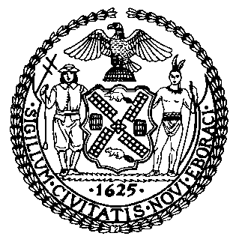 | The Council of the City of New York  Finance Division  Latonia Mckinney, Director  Fiscal Impact Statement  Proposed Int. No. 1839-A  Committee: Economic Development
Title: A Local Law to amend the administrative code of the city of New York, in relation to an annual report on the progress of the Brooklyn Navy Yard master plan | Sponsors: By Council Members Vallone and Louis
Summary of Legislation: Proposed Int. No. 1839-A would require that each contract with a value in excess of $20,000,000 registered by the comptroller, on or after April 1, 2021, between the Department of Small Business Services and a Brooklyn Navy Yard development entity include a provision obligating the Brooklyn Navy Yard development entity to submit a report no later than January 15 of each calendar year to the mayor and the speaker of the council regarding the entity’s progress toward achieving the goals set forth in its master plan.
Effective Date: This local law would take effect immediately provided that the report required by section three of the legislation would not be required for any calendar year prior to 2023.

Fiscal Year In Which Full Fiscal Impact Anticipated: Fiscal 2022
Fiscal Impact Statement:

 | Effective FY21 | FY Succeeding  Effective FY22 | Full Fiscal  Impact FY22
Revenues (+) | $0 | $0 | $0
Expenditures (-) | $0 | $0 | $0
Net | $0 | $0 | $0

Impact on Revenues: It is anticipated that there would be no impact on revenues resulting from the enactment of this legislation.
Impact on Expenditures: It is estimated that there would be no fiscal impact on expenditures resulting from the enactment of this legislation as existing resources would be used to fulfill the requirements set forth.
Source of Funds To Cover Estimated Costs: N/A
Source of Information: New York City Council Finance Division
Mayor’s Office of Legislative Affairs
Estimate Prepared by: Aliya Ali, Principal Financial Analyst

Estimate Reviewed by: Stephanie Ruiz, Assistant Counsel
Nathan Toth, Deputy Director
Crilhien Francisco, Unit Head
Legislative History: This legislation was introduced to the Council on December 19, 2019 as Int. No. 1839, and was referred to the Committee on Economic Development (Committee). A hearing was held by the Committee on November 20, 2020, and the legislation was laid over. The legislation was subsequently amended and the amended version, Proposed Int. No. 1839-A, will be voted on by the Committee at a hearing on February 25, 2021. Upon successful vote by the Committee, Proposed Int. No. 1839-A will be submitted to the full Council for a vote on February 25, 2021.
Date Prepared: February 18, 2021

