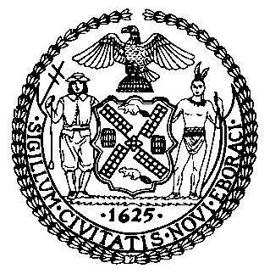 | The Council of the City of New York  Finance Division  Latonia Mckinney, Director  Fiscal Impact Statement  Proposed Intro. No: 613-A  Committee: Women
Title: A Local Law in relation to assessing on workplace risk factors associated with sexual harassment within city agencies | Sponsors: Council Members Adams, Rose, Rosenthal, Chin, Powers, Constantinides, and Reynoso
Summary of Legislation: Proposed Intro. No. 613-A would require the New York City Department of Citywide Administrative Services (DCAS) to review ongoing assessments conducted by City agencies, as well as the offices of the borough presidents, the comptroller and the public advocate, of risk factors associated with sexual harassment within such agencies, in order to help provide a fair and safe work environment for all City workers. The assessments would be submitted to DCAS for periodic review. This local law would be deemed repealed on January 31, 2022.
Effective Date: This local law would take effect immediately and would be deemed repealed on January 31, 2022.
Fiscal Year In Which Full Fiscal Impact Anticipated: Fiscal 2019
Fiscal Impact Statement:
 | Effective FY18 | FY Succeeding Effective FY19 | Full Fiscal Impact FY19
Revenues | $0 | $0 | $0
Expenditures | $0 | $0 | $0
Net | $0 | $0 | $0
Impact on Revenues: There would be no impact on revenues resulting from this legislation.
Impact on Expenditures: It is anticipated that there would be no impact on expenditures because existing resources could be used by City agencies to conduct the assessments and by DCAS to review the assessments.
Source of Funds To Cover Estimated Costs: Not applicable.
Source of Information: New York City Council Finance Division
Department of Citywide Administrative Services
Estimate Prepared by: Daniel Kroop, Financial Analyst
Estimate Reviewed by: Regina Poreda Ryan, Deputy Director
Dohini Sompura, Unit Head
Rebecca Chasan, Counsel
Legislative History: This legislation was considered at a joint hearing by the Committee on Women and the Committee on Civil and Human Rights as a Preconsidered Introduction at a hearing on February 28, 2018, and the legislation was laid over. The legislation was introduced to the Council as Intro. No. 613 on March 7, 2018 and referred to the Committee on Women. The legislation was subsequently amended and the amended version, Proposed Intro. No. 613-A, will be voted on by the Committee on Women at a hearing on April 9, 2018. Upon successful vote by the Committee, Proposed Intro. No. 613-A will be submitted to the full Council for a vote on April 11, 2018.
Date Prepared: April 8, 2018

