THE COUNCIL OF THE CITY OF NEW YORK
RESOLUTION NO. 887

Resolution approving with modifications the decision of the City Planning Commission on Application No. N 190054 ZRK, for an amendment of the text of the Zoning Resolution (Preconsidered L.U. No. 380).

By Council Members Salamanca and Moya

WHEREAS, the City Planning Commission filed with the Council on March 15, 2019 its decision dated March 13, 2019 (the "Decision"), on the application submitted by 1640 Flatbush Owner, LLC, pursuant to Section 201 of the New York City Charter, for an amendment of the text of the Zoning Resolution of the City of New York, modifying Appendix F for the purpose of establishing a Mandatory Inclusionary Housing area, utilizing Option 2, the development site (Block 7577, Lot 60), which in conjunction with the related action would facilitate the construction of a new, approximately 130,000-square-foot mixed-use development with two floors of commercial space and approximately 114 residential units at 1640 Flatbush Avenue in the Flatbush neighborhood of Brooklyn Community District 14, (Application No. N 190054 ZRK), (the "Application");

WHEREAS, the Application is related to application C 190053 ZMK (Pre. L.U. No. 379), a zoning map amendment to change C8-2 and R6 zoning districts to C4-4D and R6 districts;

WHEREAS, the Decision is subject to review and action by the Council pursuant to Section 197-d(b)(1) of the City Charter;
WHEREAS, upon due notice, the Council held a public hearing on the Decision and Application on March 19, 2019;

WHEREAS, the Council has considered the land use implications and other policy issues relating to the Decision and Application; and

WHEREAS, the Council has considered the relevant environmental issues, including the negative declaration issued October 29th, 2018 (CEQR No. 19DCP028K) which include an (E) designation to avoid the potential for significant adverse impacts related to hazardous materials, air quality, and noise (the “E” Designation (E-506));

RESOLVED:

The Council finds that the action described herein will have no significant impact on the environment as set forth in the (E) Designation (E-506) and Negative Declaration.

Pursuant to Sections 197-d and 200 of the City Charter and on the basis of the Decision and Application, and based on the environmental determination and consideration described in the report, N 190054 ZRK, incorporated by reference herein, and the record before the Council, the Council approves the Decision of the City Planning Commission with the following modifications.

Matter underlined is new, to be added;
Matter struck out is to be deleted;
Matter within # # is defined in Section 12-10;
* * * indicates where unchanged text appears in the Zoning Resolution

Matter double stuck out is to be deleted by the City Council
Matter double underlined is added by the City Council

* * *

APPENDIX F
Inclusionary Housing Designated Areas and Mandatory Inclusionary Housing Areas

* * *

BROOKLYN

* * *

Brooklyn Community District 14

* * *
Map [_] – (date of adoption)

[PROPOSED MAP]

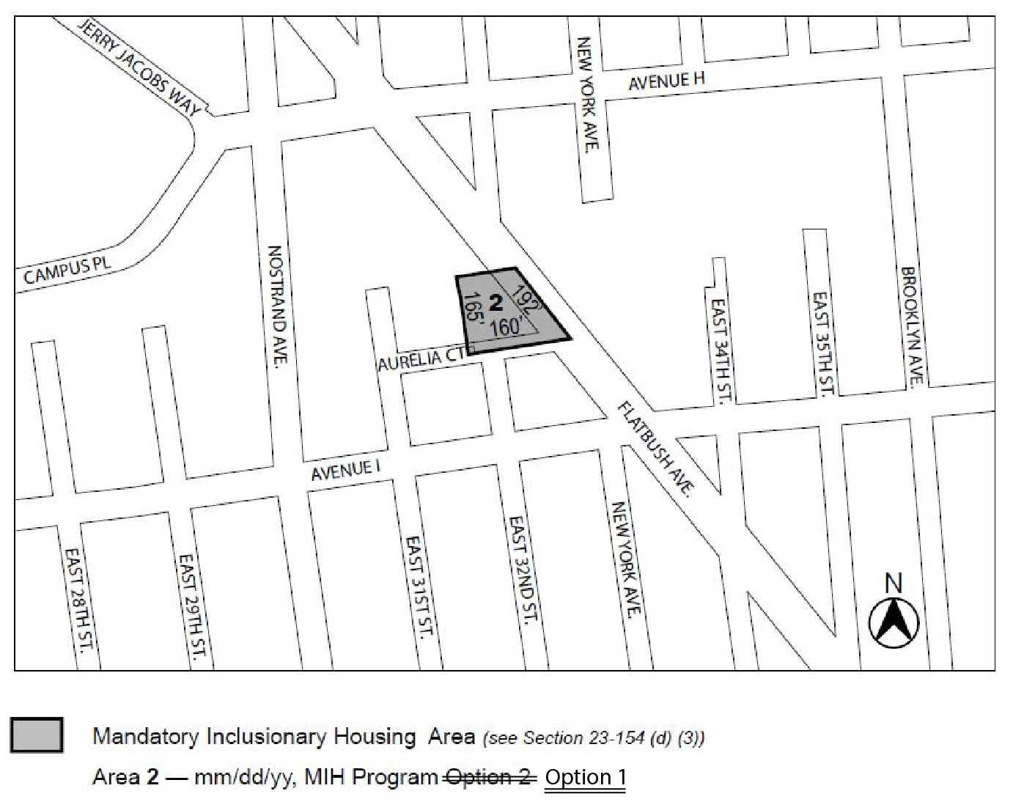

Portion of Community District 14, Brooklyn

* * *

Adopted.

Office of the City Clerk, }
The City of New York, } ss.:

I hereby certify that the foregoing is a true copy of a Resolution passed by The Council of The City of New York on May 8, 2019, on file in this office.

.....……......................................... City Clerk, Clerk of The Council

