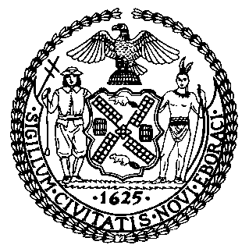 | The Council of the City of New York  Finance Division  Latonia McKinney, Director  Fiscal Impact Statement  Proposed Intro. No. 2297-A  Committee: Public Safety
Title: A Local Law to amend the administrative code of the city of New York, in relation to qualification for service with the police department | Sponsors: By Council Member Moya, the Public Advocate (Mr. Williams), the Speaker (Council Member Johnson) and Council Members Louis and Dinowitz
Summary of Legislation: This legislation would prohibit a person from serving with the Police Department if such person has previously been dismissed from a police force for misconduct, or has resigned from a police force during an investigation for misconduct.

Effective Date: This local law would take effect 30 days after becoming law.
Fiscal Year In Which Full Fiscal Impact Anticipated: Fiscal 2023
Fiscal Impact Statement:

 | Effective FY22 | FY Succeeding  Effective FY23 | Full Fiscal  Impact FY23
Revenues (+) | $0 | $0 | $0
Expenditures (-) | $0 | $0 | $0
Net | $0 | $0 | $0

Impact on Revenues: It is anticipated that there would be no impact on revenues resulting from the enactment of this legislation.
Impact on Expenditures: It is anticipated that there would be no impact on expenditures resulting from the enactment of this legislation.
Source of Funds To Cover Estimated Costs: N/A
Source of Information: New York City Council Finance Division
New York Police Department
Estimate Prepared by: Nevin Singh, Financial Analyst
Estimate Reviewed by: Eisha Wright, Unit Head
Noah Brick, Assistant Counsel
Legislative History: This legislation was introduced to the Council on April 29, 2021 as Intro. No. 2297 and was referred to the Committee on Public Safety (Committee). The Committee heard the legislation on November 22, 2021 and the legislation was laid over. The legislation was subsequently amended and the amended version, Intro. 2297-A, will be voted on by the Committee on December 8, 2021. Upon successful vote by the Committee, Proposed Intro. No. 2297-A will be submitted to the full Council for a vote on December 9, 2021.
Date Prepared: December 6, 2021

